INCO: International Scientific Cooperation Projects (1998-2002)

Contract number : ICA4-CT2002-10020
THIRD ANNUAL REPORT:
covering period from January 2005 to December 2005

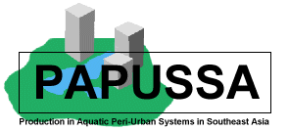

Title: Production in Aquatic Peri-urban Systems in South East Asia

Project homepage : http://www.papussa.org

Keywords : (5 maximum) Aquaculture, peri-urban, south-east Asia

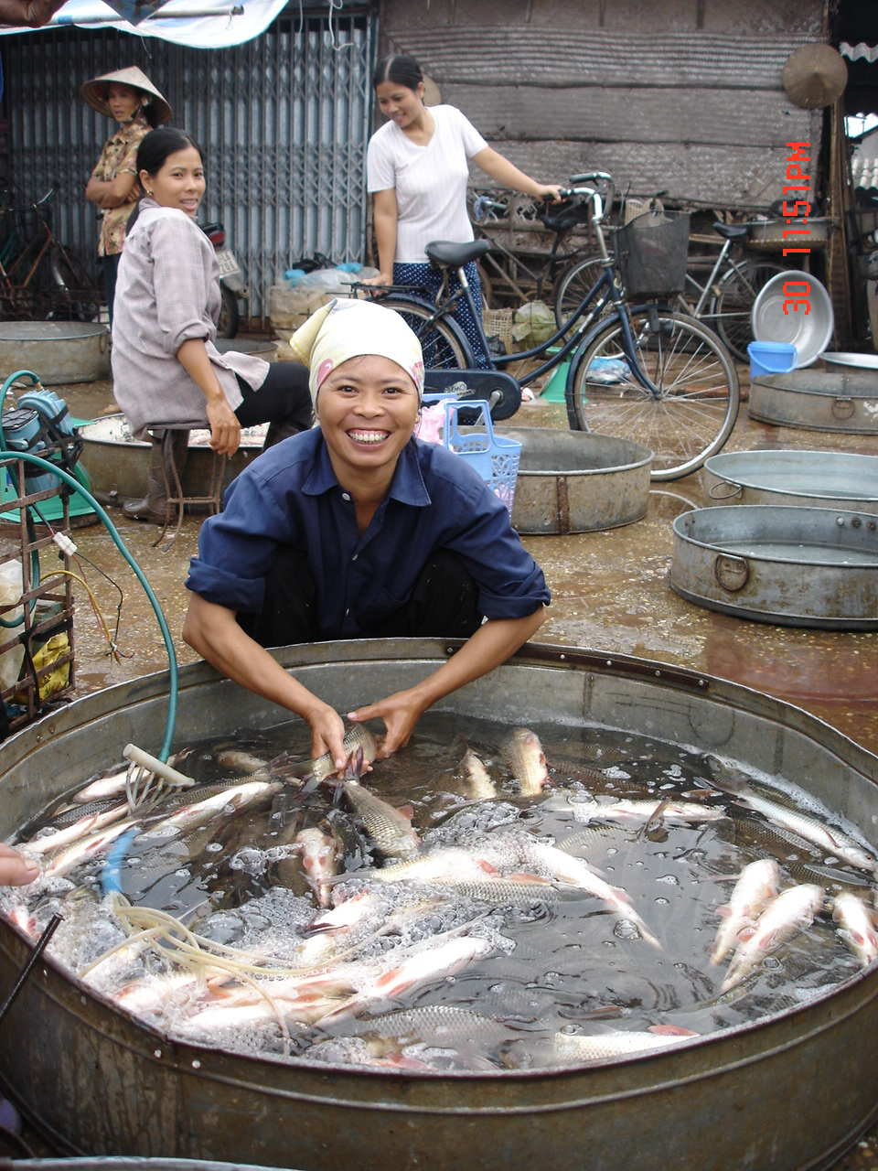
TITLE : PRODUCTION IN AQUATIC PERI-URBAN SYSTEMS IN SOUTHEAST ASIA

COORDINATOR

University of Stirling  Institute of Aquaculture  Stirling  FK9 4LA  UK | Dr Little, David  E-M : d.c.little@stir.ac.uk  TEL :44-1786-467923  FAX : 44-1786-472133
CONTRACTORS

The Royal Veterinary and Agricultural University  Dept. Veterinary Microbiology  Stigbojlen 4  Frederiksberg  1871  Denmark | Dr Dalsgaard, Anders  E-M : ad@kvl.dk  TEL : 4535282720  FAX : 4535282757
The National Institute of Hygiene and Epidemiology  Dept. of Microbiology  1, Yersin St.  10000, Hanoi  Vietnam | Prof Cam  E-M : cam@fpt.vn  TEL : 8448219074  FAX : 8449715470
University of Durham  Dept. of Geography  South Road  DH1 3LE, Durham,  UK | Dr Rigg, Jonathan  E-M : j.d.rigg@durham.ac.uk  TEL : 441913747305  FAX : 441913742456
Research Aquaculture No. 1  Dept. of Aquaculture  Dinh Bang, Tuson  Bac Nin  Vietnam | Dr Pham, Anh Tuan  E-M : patuan@fpt.vn  TEL : 8448781084  FAX : 8448273070
The University of Agriculture and Forestry  Faculty of Fisheries  Quan Thu Duc  Ho Chi Minh City  Vietnam | Dr Le Thanh Hung  E-M : lthunggts@hcm.vnn.vn  TEL : 84-8-8963343  FAX : 84-8-8963343
Royal University of Agriculture  Faculty of Fisheries  POBox 2696  Dangkor District  Phom Penh  Cambodia | Mr Chhouk, Borin  E-M : chhoukborin@hotmail.com ; 012898095@mobitel.com.kh  TE L : 855-12-898-095  FAX : 855-23-219-690
Kasetsart University  Dept. of Aquaculture, Faculty of Fisheries  Phaholyothin Road  10900  Bangkok  Thailand | Dr Yoonpundh, Ruangvit  E-M : ffisrvy@ku.ac.th  TE L : 662 5792924  FAX : 662 5613984

LIST OF ACRONYMS

AFPS Aquatic Food Production System
AIT Asian Institute of Technology, Bangkok
EC European Commission
ETC ETC Foundation, Developmental NGO Netherlands
HH Household
HHH Household Head
KU Kasetsart University, Bangkok
KVL The Royal Veterinary and Agricultural University,
Copenhagen
NGO Non Government Organisation
NIHE National Institute of Hygiene and Epidemiology, Hanoi
PUAFPS Peri-urban Aquatic Food Production System
RUA Royal University of Agriculture, Phnom Penh
RIA1 Research Institute of Aquaculture Nos 1, Hanoi
SOS State of the System
UAF University of Agriculture and Forestry, HCMC
UoD University of Durham
UoS University of Stirling
VAC “Vuon, ao, chuong “meaning garden, pond, livestock pen
production system

Contents
1.0 Co-ordinators Report Summary…………..................................................... 5
Executive Summary…………………………………………………………. 7

2.0 Annual Scientific Report…………………………………………………… 15
2.1 Introduction………………………………………………………………… 15
2.2 Activities and outputs during Year 3 of the project……………………………. 15
2.21 Completion of third household monitoring surveys.............................. 15
2.22 Data entry, Data cleaning, Data Analysis……………………………. 15
2.23 Guidelines for Data Analysis and Research Hypotheses …………… 16
2.24 Water sampling programme (January 2005 ongoing)……………… 16
2.25 Interactive Livelihoods Module – Policy Briefs February…………. 17
2.26 Project Interventions: DVD and Aquatic Plants Users Manual……… 17
2.27 Specific Pilot intervention strategies in individual Papussa study cities20
2.28 Ornamental Fish Study HCMC and Bangkok …..…………………... 23
2.29 Special Peri-urban Aquaculture Edition of Urban Agriculture .......... 24
2.30 Data Analysis Workshop, Siem Riep, Cambodia ………………….. 26
2.31 Natural World Documentary:Livelihoods Beung Cheung Ek villagers26
2.32 Dhaka Workshop on Aquatic Food Production in Urban Livelihoods 27

2.4 Dissemination activities throughout the year (Work Package 8)………............. 28
2.5 Technical Problems……………………………………………………………. 32
2.6 Work Plan for 2006…………………………………………………………….. 33
2.7 Publications……………………………………………………………........... 35

3.0 Management annual report…………………………………………………. 37
3.1 Organisation and collaboration……………………………………………….. 37
3.2 Project Meetings and visits…………………………………………………… 38
3.3 Project Exchanges……………………………………………………………. 38
3.4 Problems: Managerial, Administrative and Financial……………………….. 39

4.0 Individual partner annual reports
4.1 Partner 1: University of Stirling……………………………………………… 40
4.1 Partners 2and 3: Royal Veterinary and Agricultural University (KVL)
Copenhagen and National Institute of Health and Epidemiology (NIHE) Hanoi. 45
4.2 Partner 4: University of Durham (UoD), UK………………………………… 57
4.3 Partner 5: Research Institute of Aquaculture 1 (RIA 1) Hanoi………………… 61
4.4 Partner 6: University of Agriculture and Forestry (UAF) HCMC…………… 75
4.5 Partner 7: Royal University of Agriculture (RUA) Phnom Penh…………… 81
4.6 Partner 8: Kasetsart University (KU) Bangkok……………………………… 91

Data Sheet For Annual Report…………………………………………….. 99

Annexes provided in separate document.

THIRD ANNUAL REPORT

Prepared by the project co-ordinators:

CO-ORDINATORS REPORT PARTNER 1: UNIVERSITY OF STIRLING, STIRLING, SCOTLAND, UK

Personnel Involved in the Project

Dr David Little Principal Investigator
William Leschen Research Assistant
Dr Francis Murray Research Assistant

1.0 SUMMARY

The 2nd Progress and Planning Project Meeting held in Penang in December 2004 whilst reviewing the years work and setting a work plan for year 3 also involved the partners agreeing to apply to the EC for a six months extension to the project so that it would now be finishing in June 2006. This decision was taken to allow the project partners more time after reviewing the outstanding project outputs that needed to be completed within the remaining timescale available. This was as a result of all four of the SE Asian city partners still requiring further time to complete their 3rd Household Monitoring Surveys as well as completing their data entry, data cleaning and data analysis, whilst also having to carry out their various intervention pilots which had originally been planned for year 3.

Therefore the opening months of 2005 involved the SE Asian partners completing the 3rd Monitoring survey with a total of 200 households interviewed in each of the four cities. This data was then checked and entered into the overall Access database with the partners then going on to begin their data analysis.

In February an interactive internet linkage was successfully set up between students on the Stirling MSc Aquaculture and Sustainable Development courses and project staff in the 4 SE Asian cities resulting in them jointly producing 4 Policy Briefs from the overall findings of the project so far. Following further discussions and clarification of the production systems to be sampled in the previous Progress and Planning meeting the water sampling programme was continued in each of the cities with the aim of gathering together a 12 monthly record of chemical and biological water quality parameters concentrating on treatment potential and nutrient fluxes from a number of different types of peri-urban aquatic production systems in each of the 4 cities.

The main focus of the third years project work as planned was the setting up and implementation of intervention style pilots in each of the four cities. In Hanoi this involved dissemination of information using posters to peri-urban households on a novel fish fingerling production system which could be lucratively carried out in peri-urban rice fields by lower income households. In Bangkok a trial was set up comparing high input chemical and integrated chemical free (using fish) production of morning glory, whilst in HCMC another dissemination poster in the form of a calendar including details of how fish farmers could improve their production systems was trialled with two peri-urban fish farming communities.

Year 3 saw further dissemination of project outputs (Work Package 8) beginning to develop well, with each of the partners also continuing to disseminate out their State of the System (SOS) Reports to a wide range of stakeholders also including a questionnaire eliciting feedback. Stirling in conjunction with ETC Netherlands was also responsible for the compilation of a special Peri-urban Aquaculture edition of the Urban Agriculture Magazine published in June, with the publication being sent internationally to over 300 regular subscribers as well as being made available to download on the Papussa (www.papussa.org) and RUAF (www.ruaf.org) websites. In November Papussa representatives also attended and gave presentations of project findings to a two day Peri-urban Aquaculture Workshop in Dhaka, Bangladesh. Audio-visual outputs were also produced during the year: A BBC short documentary film was shot in Phnom Penh illustrating and describing the livelihoods of urban dwellers who relied on the cultivation of water morning glory from the waste water- fed Beung Cheung Ek Lake. Stirling also filmed and produced a 25 minute DVD video describing the importance of Aquatic Plants Cultivation in the 4 Papussa cities.

Executive Summary

Findings from 2005 (year 3) of the project can be divided into the initial results from the health and environmental research studies carried out in Phnom Penh and Ha Noi, as well as the initial analyses of the socio-economic data (see Annex 3 for related Tables and Figures) from the comprehensive household baseline and monitoring surveys carried out in the 4 Papussa study cities. As at the time of annual reports writing the intervention pilot studies had not been completed and written up and therefore their findings and reports will be included in the final project report January – June 2006:-.

Health studies – initial findings.

- In-depth studies have been conducted in Phnom Penh and Hanoi to assess:

- skin problems among farmers engaged in wastewater-fed aqua- and agriculture;

- the efficiency of wastewater-fed aquatic systems in Phnom Penh and Hanoi to
reduce key microbiological faecal pollution parameters and

- the microbiological and chemical (toxic metals) food safety of wastewater-fed fish and plants.

- Initial results show that farmers engaged in wastewater-fed aqua- and agriculture experience a number of skin problems (primarily contact dermatitis) at a much higher level compared with farmers engaged in non-wastewater farming activities.

- Both the wastewater-fed aquatic systems in Phnom Penh and Hanoi reduce numbers of faecal micro-organisms and parasites to levels where the outlet water often meets the proposed guideline values of the WHO for wastewater irrigation (See Figures 1-5 from Annex 3). In Phnom Penh there was a 3-4 log reduction in nos of thermotolerant coliforms between the inlets/outlets of the studied AFPS compared to Hanoi where there was a corresponding 1-3 log reduction between inlets and outlets. Few samples were found to contain helminth eggs with no apparent reduction in the number of samples positive for helminth eggs between inlets and outlets.

- Both fish and plants cultured with wastewater contain surprisingly low concentrations of toxic metals (Figures 6-9, Tables 1-3) which in most cases are within the acceptable limits set by FAO/WHO.

- Plants grown in or irrigated with wastewater do show various levels of faecal contamination, e.g. with presence of pathogens like protozoan parasites. Further analyses are needed to assess the relative importance of such faecal contamination compared with the contamination taking place further down the food chain, in particular at the markets level.

Socio economic analyses of Peri-urban Aquatic Food Production System households (PUAFPS) – initial findings (should be read in conjunction with data presented in Annex 3)

- The household baseline and 3 monitoring surveys were carried out between April
2004 and March 2005 involving a total of 818 households (HH) across 4 cities
largely involved in peri-urban aquatic food production systems (PUAFPS –
growing fish and aquatic plants), 212 HH in Bangkok, 209 in Ha Noi, 197 in
HCMC, and 200 in Phnom Penh, with a total household membership of 4,016 as
enumerated at the end of the last (third) monitoring survey.
- Phnom Penh (at 6.2) had the highest average household size, decreasing to 4.9 for
Ha Noi, 4.4 for Bangkok and 4.2 for HCMC. This significantly higher average
household size for Phnom Penh is surprisingly not explained by larger families ie
more children, but mainly by the presence of more extended family members.
- Although most household heads surveyed were men, there were a significant number of female household heads (Table 6 in Annex 3) in Bangkok (21.8%) and HCMC (17.3%). Overall female household heads were on average older than male household heads (52 versus 46 years of age) which could point to widowhood being a factor with Ha Noi and Phnom Penh having significantly higher proportions of female household heads being widows (61 and 50% respectively). However in Bangkok and HCMC a large number of female household heads were married with it seems particularly for Bangkok, female headship not being restricted to instances where a husband is absent
- The greatest fluctuation (movement in and out) in household size over the survey period was seen in Phnom Penh (Figure 10). This was due to nearly 70% of households sampled in Phnom Penh coming from Beung Cheung Ek lake area - an informal settlement whose main function we would speculate is as a dormitory community where relatives from outlying provinces using family networks can access temporary accommodation whilst looking for employment and income in the city. Non relatives accounted for less than 10% of the in-migrants. This migration can also be seen as having a seasonal aspect as numbers increase during busy periods when the morning glory plots are being prepared and after the floods when repairs and upkeep are required. Thus the surveyed population in Phnom Penh are more likely to be recent migrants than in the other three cities with fluctuating household membership being linked to greater turbulence in what are comparatively “younger” urban settlements.
- 70% of the household heads interviewed in Phnom Penh were not born in the district, community or village where they are currently living compared to 24% in HCMC, 13% in Bangkok and just 4% in Ha Noi. This gives further evidence for the Phnom Penh communities surveyed being relatively young in terms of their migration, natality and development profiles, compared to the “more mature” survey sites in the other three cities. This is likely to have significant implications in relation to patterns of work, land ownership profiles and the tenurial status of land holders in each of the cities, as well as the nature and operation of their aquatic production systems. For those household heads who moved the major reasons they gave for moving to the field sites were to find work (32%), to move into a new economic zone (15%), and to pursue a work related initiative (14%), making a total of 61% of these moves being propelled primarily by work/livelihood concerns.
- In terms of education (Table 7) Phnom Penh shows the highest proportion of household heads with no education at all (55% female household heads and 18% of males). This is likely to be linked to the events relating to the Pol Pot regime and the killing of intellectuals which included those with secondary level education. The gender divide in education is further reflected in the other cities where male household heads have much higher levels of secondary education than their female counterparts. Contrary to one of our original research hypotheses Bangkok amongst the four cities had the lowest proportion of household heads who were educated to secondary (females 2.2%, males 13.5%) or further education levels (females 2.2%, males 1.8%), with the majority of its household heads being educated to just primary level (females 78.3%, males 72.4%) or no formal education at all (females 17.4%, males12.3%). It is worth noting that the two Vietnamese cities had proportionally significantly more household heads as well as other household members who entered secondary level education than Bangkok and Phnom Penh.
- Occupational multiplicity or pluriactivity (Table 8 and Figure 11) would seem to be a common feature of livelihoods in the study sites with household heads juggling different occupations depending on the seasons and demand for labour. In Ha Noi household heads were primarily involved in livestock (90%) and fish production (72%) with a smaller proportion engaged in aquatic plants production (23%) which reflects the high involvement of those surveyed in VAC (garden pond livestock) systems and as yet the slow development of the commercial livestock sector in Hanoi. Since the overall focus of the surveyed households is Aquatic Food production Systems (AFPS) the occupational data gathered will obviously reflect this, however AFPS household members over the age of 12 years old are also involved in a variety of other non AFPS income earning activities including professional work, security services, other forms of skilled and unskilled manual labour. Nearly 20% of all household members surveyed were dependents: either students, unemployed, handicapped, or retired people.
- A significant proportion of other AFPS household members in Bangkok, Phnom Penh and Ha Noi (74%, 66% and 100% respectively) had no previous experience working in AFPS systems (Tables 9 and 10). It appears that despite the requirement for technical knowledge for some AFPS, in three out of four of the cities adoption is not strongly linked with the prior experience and engagement of other family members. It also seems based on our data that inter-generational transfer of knowledge is not significant when it comes to understanding who engages in AFPS.
- There appears to be a uniformly low role played by government extension in AFPS knowledge transfer (Table 11) with only Ha Noi’s household heads (20%) mentioning that they had learnt technical AFPS knowledge from government extension. In general “Own experiment” (74.1% in Bangkok who responded to the question), Friends (40% in Ha Noi) and Neighbours (60.9% and 58.0% in HCMC and Phnom Penh respectively) were the main sources of learning for AFPS mentioned in the survey. This is a testament to the low profile of such peri-urban production systems in relevant government departments and ministries, as well as conversely to the ability and motivation of individuals, their families and friends and the commercial sector to successfully promote, adopt and develop such systems almost by themselves. This is a positive indication to planners at policy level that AFPS in each city have developed successfully with minimal government investment or intervention to produce food, incomes and employment for poorer, less educated people, whilst also recycling urban waste water.
- The use of family labour (Figure 12) is integral in AFPS especially in the non commercial scale operations that are prevalent in Ha Noi, Phnom Penh and HCMC with the ratios of mean total HH person days of family labour versus hired labour per week being:-
    - 11.3: 2.1 for Ha Noi
    - 6.2 : 2.0 for Phnom Penh
    - 6.7 : 0.8 for HCMC
    - 4.2 : 3.6 for Bangkok.

- The units (eg ponds, fields) of AFPS production in Bangkok (Table 16) are significantly larger in area than they are in the other three cities along with the higher levels of commercialization reflecting this comparative labour balance above and also illustrating the transition from being “a way of life” to “becoming a business”. Ever increasing competing demands from Bangkok’s dynamic labour market have been attracting away family members to more attractive and lucrative alternative occupations. This can result as in the case of catfish farmers in Lumsai, Bangkok using migrant Burmese to work on their farms.
- Fish farming generally appears to use relatively more hired labour than aquatic plant production probably due to greater complexity of activities and higher levels of commercialization within fish culture; whereas growing aquatic plants is more malleable around the competing demands on household labour and particularly to the demands of women who across the four cities are relatively speaking much more involved in aquatic plants cultivation than in farming fish.
- Hired/wage paid workers (Table 12) working in fish culture are paid significantly more than their counterparts in aquatic plants cultivation with the exception of Phnom Penh, with Bangkok having significantly higher overall wage rates than the other three cities. Seasonal patterns of wage rate variations were noted in each of the cities which are most probably due to variations in demand for labour related to the different stages of the AFPS production cycles, as well as from other competing income earning activities.
- Ownership of land amongst surveyed AFPS households (Table 13) is relatively high in Bangkok (56.7%) and HCMC (68.3%) compared to Phnom Penh (37.3%) and Ha Noi (0.2%). This difference between the Vietnamese cities we believe is due to Ha Noi’s farmers perception that despite the long term bestowal of land use rights on agricultural lands by the state they consider that ultimately the state retains ownership. This difference relates to historical factors since by contrast in HCMC private ownership was the norm through to the mid 1970’s and despite subsequently trying to introduce co-operatives in the Mekong Delta in the years immediately following re-unification this effort was generally short lived and overall ineffective. More recently in Ha Noi de facto private ownership of land is beginning to emerge with increasing numbers of households (11.4% of those surveyed) parcelling out some of their lands for rental by other households.
- Acquisition of land (Table 14) differs between Phnom Penh where it is generally purchased (73% of those Households surveyed), compared to Bangkok and HCMC where households stated they acquired their land by inheritance (72% and 69% respectively). In Thailand the settlement history of the research sites is relatively longer and thus land has been passed on from one generation to the next over several generations. In HCMC as previously mentioned the persistence of de facto private ownership of land has reflected the apparently widespread view among farmers that their land has been inherited. In contrast in Phnom Penh a sizeable proportion of the households were resettled to their current place of residence from elsewhere (with little documentation) following the end of the Pol Pot regime such that there was no prior ownership of the land and therefore little scope for transfer and acquisition through inheritance.
- The patterns of proof of ownership or long term land use rights between the cities (Table 15) largely reflects the institutions and land management systems in place in each country and their respective maturity. In Bangkok 94% of landowners had official “deeds” as proof of ownership compared to actually none in Phnom Penh and only 1.4% in HCMC. In these latter cities 89% in HCMC and 42% in Phnom Penh could show what they termed as “occupancy licences”. Land management systems in Cambodia are still undeveloped with the country’s revised Land Law only passed in 2001, a framework which is still struggling to set up a formal systematic mechanism for the registration of its lands.
- Amongst the cities (Table 16) Bangkok and Hanoi have the largest average plot sizes used for AFPS (1.58 ha and 1.14 hectares respectively) whereas Phnom Penh and HCMC have mean plot sizes less than half these figures (0.48 ha and 0.49 ha respectively). These data are the consequence of a number of factors however Ha Noi has a significant proportion of waste water fish producers utilizing larger (up to 20 hectare) grow out ponds – a situation which unrealistically alters the mean and is not found in the other cities. Higher than average plot areas in Bangkok also reflect the maturities and commercialisation of the production systems and the communities themselves in this city.
- The highest average annual net incomes (ie after taking off all production costs) for AFPS in 2003 -2004 were recorded in Bangkok for both fish and aquatic plants cultivation (Table 17). Fish seed producers, although proportionally less in number, earned significantly higher incomes than their food fish growing counterparts in all cities ie hybrid catfish seed producers in Bangkok average earnings 17,867 US$ per annum compared to hybrid catfish producers earning 8,490 US$. In HCMC (Figure 14) Fish seed producers using waste water earned 3,670 US$ per annum compared to polyculture food fish farmers using waste water who earned only 633 US$.
- The commercial morning glory growers in Bangkok averaged 4,180 US$ compared to the more conventional waste water morning glory growers in HCMC (1,330 US$) (Figure 15) and the waste water morning glory farmers in Beung Cheung Ek lake Phnom Penh averaging between 200-500 US$ (Figure 16). These figures reflect the scale of commercialisation and intensivity of cultivation of aquatic plants between the study cities.
- These figures on income show that in general for Bangkok, Hanoi and Phnom Penh peri-urban fish farmers earn higher incomes than aquatic plant growers, however aquatic plant systems have higher yields and productivity (tonnes per hectare per year per unit area – Figure 13) and thus farmers can harvest and obtain income on a more regular basis due to the rapid re-growth of the plants. However in HCMC there is surprisingly more of a parity in incomes between fish and aquatic plants growers with certain aquatic plant production systems actually earning significantly more than their fish culturing counterparts. This finding is quite significant as it indicates that cultivation of aquatic plants in HCMC can be a financially lucrative undertaking which generally involves less initial capital and input outlay and thus less risk than farming fish. Both in terms of an income earning opportunity for poorer people with a higher proportion of women being involved, and aquatic plants potential for low cost treatment of urban waste water these findings are significant indicators to policy makers and urban planners of the multi-beneficial roles that aquatic plant cultivation can play in HCMC.
- Households perceptions of urban change and future drivers of development (Table 18) were compared in each city. While taking note of differences in the different cities surveys administration the pattern and frequency of observations regarding new developments in each city can give clues as to the sources of dynamism within the peri-urban landscape. The construction of new roads and bridges (54% of observations) is particularly noticeable in Hanoi where the Ring Road III and Thanh Tri bridge are particularly prominent as part of ongoing improvements in the city’s transport infrastructure. HCMC recorded the highest proportion of households (22%) that believed that the area used for aquaculture was actually declining. This could be a reflection of new towns being built in districts of HCMC where aquaculture is particularly prominent. Whereas conversely proportionally more respondents in Bangkok, Phnom Penh and Hanoi anticipated an increase in area for peri-urban aquaculture. Hanoi had by far the highest overall number/proportion of recorded observations on perceptions of change which in some ways is a reflection on the level of development currently underway in the city and the tangibility of its impact. The number of observations then decreased by city in the following order: Phnom Penh, HCMC, Bangkok, which dependent on how one can reasonably measure change would reflect our overall observations of the situation in each study city.
- More specifically on perceptions of future threats related to their production systems 43% of surveyed household heads overall observations related to future production losses linked to diseases, pests, stealing, natural disasters, pollution, lack of knowledge, lack of suitable equipment, low quality seed, and lack of water. These categories causing future production losses are highest in Hanoi (88% of respondents mentioning them as a threat to their AFPS) followed by Bangkok (60%), and then HCMC and Phnom Penh at 54% and 32% respectively. Other perceived threats included marketing problems and increasing input costs (particularly prominent in Ha Noi (32% and 37% of respondents respectively). It was interesting to note the significant lack of importance given to future health problems of producers across all 4 cities.

Initial Recommendations
For the future sustainability and development of growing fish and aquatic plants in the 4 Papussa study cities the following five points need to be addressed jointly by all of the stakeholders involved:

a. Historically up to the present day minimal government investment and intervention has been involved in the development and success of AFPS in each study city to generate significant incomes and employment for poorer, generally less well educated people, whilst also recycling waste water and producing nutritious and affordable food which is consumed on a daily basis by millions of urban dwellers. With an increase in information now available about the systems, their benefits and constraints, planners can at relatively low levels of investment outlay begin to target and incorporate AFPS in their future urban development strategies.

b. A framework for the development of regulations and legislation concerning individual land ownership and tenureship in urban and peri-urban areas needs to
be standardised for each of the cities and clarified, with the so called “illegal
registration status of many incoming migrating individuals being constructively
addressed.

c. Aquaculture, health and food safety institutions need to collaborate further to jointly identify and produce research based data on specific food safety
parameters for consumers within urban waste water and non waste water produced
fish and aquatic plants. The resulting data should then be made widely available to
a range of stakeholders

d. The govt (Dept of Fisheries) in each city should set up and develop a
unit/sub dept which has the specific remit to develop peri-urban aquaculture both
fish and aquatic plants. This could be initiated at low initial cost by just one or two members of staff.

e. Aquaculture, Fisheries, and Agriculture teaching and research institutions should pro-actively include and develop the concept of peri-urban aquaculture
within their curricula. There is presently little or no exposure. Particular emphasis
should be made in this research area in developing the protocols for specific
sustainable peri-urban aquatic production systems which are economically viable
and can be readily understood, taken up and practiced by peri-urban dwellers.

Scientific Annual Report

2.1 Introduction

The report outlines the outputs and activities of the third year of the Papussa project which has been extended to run for a total of 42 months finishing in June 2006. This report covers the period from 1st January 2005 – 31st December 2005.

2.2 Activities during Year 3 of the project

Year 3 of the project was initially planned on being based on the following Work Packages (WP’s):

WP5 Public Health and Hygiene Pilot

WP6 Production Systems and Livelihoods Pilot

WP7 Social Policy and Institutional Pilot

WP8 Dissemination

2.21 Completion of Third Household Monitoring Surveys

The third year of the project began with the initial phase of implementing the overall workplan agreed at the Progress and Planning Meeting held in Penang in December 2004. Following the presentations and discussions reviewing the work of each of the partners concerning the years work ahead it was decided that some modifications to the original project workplan would have to be made in order to complete all of the necessary outputs. This was due to, by January 2005, each of the 4 SE Asian city partners still having to complete their Third Household Monitoring Survey mainly as a result of them beginning their 200 Household Baseline and monitoring surveys only by April/May of the previous year. This meant that in order for the project to get meaningful data over a seasonal duration, the third household monitoring surveys would have to be carried out and completed at the beginning of 2005. It was therefore decided to put back the project interventions to later in the year from June onwards.

2.22 Data entry, Data cleaning, Data Analysis (Feb – June 2005).

Following the completion of the Monitoring survey by February for each of the partners the remaining data were entered into the database. There then followed a further process of data cleaning for each of the partners. Since this was the first experience many of the partner institutions had had in carrying out such relatively large data collection household surveys as well as in the use and application of Access databases the correct entering and cleaning of the survey questionnaire data was a prolonged and long drawn out process. However as in the previous year considerable time and support towards this was provided to the partners by Albert Salamanca (UoD) who painstakingly checked through the data of each individual city partners databases and through email communication supported them in modifying and updating their data.

2.23 Guidelines for Data Analysis and Research Hypotheses

Following earlier guidelines given to the partners in data analysis the previous year during project visits, in March William Leschen (UoS) provided a further more detailed guide to the household survey data analysis with specific Research Hypotheses to be answered and including a basic format for the subsequent report to be written in which the overall findings were to be presented.

2.24 Water sampling programme (January 2005 ongoing)
For year 3 the water sampling programme of aquatic production systems for the 4 city partners was divided up into the assessment of the water treatment capacity measuring indicative physio-chemical parameters of one specific production system in Ha Noi and also Phnom Penh, whilst in Bangkok and HCMC project staff studied nutrient flows (principally P and N) in individual systems also recording other related inputs and outputs (feed, fertilisers) to these systems. Following on from previous sampling last year the National Institute of Hygiene and Epidemiology (NIHE) continued to work in collaboration with the Research Institute of Aquaculture Nos 1 (RIA1) in measuring health related water quality parameters from the inlet and outlets of aquatic production systems in Hanoi. The results and findings from the water sampling programme in each of the 4 cities will be put together in report formats to be completed by the partners between January – June 2006.

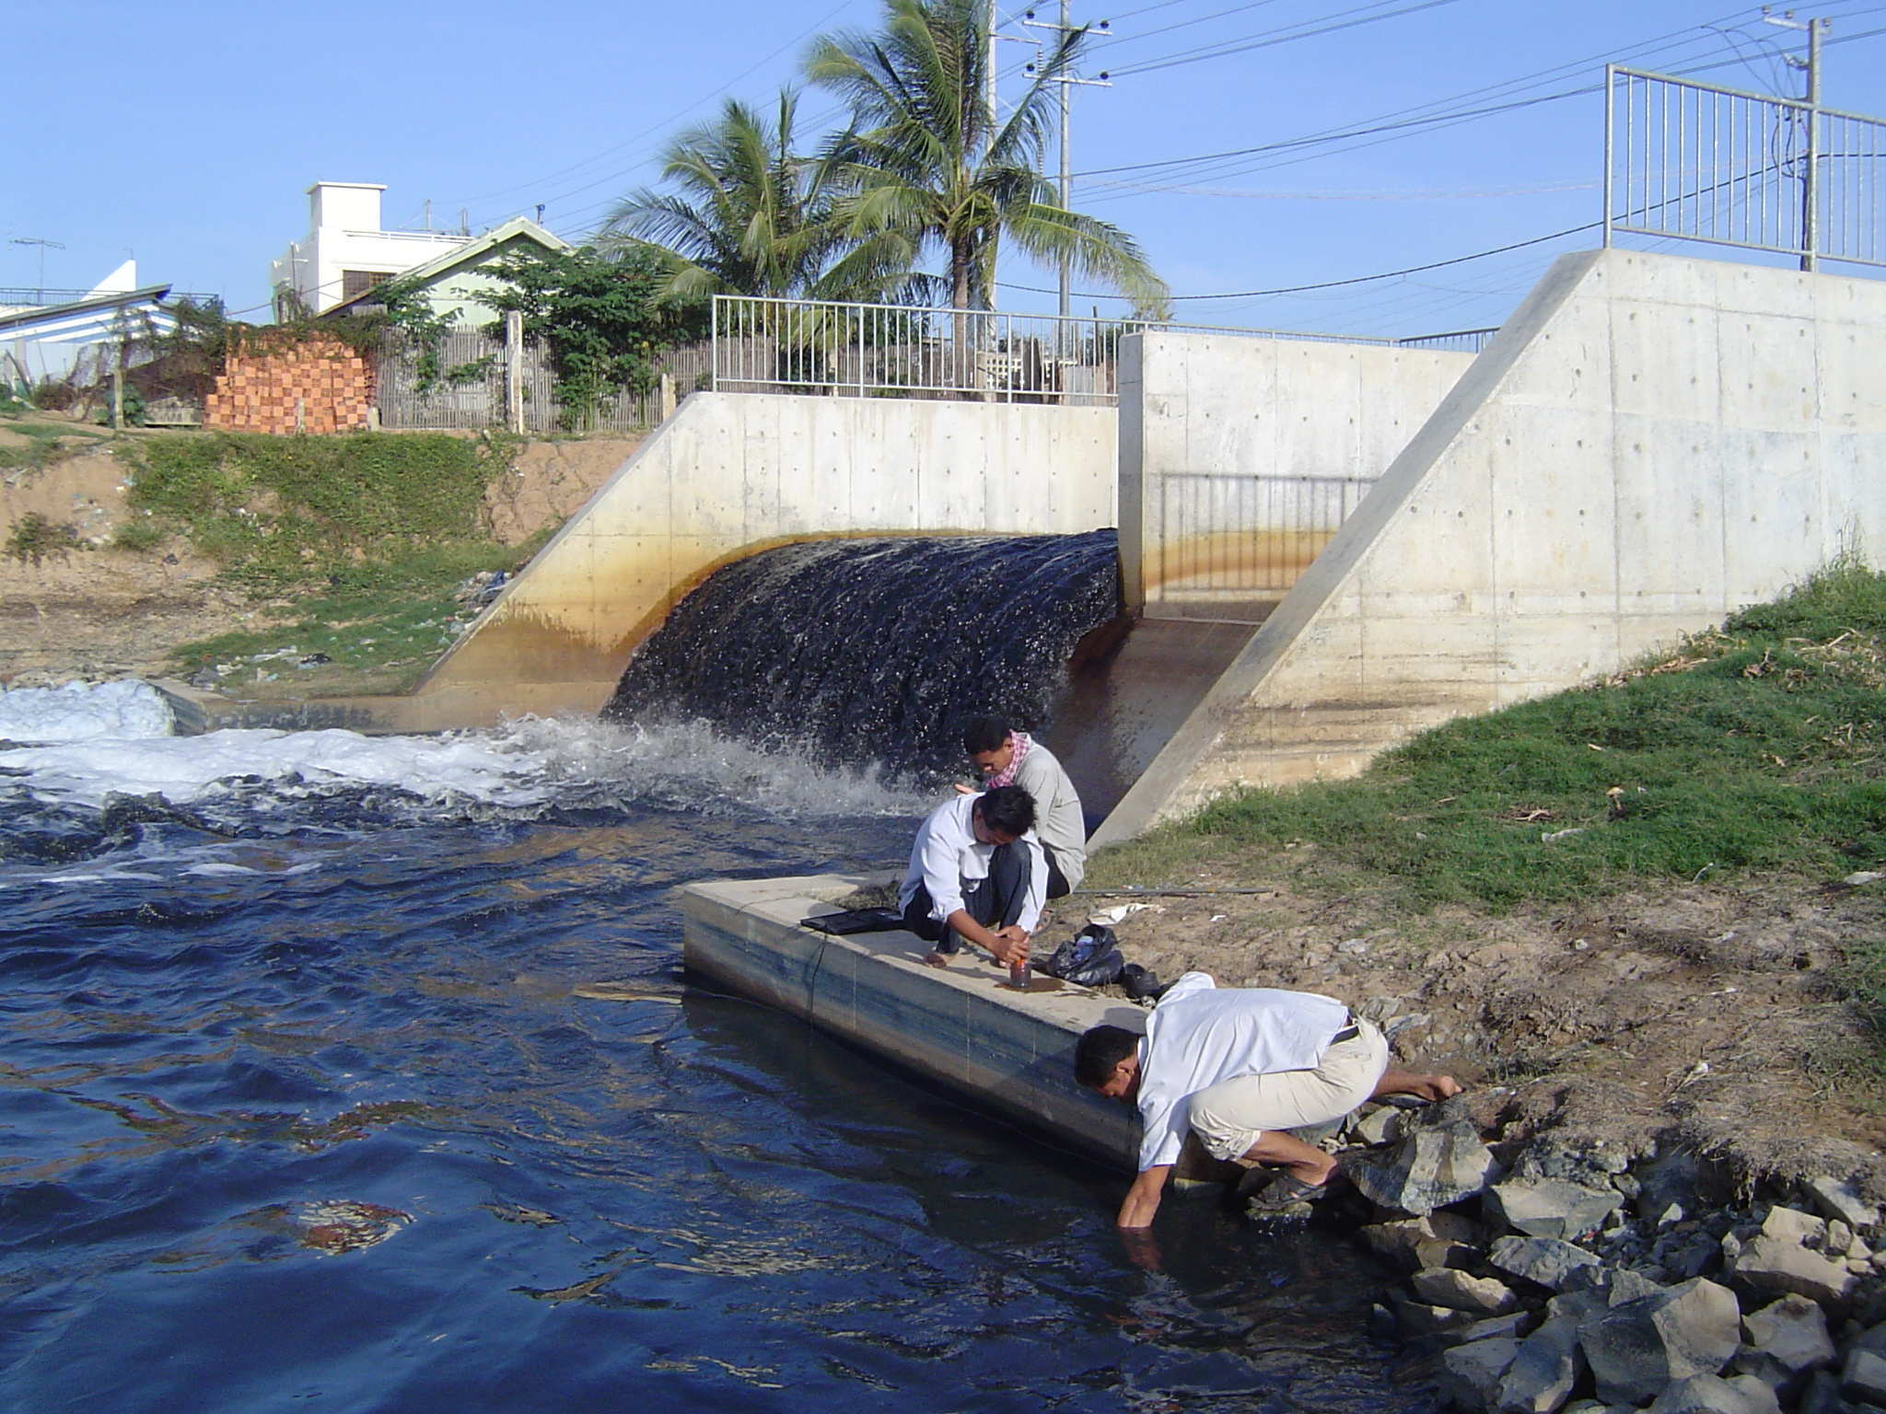

Figure 1 Water sampling RUA team: Inlet Beung Cheung Ek Lake, Phnom Penh February 2005

2.25 – Interactive Livelihoods Module – Policy Briefs February

MSc students on the Aquaculture and Sustainable Development courses at Stirling were involved in a 3 week interactive link with Papussa project staff in the 4 study cities with the objective of producing an illustrated 4 page Policy Brief for Senior Stakeholders on the current status and potential for peri-urban aquaculture in each of these cities. This involved the students sourcing and researching both Papussa project outputs and other secondary data, working together in groups, as well as being in daily contact with their counterparts in each SE Asian city. Their resulting Policy Briefs which can be seen in the Annex were judged by Marielle Dubbeling of ETC with the winners being the Bangkok group. These policy briefs will also be used and further developed by Marielle to go towards the projects’ final Policy Briefs which will be finalised by April 2006 in order to include the relevant findings from all project outputs.

2.26 Project Interventions: Aquatic Plants DVD and Aquatic Plants Users Manual (March – December 2006)
Due to each of the city partners in year 3 requiring more time to complete their Baseline and Monitoring survey analysis and reports writing it was decided to develop two extra, more broader scope interventions which could be carried out collectively in each of the four cities with help from the project coordinators.
Firstly we planned a DVD video showing the importance and impact of cultivating aquatic plants in 4 SE Asian cities – from production through harvesting, marketing and then finally to the consumer. Will Leschen (UoS) took video footage in each of the 4 cities including interviews with different stakeholders with help from each of the city partners. This was then edited with a soundtrack commentary added and then by November 2005 finished off into a 25 minute DVD video. This DVD is now available for dissemination via the project website to be sent out to interested persons and stakeholders. For each person to receive a copy of the DVD they firstly have to complete a short email questionnaire which draws on their interest and background in peri-urban aquaculture particularly aquatic plants cultivation and waste water re-use. Secondly after viewing the DVD they are asked to complete a short questionnaire in order for us to receive feedback from what they have viewed. It is planned in the new year to add the option of Thai, Vietnamese and Khmer language soundtracks onto the same DVD so that it can have a much wider impact and distribution to in-country stakeholders.

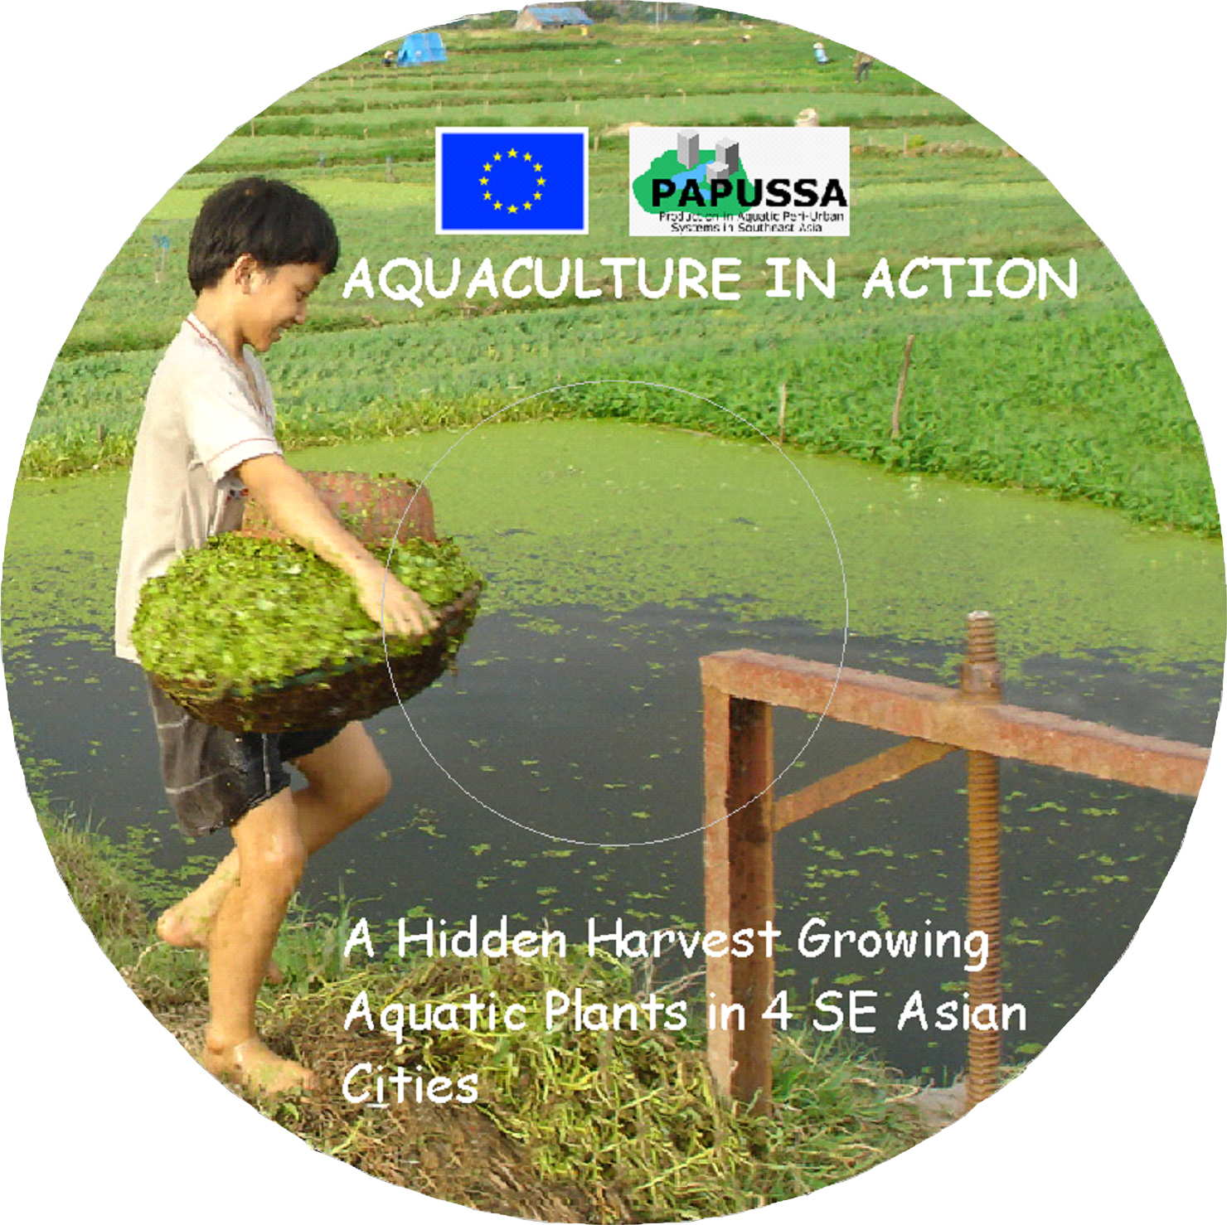

Figure 2 Aquatic Plants Cultivation DVD June 2005

In conjunction with the DVD each of the city partners were also involved in producing a Users Manual for Aquatic Plants Cultivation based on aquatic plant production systems in their own cities. This involved them drawing on their experiences and data collection in the field over the past two and half years of the project as well as secondary data sources and further key informant interviews with farmers. By the end of the 2005 reporting period UAF HCMC, RIA 1 Hanoi and RUA Phnom Penh had all completed final drafts with KU Bangkok to complete their manual by the beginning of January. Once all of the cities manuals are completed Stirling will put them together into one overall document. This will then be sent back to each city partner to be translated from English into their own languages with the resulting manuals (in 4 languages) being published and disseminated out both in country and internationally.

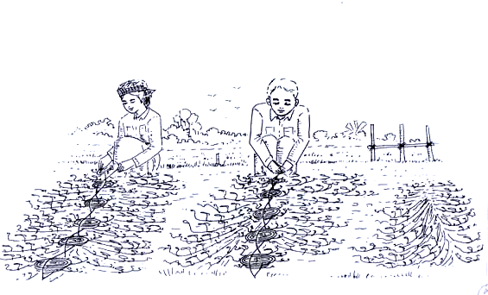

Figure 3 Figure from Aquatic plants booklet RUA Phnom Penh: Morning glory seedling braiding activities
These two interventions and dissemination outputs originated out of our project findings of a distinct lack of both technical and also more descriptive research based publications on aquatic plant cultivation. Our aim is to inform relevant stakeholders of the relative importance and technical knowledge base behind growing aquatic plants in each of these cities whilst also outlining the major benefits and also constraints from these systems. This DVD was first shown at the Peri-urban Aquaculture Workshop in Dhaka in November (see below) where it generated considerable interest amongst Bangladeshi participants who were generally unaware of the potential for aquatic plants cultivation particularly to help create income and employment for poorer peri-urban citizens whilst also recycling urban waste water.

2.27 Specific Pilot intervention strategies in individual Papussa study cities April – December
Aside from the collective aquatic plants DVD and Users Manual, specific interventions were carried out in three out of four of the Papussa study cities. Planning for these interventions began in earnest in April with each city putting forward two proposals for interventions to the co-ordinators (Stirling) from which following discussions one was chosen for each city. The city partners then followed this up by making the necessary plans and preparations for their interventions. The interventions are described in more detail in the individual partner’s reports however they are summarized below:
KU Bangkok: “Chemical free” cultivation of morning glory in integrated system.
Following Bangkok’s consumers increasing interest in chemical free and “organic” vegetables KU set up an on-farm trial in which they compared the production of morning glory in two pond based systems:
- A conventional and widely practiced intensive cultivation system using high inputs of inorganic fertilizer with the regular application of chemical pesticides.
- A “chemical free” production system using poultry waste as a source of organic fertilizer integrated with the culture of giant gourami fish (Osphronemus gourami) which acted as biological controls for the removal of pests from the plant stems.
The trial was carried out over 4 months between September – December with the productivity (biomass produced per m² per month) of both systems being compared. The results are now being analyzed and will be written up in the form of a report in the last 6 months of the project. We are also planning next year to publish a poster and also 3-4 page colour summary leaflet of the trial, both of which would be disseminated out to related stakeholders and institutions eg food safety and certification, health, wholesale and supermarkets, environmental groups and farmers.

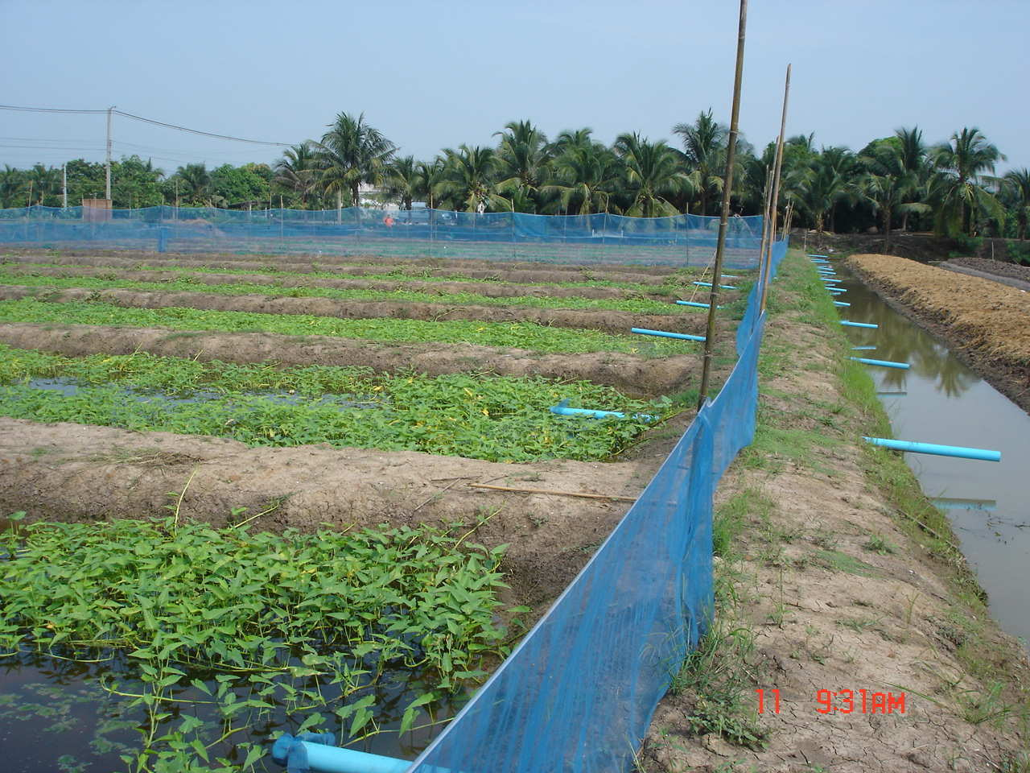

Figure 4 “Chemical free” morning glory trial Bangkok October 2005
RIA 1 Hanoi: A novel system for producing seed tilapia in peri-urban rice fields: Dissemination Poster and Booklet.
RIA 1 Hanoi identified the potential for lower income peri-urban households many of whom were involved in rice production to increase their incomes by introducing broodstock tilapia directly into the paddy fields of their spring rice crop. Within 4 months, with little further inputs and labour this produces a significant quantity of tilapia fingerlings which they would then be able to sell to supplement their incomes. An attractive poster was then produced by RIA1 which clearly and simply explained (in Vietnamese) how peri-urban rice farmers could successfully carry this out and what benefits they could obtain from such a low input system – a contact name, address and telephone number at RIA 1 was also included for those interested persons who wanted further information. These posters were then piloted in 2 peri-urban communities to check that the content and information of the poster were clearly understood with the necessary modifications made afterwards. Also different locations within the communities themselves were tested to see where the poster could have the maximum readership and impact eg market place, local shop, commune office etc. Following this three further peri-urban communities were chosen where copies of the poster were put up at different locations around the community. The response to this intervention was then measured by the number of people who responded by contacting RIA1 for further information. The necessary tilapia broodstock have been made available at RIA1 for the early part of next year when they will be supplied out to a selected number of interested farmers. This process and methodology behind the intervention is essentially to see whether disseminating such technical information in this low cost, extension free format is able to be converted into actual take up and livelihood change in peri-urban areas.
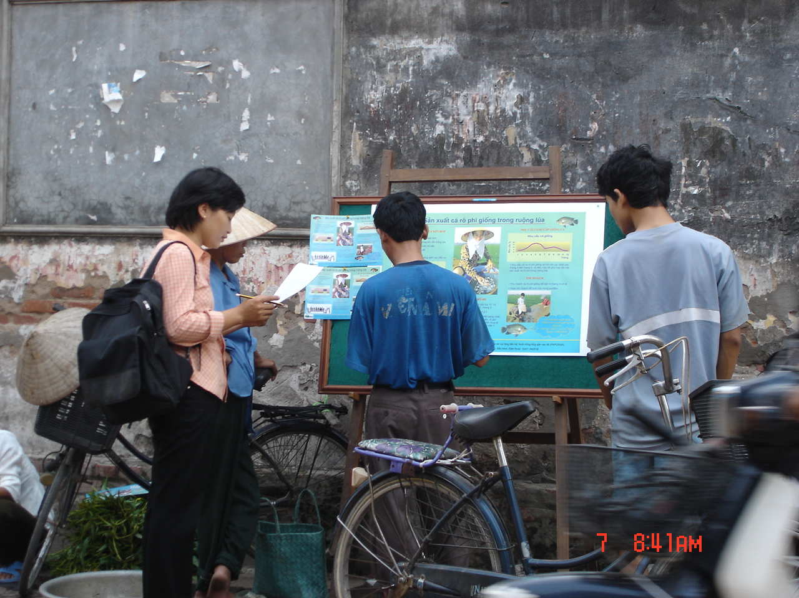

Figure 5 Piloting Peri-urban Rice fish fingerling poster October 2005, Hanoi

UAF HCMC: Techniques for improvement in pond management in peri-urban districts of HCMC.
From previous Papussa project data and field visits UAF identified four particular peri-urban communities which were involved in fish culture as lacking in institutional support, training and technical information in how best they could manage and improve the production from their fish ponds. The UAF team then discussed different methodologies for providing this information eg field based training, workshops, information booklets etc but in the end decided in producing a 2006 calendar which in sections contained technical information (in Vietnamese) on better pond management, fish husbandry and treatment of fish diseases. This calendar was given out in December 2005 to all households practicing fish culture in these four communities, and following a period of 2 months UAF staff will return to each of the households to interview the household head with a series of questions and also informal discussions in order to discover what impact or changes they had made in their aquaculture practices.

RUA Phnom Penh
Due to managerial problems encountered at RUA during 2005 (please see in Management Report) it was not possible for the staff to carry out a specific intervention in Phnom Penh. However to the staffs credit they did produce a well illustrated Aquatic Plants User Manual (see Annex) and were also involved in helping NIHE staff in the field with their Health related studies.

2.28 Ornamental Fish Study HCMC and Bangkok – June – onwards 2006

Following project findings from Years 1 and 2 the importance and future potential for freshwater ornamental fish production in HCMC was recognized particularly in relation to those lower income peri-urban households with a background in fish culture who through urbanization and water quality problems were finding it increasingly difficult to produce and sell food fish. It was decided to carry out a comparative study with Bangkok where ornamental fish production is far more developed and currently generates considerable income from export related earnings. UAF took on a new member of staff, Dr Vu Cam Luong, who was responsible for co-ordinating the study and carrying out an overview of ornamental fish production in and around HCMC. Whilst Ms Wanwisa Saelee of AIT Bangkok was given responsibility for producing an overview report (available in Annex) of the freshwater ornamental fish sector in and around Bangkok. This study will involve further field work in both HCMC and Bangkok concentrating on the livelihood aspects of those involved in the industry and will be completed by March 2006.

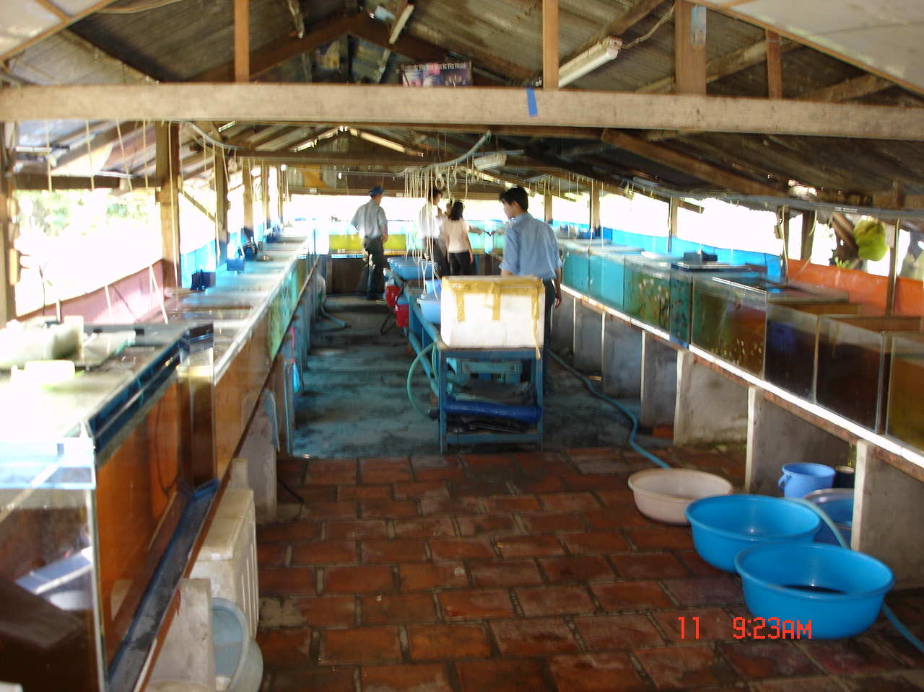
Figure 6 Ornamental fish producer peri-urban HCMC July 2005

2.29 Special Peri-urban Aquaculture Edition of Urban Agriculture - June
Preparation of a special issue of the Urban Agriculture Magazine (UAM), focussing on peri-urban aquatic production was started at the end of 2004. ETC (Netherlands) and Stirling University co-edited the Magazine. William Leschen of Stirling, PAPUSSA and René van Veenhuizen of ETC coordinated this.

The PAPUSSA partners provided 4 country contributions, while Stirling University drafted the editorial based on the analysis of results and inputs from a PAPUSSA workshop. Three articles were drafted by PAPUSSA linked authors. Despite several contacts, neither FAO nor ICLARM provided inputs. Through the regular call for contributions and the RUAF network, 11 additional contributions were submitted out of which 6 were included in the UAM. Three articles were combined into one on Africa, and two articles on Cuba were also combined.

- The Use of Treated Sewage Water from Settlement Ponds in San Juan, Lima
- Family Aquaculture in Cuba
- The Role of Aqua Farming in Feeding African Cities
- Tilapia Culture in Homestead Concrete Tanks in Periurban Nigeria
- Periurban Aquaculture in Ghana
- Urban Agriculture in Istanbul, Turkey

A total number of 3200 copies were produced in June 2005.

2650 copies were sent to the regular international subscribers as well as ETC/RUAF partners for further distribution in the Region. 400 copies were sent to the PAPUSSA partners and an additional 120 to Stirling University. Another 100 copies were distributed at the PAPUSSA workshop in Dhaka.

The articles of this issue have been published on both the Papussa (www.papussa.org) and the RUAF website (www.ruaf.org) and are currently under translation for publication into French, Spanish, Chinese and (partly) Arabic UA Magazines (under the responsibility of the ETC/RUAF partners).

In the collaboration between ETC/RUAF and PAPUSSA, it also involved an input to the RUAF Bibliography and website management, the introduction to the bibliography, the editorial and three cases of this issue of the UA-Magazine, are also being used for the chapter on Aquatic Production for the RUAF publication, due for publication in May 2006.

The editor of Appropriate Technology has requested to reprint the articles on Africa of this UA Magazine issue, which has been granted.

The Magazine will also be included on the PAPUSSA CD Rom under development.

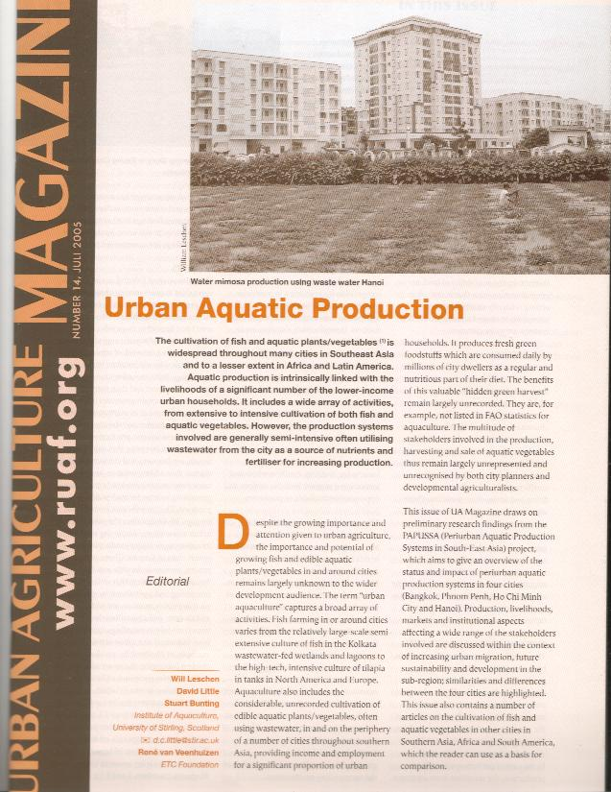

Figure 7 Special Peri-urban Aquaculture Edition of Urban Agriculture

2.30 Data Analysis Workshop, Siem Riep, Cambodia – 4-9th July

An Access Database Analysis training workshop was held between 4-9th July in Siem Riep, Cambodia for Papussa staff members from the 4 city partners with the objective of further familiarisation of the techniques for data analysis of the Household Baseline and Monitoring Survey database. The workshop was conducted by Dr Francis Murray (UoS) with the assistance of Albert Salamanca (UoD) and Will Leschen (UoS). Guidelines and an amended format for the survey report were also given out to the partners.

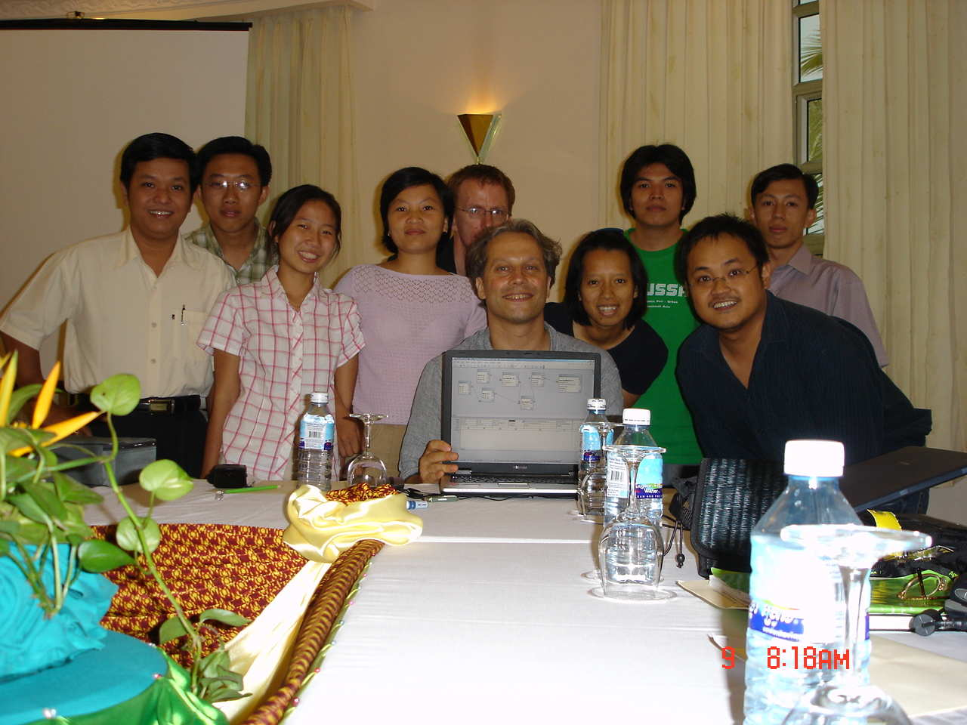

Figure 7: Database analysis workshop, Siem Riep July 2006

2.31 BBC Natural World Documentary Livelihoods of Beung Cheung Ek villagers Phnom Penh October 2005

A short 5 minute BBC documentary as part of the Natural World series was shot around the lakes of the 3400 hectare waste water fed Beung Cheung Ek lake in Phnom Penh which tells the story of households who are reliant on the production of morning glory for their livelihoods. This will be shown internationally on BBC cable and satellite channels as well as on British Airways in-flight entertainment. Se below online link where the video can be viewed:

http://www.handsontv.info/series7/programme_4.html

2.32 Workshop on Aquatic Food Production in Urban Livelihoods (Dhaka, Bangladesh) 22-23rd November

A 2 day Workshop funded through the DFID Aquaculture Fish and Genetics Research Programme Stirling (AFGRP) in collaboration with Practical Action (formerly ITDG) Bangladesh, and the Bangladesh Fisheries Research Forum (BFRF) on Peri-urban Aquatic Production and Improvement of the Livelihoods of the Urban Poor in SE Asia was held in Dhaka, Bangladesh between 22-23rd November 2005 . A wide range of stakeholders attended from Bangladesh, India, Vietnam, Thailand and Cambodia with the main objective of the workshop being to set up a Platform for Communication and Information Exchange towards the sustainable development of peri-urban aquaculture in the region. Representatives from the Papussa Project from Bangkok, HCMC, Hanoi and Phnom Penh gave presentations disseminating their findings from the project, whilst a 25 minute Papussa DVD entitled “ The Hidden Harvest” which describes the considerable importance of edible aquatic plants cultivation in the four cities was also shown.
The overall message that was communicated to the Bangladeshi participants from the Papussa presentations was that the cultivation of both fish and edible aquatic plants often using and recycling urban waste water is practiced successfully and commercially in a number of SE Asian cities which is often to the benefit of poorer peri-urban households providing food, incomes and employment. This message was developed in discussions to explore the best ways forward for peri-urban aquaculture not just in Dhaka but also in Bangladesh’s other major cities to be developed.

Calls were made to improve the use of ponds and water bodies in urban and peri-urban areas of Bangladesh in order to increase aquaculture production as well as providing incomes and employment for lower income peri-urban households. In order to achieve these goals attendees suggested that regulations guiding the use of potential areas for aquaculture within and surrounding cities and towns should be revised, encouraging the uptake of environmentally friendly aquaculture production within these systems. The Secretary of the Fisheries and Livestock Ministry Md Abdul Karim, who also attended, reinforced these recommendations stating “the regulations should be updated and executed to ensure an increase in peri-urban aquaculture production.”

The workshop received media coverage from Bangladeshi national television news and in a 15 minute Agriculture based documentary as well as two Dhaka daily newspapers. It was also disseminated out through a number of other publications and websites including Fish Farmer, Fish Farming International, Stream, NACA, RUAF and the Urban Agriculture Magazine. Workshop minutes are included in the Annex and a Working Group/Committee has been set up whose first role is to summarise the workshop minutes and recommendations into a document to be sent to the Ministry Secretary.
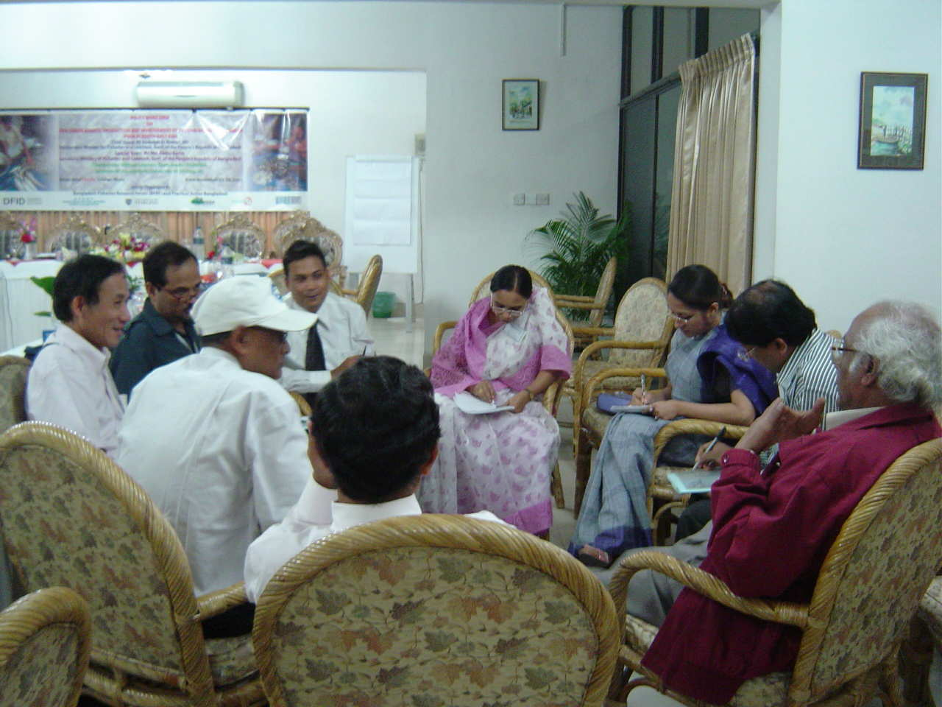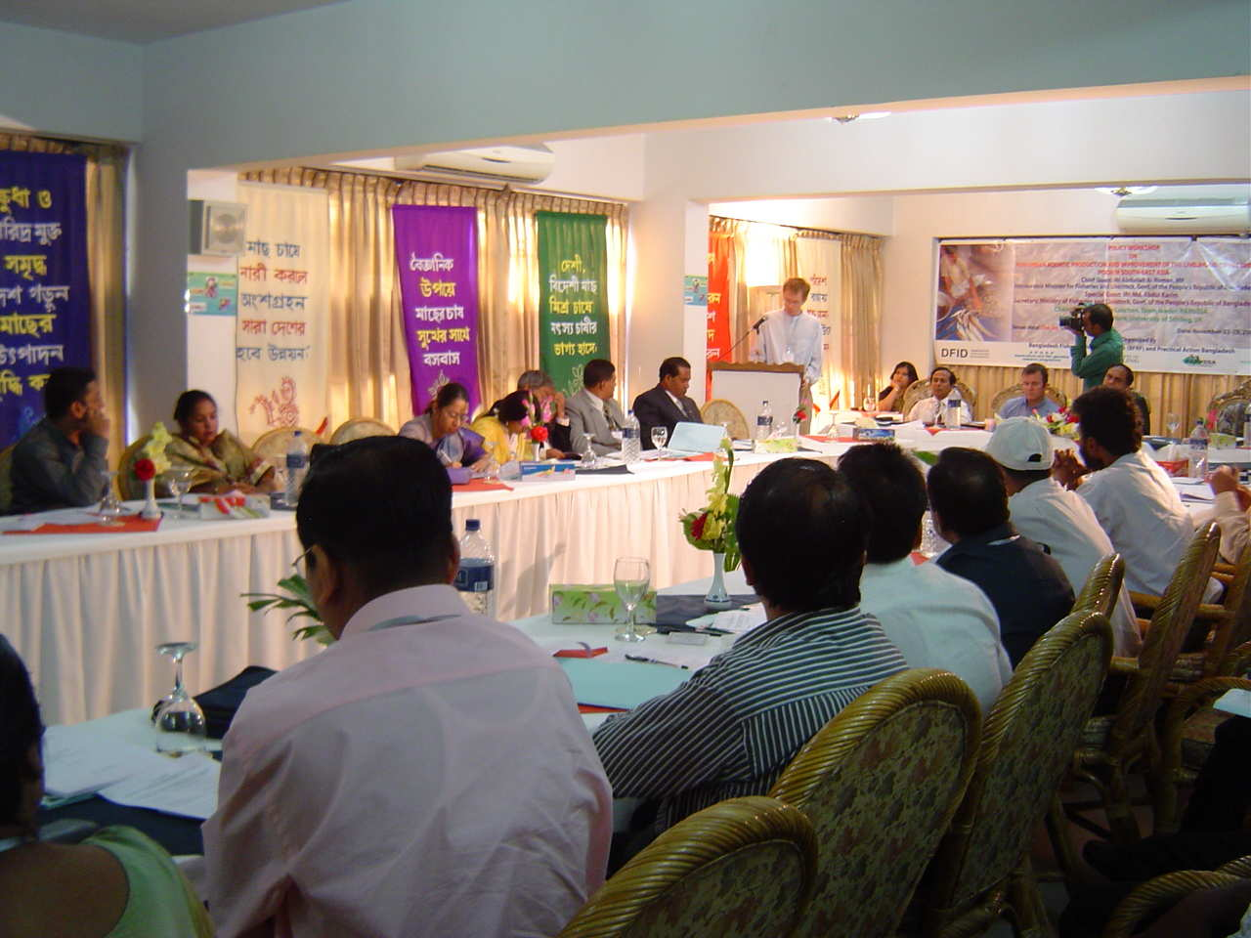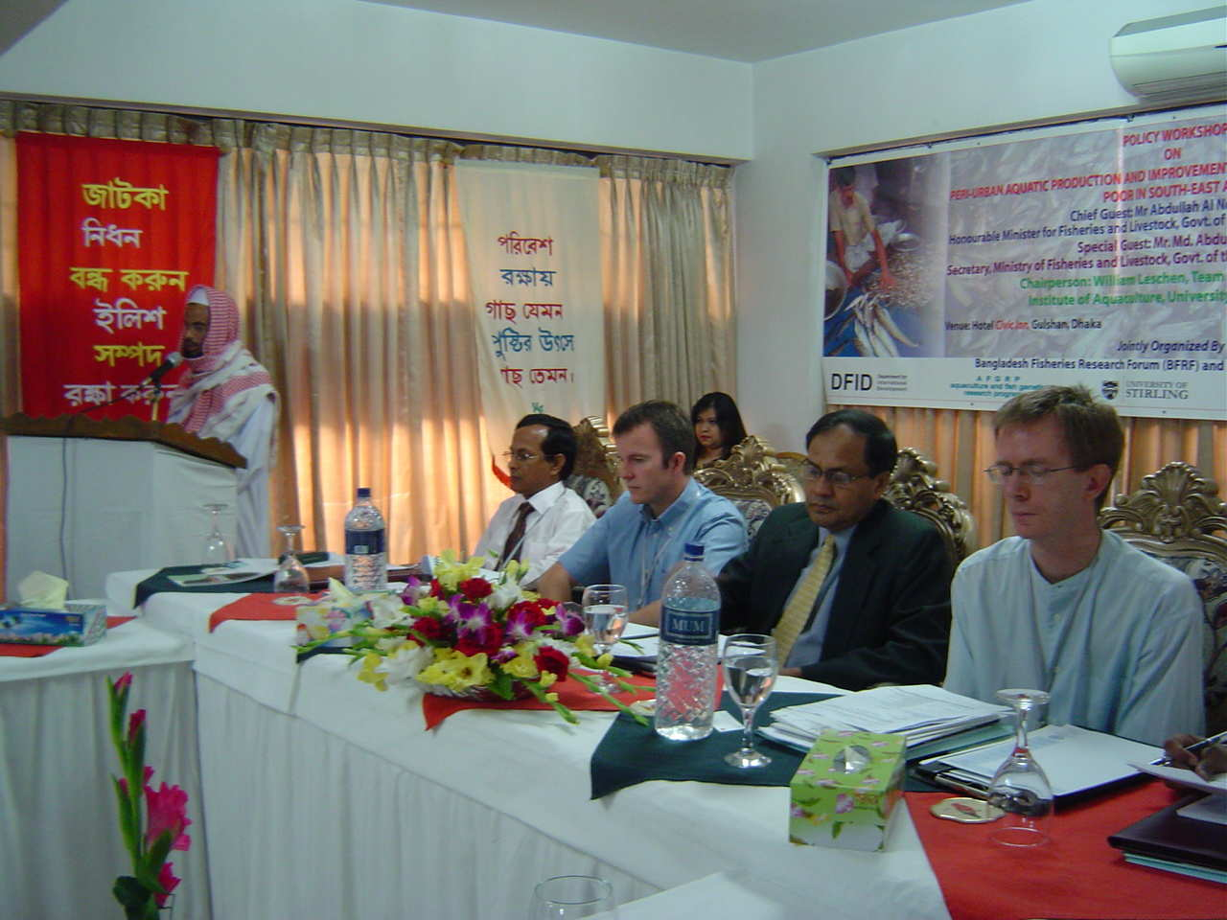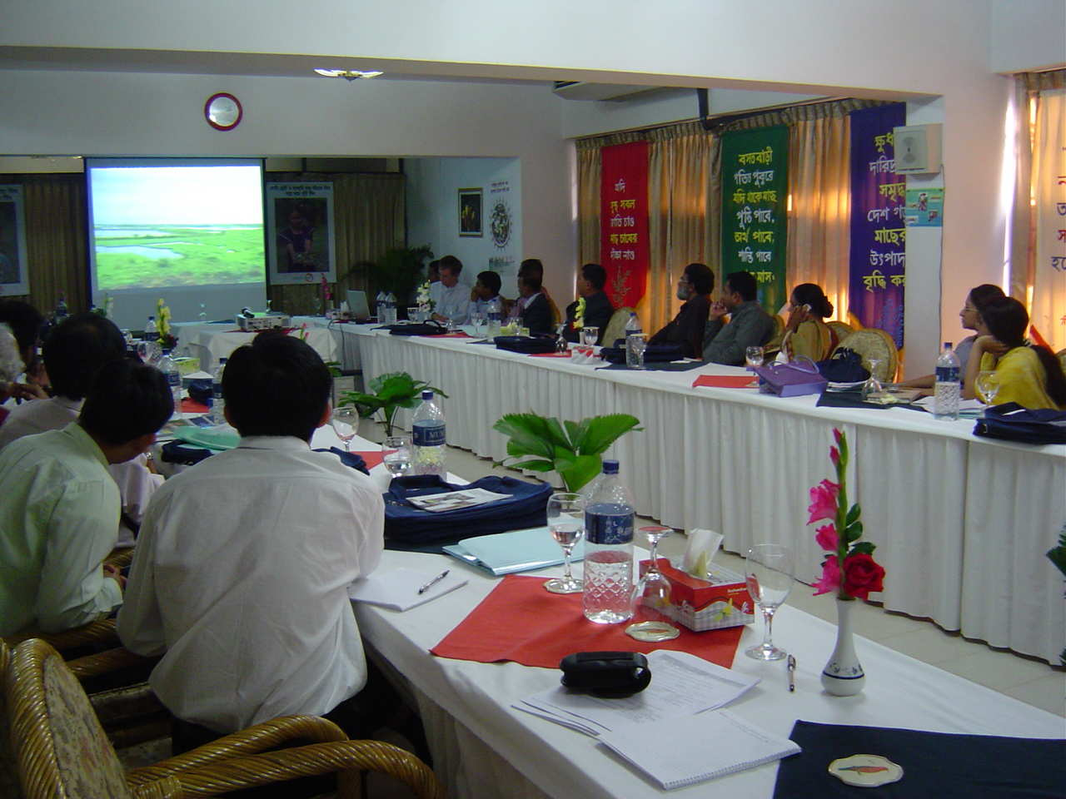

Figure 8 Peri-urban aquaculture workshop Dhaka November 2005

2.4 Dissemination activities throughout the year (Work Package 8)

These activities benefited from the continued involvement in 2005 of the sub-contracted partner ETC (Netherlands) in collaboration with the co-ordinators Stirling. ETC were responsible for the upkeep and further development of the project website as well as other activities listed below:

Maintenance and further development of the project website and electronic list-serve for PAPUSSA
This activity has been developed in various ways:
- Various project related publications were published on the website, such as completed project reports as well as the complete issue of the Urban Agriculture Magazine – Special Edition on Urban Aquaculture (July 2005).
- The online photo gallery was expanded with pictures of the latest PAPUSSA workshop held in Dhaka Bangladesh (December 2005). Also more pictures from the various cities were added. The photo gallery now holds almost 150 pictures.
- The notice board page was continuously updated to inform visitors of recent project news and updates on the website. To better highlight project activities and changes on the website, a new home page was developed showing the latest messages on the notice board.
- To visualize the theme of urban aquaculture and make the website more attractive to visitors, pictures of urban aquaculture related objects and situations were placed on the various pages of the PAPUSSA website.

The website now includes the following sections:
- Home: Start page of the website, containing latest news and information on website updates.
- About PAPUSSA: General information on the project, available in various local languages
- Partners: Background information and contact details of the partners
- Publications: Documentation produced by the project (as well as a link to urban aquaculture literature on the RUAF site).
- PhD Studies: Presentations of PhD studies, linked to the PAPUSSA project.
- Forum: A public forum for discussion of issues related to the PAPUSSA project theme. Visitors to the forum can either initiate or respond to topics of their own choice, or they can contribute to occasional key themes identified by PAPUSSA partners.
- Links: The links page contains information on other relevant websites related to the subject of peri-urban aquaculture and the social/health/institutional aspects of this topic.
- Notice Board: The notice board is a section of the site dedicated to various items such as project (or other) events, news items of interest, developments in the project, reports by PhD students on the progress of their research. Also notes on website updates were published here, directing visitors to the concerning page on the website.
- Photo Gallery: A collection of project and theme related photos, categorized per city (Ha Noi, Ho Chi Minh City, Phnom Penh and Bangkok) and some pictures of the Dhaka, Bangladesh workshop (December 2005).

Additions to the website have been mainly supplied by the University of Stirling. Some messages on the forum were from other members of the PAPUSSA project. The project website can be visited at www.papussa.org, the forum at http://www.papussa.ruaf.org/cgi-bin/ruaf/papussa/webbbs_config.pl.

Maintenance of project communication channel
To facilitate communication channels in the project, RUAF maintains a closed listserv mailing list for the PAPUSSA partners. Maintenance of this mailing list involves membership management (adding and removing members to or from the list), error handling and removing SPAM.

Results

Website
One approach to monitor how people are using a website is the analysis (and interpretation) of user statistics: the number of visitors to the site, the way in which visitors find the site and the sections to which the attention of the visitors is mainly drawn. An impression of the statistics of 2005 is given below.

Site visits
Statistics show a low number of visitors during the summer months, which was around the same time the website was moved to its new location. From August onwards many visits are counted on the old address (twice as many as in 2004), but not as many visitors are following the redirection to the new location. Starting at about 500 visits on the new site in August there were over 700 in November. The average number of visits a day stays the same as in 2004: 20 visits.
Possible explanation for the fact that visitors entering the old site did not follow the links to the new location is that they have been mainly visiting the discussion forum. This Forum, the most visited section of the website, remained on the old location until late December.

Most visited pages
Most visited page on the website was the Forum, followed by the Home page and the publications section. That the Forum was better visited than the home page shows that many people entered the site via the Forum.

- Access to the website
Almost 50% of the visitors accessed the website by directly entering the url (www.papussa.org). Others where often lead to the site via search engines. Mainly by Google Thailand (google.co.th) and Google Vietnam (google.com.vn), but also via the international search engine of Google (google.com).

- Keywords
(Combinations of) the following keywords where mainly used for internet searches that lead to the PAPUSSA website:
  - Names: papussa
  - Regions: ha noi / bankok / ho chi minh city / phnom penh / (south east) asia
  - Subjects: aquaculture / fish culture / fish / aquaponics /
aquatic plants / food production / urban
  - Type of info: gallery or galleries / photo

- Forum messages
This year 8 posts were submitted on the PAPUSSA forum and 2 replies, making total number of messages posted 10.

Mailing list
The listserv has been used regularly by the project partners and seems to be fulfilling the desired function. Some statistics of the mailing list follow below:

- Total number of e-mails sent this year : 69 (69 in 2004)
- Most messages sent in : July, covering planning issues of the P&P meeting
- Number of messages sent in November : 16 (19 in 2004)
- Changes in the members list : 12 subscriptions and 3 unsubscriptions

Future of the Website

The future planning for the website is that it will still be available for public viewing and access after the end of the project ,June 31st 2006, when ETC Netherlands will hand over the running and management of the site to Stirling. As the project is drawing to a close many more outputs in a number of different formats (reports, users manuals, policy briefs, video, posters) will be made available on the site with an emphasis in the next 6 months being on producing and making available more regional native language materials.

Dialogue with senior stakeholders
In 2004, the PAPUSSA partners, with help of ETC, planned to approach a wider group of experts and senior stakeholders in urban aquaculture (including policy-makers, land use planners, food processing and marketing experts, health officials, urban waste and recycling managers) with the aim to establish a dialogue on the SoS reports and their consequences for policy development. Two questionnaires were developed by ETC and Stirling, incorporating inputs from local PAPUSSA partners, to encourage the local and international stakeholders to:
- give their view on the situation as depicted in the project SoS reports (especially regarding their field of expertise);
- indicate which interventions they would recommend in the given situation;
- contact each other and exchange information and ideas.
Dissemination and follow-up strategies to over a 100 people combined postal and electronic mailings as well as personal and telephone contacts. Local PAPUSSA teams processed all reactions received from respondents with the use of an Excel spreadsheet to facilitate the result analysis. Results will be used by ETC in further development of a series of Policy Briefs (see below).

Production and distribution of a CD-ROM
A proposal for the production of a practical, informative CD Rom was elaborated by ETC and communicated to Stirling. During the PAPUSSA project, various types of information were used or created in the four partner cities, as well as in the context of the general programme. The purpose of this CD is to provide a larger number of stakeholders with all of these documents. The proposed contents include:

Urban Agriculture Magazine: Special issue on Urban Aquatic Production
- State of the System Reports (4 cities)
- Household baseline and monitoring reports (4 cities)
- City surveys and analysis (health, water quality)
- Reports on local interventions and trials
- Policy Briefs
- Dhaka workshop report
- Extensive photo gallery
- Other audio and or video materials eg Aquatic plants DVD, Beung Cheung Ek lake documentary

The CD was originally planned to be produced in 2005. However as the idea behind the CD was to include the majority of the project outputs, it was decided it would be better to put the CD Rom together from January 2006 onwards.

2.5 Technical Problems

After completion of the third monitoring survey the third year of the project mainly involved the four city partners continuing to have difficulties in completing the data entry, cleaning and most importantly the analysis of the household baseline and monitoring survey data. This resulted in the co-ordinators arranging another 5 day Access database analysis workshop in Siem Riep in July, following the three previous training sessions held last year. With the probable exception of UAF HCMC the partners have had little or no previous experience in carrying out such larger household surveys with a result that the data entry and cleaning has had to be repeated on a number of occasions. The partners have also had problems with the interpretation of their data and interpreting it through analysis to prove or disprove potential research hypotheses. As a result the final city reports for the household baseline and monitoring surveys have been delayed. It has been agreed that each partner will bring a copy of their analysis report to the final Progress and Planning Meeting to be held at AIT Bangkok in January 2006 so that during the three days we can jointly work together to produce final drafts.

The production of the Users Manual for Aquatic plants also encountered some difficulties in its inception and original drafts writing. Each partner originally tended to write their own versions in more report orientated formats which would have been difficult and unclear for a wide range of stakeholders to understand and benefit from especially existing farmers or those who were thinking about going into aquatic plants production. Therefore their documents were edited a number of times by Stirling in order to produce more illustrated, hands on, user friendly documents which could be practically referred to especially by those people who had no previous experience of aquatic plants cultivation. It is also perhaps true to say that as each of the four city partner institutes primarily specialise in fisheries and fish culture they had initial problems in understanding, gathering together and recording down technical details concerning the cultivation of aquatic plants. However through this process each of the partners now arguably have unrivalled knowledge of these production systems and their associated benefits and constraints within the research and extension communities of their own cities.

The water sampling programme amongst the 4 cities also had some technical difficulties particularly in relation to the choice of indicative production systems for fish and aquatic plants. Since many of the aquatic plant production systems which were based on the introduction/inflow of waste water (as a nutrient source) did not actually have a definitive outflow it was difficult to assess their ability or potential as a successful means of treating waste water. Many of the systems also only had introductions of waste water at certain times each week therefore for water sampling it was necessary to remain informed and then take inlet samples during these pumping times. In systems which had no definitive outflows a sump was dug and sunk into the bed of the pond where 2-3 days after the introduction of waste water further water samples were taken . Similar problems were also encountered for some of the waste water fish production systems as it was often difficult for the research staff to know exactly when the waste water was being introduced into the ponds. Also for considerable periods of time the fish ponds were in effect static systems with no corresponding inflows and outflows, with farmers only deciding to introduce waste water when they wanted to input further organic based nutrients into their ponds.

Regarding the website in the past, the PAPUSSA website was hosted under the RUAF site at www.ruaf.org/papussa. Due to upcoming changes on the RUAF website, the PAPUSSA site had to be moved to a new location. This coincided with the desire of the PAPUSSA team to better advertise the existence of the project website. A new web domain www.papussa.org was created and the website, was moved to this location. Also the forum moved and can now be reached from http://www.papussa.ruaf.org/cgi-bin/ruaf/papussa/webbbs_config.pl.The new address of the website was advertised in the latest PAPUSSA publications and e-mail signatures of the team members.
As was the case in previous years, the online forum was not much used to post messages. Periodical posts from the PAPUSSA team were still viewed often, however.

2.6 Workplan: January – June 2006

1st - 15th January Editing of Partners Annual EC Progress and Financial Cost Statement Reports
Date for Deadline | Output to be completed
P and P meeting Bangkok Jan 16-18th 2006 | Technical reports + CS 2005  Invoices X 3 signed and certified copies
31st Jan | 2005 Annual Technical report (ATR) to Stirling  2005 Financial Cost Statement (CS) to Stirling  Draft versions of BL and Mon survey report to Stirling  BL and Mon survey analysis of Health (NIHE) to Stirling  Final SOS dissemination reports to be completed  Aquatic plants booklet overall draft produced and  sent to partners for translation  Kuong to Stirling for completion of all RUA PP project outputs
30th February | Deadline for submission to EC of above ATR & CS  from Stirling  Translation of aquatic plants booklet by all 4 partners  to completion
31st March | Deadline for individual partners to submit to  chemical water quality reports to Anders (Max 10 pages)  Phuong planning to come to Stirling for completion of remaining RIA1 outputs + PhD work
10th April | Draft for Bangkok intervention report to Stirling
31st April | Final version of BL and Mon survey Report to  Stirling  Draft versions of all ornamental fish outputs to  Stirling  Born would be available to come to Stirling for finishing KU outputs
10th May | Final version of Bangkok intervention report to Stirling
15th May | Draft version of HCMC intervention report to Stirling  Final version of Ha Noi intervention report to Stirling
31st May | Draft version of Policy Briefs from ETC(RUAF) to  partners for revision/comments  Final report for HCMC intervention  All inputs for CD Rom reports etc to ETC
31st June | Official end date of Project. No further claims can be made for project funds after this date  Return of Revised Policy Briefs to ETC by partners  CD Rom produced/finalised by ETC  Final drafts of Final reports and cost statements to be submitted to Stirling
31st July

31st August | All final reports of the project to be submitted to EC  by Stirling  Stirling to forward good example of final report to partners  Final Policy Briefs to EC

2.7 Publications

Non Refereed Scientific Publications

Phuong N.T.D. (2005) Technical Booklet: Production of tilapia fingerlings in peri-urban rice fields Research Institute for Aquaculture Nos 1 (RIA1) September 2005 (In Vietnamese) pp 23.

Tien, N.T.H. , Leschen, W (2005) Feeding Cities – Dong My, a peri-urban community in Ha Noi, Vietnam, involved in the cultivation of fish.
Aquaculture News, Institute of Aquaculture, University of Stirling. (32) October 2005.

Seyha, Tuan Anh, V., (2005) Case Study Skin Diseases Beung Cheung Ek lake. Papussa website August 2005 www.papussa.org

All below in Peri-urban Aquaculture edition of Urban Agriculture Magazine (July 2005) ETC RUAF Netherlands:

Yoonpundh, R. et al. (2005) Aquatic Food Production Systems in Bangkok. Urban Agriculture Magazine. p8-9 ETC RUAC Netherlands (July 2005)

Phuong, N.T.D., et al. (2005) Current Status of Periurban Aquatic Production in Hanoi. Urban Agriculture Magazine. p10-12. ETC RUAC Netherlands (July 2005)

Khov, K, and Daream, S., (2005) Peri-urban Aquatic Food Production Systems in Phnom Penh. Urban Agriculture Magazine. p13-15 ETC RUAC Netherlands (July 2005).

Hung L.T. and Huy H.P.V. (2005) Production and Marketing System of Aquatic Products in Ho Chi Minh City. Urban Agriculture Magazine. p16-19 ETC RUAC Netherlands (July 2005)

Rigg, J., and Salamanca, A.M., (2005) The Future of Peri-urban Aquatic Food Production Systems in Southeast Asia. Urban Agriculture Magazine. p20-23 ETC RUAC Netherlands (July 2005).

Edwards, P., (2005) Demise of Periurban Wastewater-fed Aquaculture? Urban Agriculture Magazine. p27-29. ETC RUAC Netherlands (July 2005).

Van Der Hoek, V., et al. (2005) Skin Diseases Among People Using Urban Wastewater in Phnom Penh. Urban Agriculture Magazine. p30-31 ETC RUAC Netherlands (July 2005).

Audio visual publications:

Leschen, W., et al, (2005). A Hidden Harvest: Cultivating Aquatic Plants in 4 SE Asian cities. University of Stirling. DVD video, 27 minutes. November 2005.

Aquatic Plant Growers of Beung Cheung Ek Lake (2005) (In production). Handsontv in conjunction with Papussa Project. 5 minute documentary in Natural World Series.
Link to view on internet http://www.handsontv.info/series7/programme_4.html

3.0 Management Annual Report

3.1 Organisation of the collaboration within the third year

As in the first two years of the project Stirling University were responsible in the third year as the “lead contractor” in the overall co-ordination of project activities. This involved Stirling being regularly in contact with partners through visits, email correspondence and if necessary also by telephone.

Throughout the year regular visits were made by Stirling (William Leschen, Dr David Little and Dr Francis Murray) and the University of Durham (Albert Salamanca) to each of the four city partners.

Prof Anders Dalsgaard (KVL) also carried out project visits particularly to Ha Noi and Phnom Penh in his role of co-ordinating all health related activities within the project between the partners and the National Institute of Health and Epidemiology (NIHE), Hanoi. Dr Vuong Tuan Anh (NIHE) continued in his role co-ordinating health related activities on a regional basis and visited Phnom Penh twice during the year to oversee household health surveys and subsequent referral of household members to a dermatologist for examination. A further Access database analysis training workshop was carried out by Stirling and Durham in Siem Riep, Cambodia in July. Dr Tuan Anh also collaborated with RIA1 Ha Noi over the design and implementation of a water sampling survey of aquatic production systems in order to assess their treatment potential for both biological and chemical parameters.

The Asian Institution of Technology (AIT) Bangkok under the involvement of Professor Kwei Lin and Ms Wanwisa Saelee continued to carry out its role of project co-ordination and technical support to Kasetsart University Bangkok, however due to certain managerial problems at RUA Phnom Penh, AIT terminated its involvement in 2005 in supporting the Cambodian partner as a sub-contractor.
AIT were also involved in the joint comparative study of peri-urban freshwater ornamental fish production in HCMC and Bangkok. The study was set up following a visit of UAF HCMC Papussa staff ( Dr Luong, Dr Hung) to AIT in June 2005. Ms Wanwisa Saelee has since produced an Overview report of the Ornamental fish sector in Bangkok which is attached in the Annex.

Albert Salamanca (UoD), continued to be involved in supporting the local city partners in their database cleaning and analysis. He was also involved in co-ordinating the visit of the BBC film crew who shot the Beung Cheung Ek Lake livelihoods documentary in August.

Regular email and phone contacts between Stirling University and ETC took place during the year 2005 and assured frequent information exchange, up-to-date progress reporting and coordinated planning of (new) activities. The dialogue with senior stakeholders and

the production of a special Aquaculture Magazine were completed in 2005. The PAPUSSA website was regularly updated. Due to delay in and extension of activities of PAPUSSA project partners, several activities originally planned for 2005 could not be completed and were postponed to 2006 (such as the final development of Policy Briefs and the production of a CD Rom). In this context

it was agreed that the ETC project coordinator would participate in the January 2006 PAPUSSA programme meeting to facilitate personal contact with the PAPUSSA partners and coordinate future project planning.

3.2 Project Meetings/Visits

Co-ordination Visits Throughout 2005

Will Leschen carried out co-ordination and support visits to: RIA 1 Ha Noi in July and October, KU Bangkok in June and November, UAF HCMC in July, and RUA Phnom Penh in June. As part of his PhD studies he also visited the surrounding provinces of Ha Tay, Hai Duong, Son Tay and Cao Bang where he carried out surveys on markets and aquaculture development in association with linkages to urbanisation in Hanoi.

Dr David Little also visited RIA 1 Ha Noi in May and November, UAF HCMC in October, and KU and AIT Bangkok in December for project co-ordination visits and to supervise Ms Phuong at RIA1 with her ongoing PhD studies.

.
Data Analysis Workshop 4th- 9th July Siem Riep, Cambodia.

This 5 day workshop was carried out by Dr Francis Murray and Will Leschen (UoS), and Albert Salamanca (UoD) and attended by representatives from each of the 4 city partners.

Progress and Planning (P and P) meeting

Due to the project being extended to June 2006 it was agreed to hold the third and final P and P meeting between 16th – 18th January at AIT, Bangkok.

3.3 Project Exchanges

Between 12th February – 9th April Ms Nguyen Thi Dieu Phuong from RIA 1, Hanoi, visited The Institute of Aquaculture, Stirling University for a visit to see her supervisor Dr David Little and further develop her PhD studies. During her visit she also took part

in a number of short courses, including participating in the interactive MSc student email link producing Policy Briefs in conjunction with Papussa staff in the 4 study cities.

3.4 Problems: Managerial, Administrative and Financial

Similar to the previous year the major constraint to the smooth running of the project was the delays particularly for each of the SE Asians partners in being re-imbursed for their budgets, which had considerable effect on the partners in keeping to their proposed workplans and completing outputs. This again was as a result of the annual reports – more specifically the Financial Cost Statements for year 2004 being finally submitted late to the EC by May of the following year (2005). A similar scenario to the previous year repeated itself where the co-ordinators following extensive email and phone correspondence were waiting for the final 1-2 partners to correctly complete and submit their cost statements. This finally resulted in repayments from the EC being made in November 2005 for the 2004 cost statements. During this period in-between the co-ordinators Stirling had to advance funds to certain of the SE Asian partners in order to allow them to keep up with carrying out project activities. These advances will now be claimed back by Stirling from the partners from their remaining cost statements.

Despite making these advances particular problems were experienced with the RUA Phnom Penh partner who despite numerous unanswered communications from Stirling and a visit in July, continued to allow its project staff to remain unpaid for periods of up to 4 months despite these staff working diligently and conscientiously on the project. This resulted in a lack of morale within the staff, and one key member leaving – following two the previous year, as well as it became increasingly obvious that the partner was not going to complete all of its required project outputs. As a result of this in November 2005 Stirling took the matter up with the Rector of RUA explaining the situation and asking him to take steps to rectify the situation immediately. As a result in December a new person – the Vice Rector – was made responsible as the RUA contact for the remainder of the project and unpaid staff salaries were repaid up to September 2005. It was also decided that Mr Khov Khuong would travel and visit Stirling from January – April 2006 in order to complete the write up of all remaining RUA project outputs under the supervision of Dr David Little. It was also decided that the Rector of RUA should write to the EC giving Stirling permission to administer the remaining RUA budget until June 2006 when the project ended.

On a more positive note the performance and contribution of the KU Bangkok partner considerably increased over 2005 with the KU team successfully carrying out an innovative intervention trial on chemical free cultivation of morning glory as well as the standard and content of their reports and outputs also improving. Much of the basis of this improvement was down to the support and guidance from Prof Lin and Ms W Saelee from AIT who held regular monthly meetings with the KU team to monitor, support and keep up to date with their progress. Ms Saelee also kept in weekly email contact with the team and gave considerable help with editing and content of their reports.

INDIVIDUAL PARTNER ANNUAL REPORT
2005
INCO-DEV PROJECT: PAPUSSA
Proposal No: ICA4-2001-10072

Partner 1: University of Stirling

Personnel involved in the project:
Dr David Little Principal Investigator
William Leschen Research Assistant
Dr Francis Murray Research Assistant

Objectives for Year 3

Following the Progress and Planning Meeting in December 2004 in Penang where a workplan for 2005 was formulated and agreed the main objectives for Stirling in year 3 were through its role as co-ordinators to:

- Ensure that the partners had completed the Third Household Monitoring Survey and correctly entered all of their data onto the joint Access database
- Further guide and support the partners in their analysis of the database and writing of the associated reports for each city with an emphasis of producing and identifying significant findings which are relevant to senior stakeholders and urban planners.
- Support and guide the partners in their various “intervention pilot studies”.
- In association with ETC Netherlands and AFGRP/ DFID to promote further project dissemination and dialogue with stakeholders through the other partners, the project website, an international workshop in Dhaka, publications and articles, a DVD video on aquatic plants cultivation.
- Support the partners in the editing of reports and other project outputs, as well as in administrative matters and acting as a link between the partners and the funding body – the European Commission.

Activities in 2005

January - Annual reports and cost statements.

Stirling was involved in the writing up, editing and compilation of all annual reports and financial cost statements.

February - Policy Briefs: Interactive Student Link (21st February - 8th March)

An internet linkage was set up between the project staff teams in the 4 SE Asian cities with 16 students on Stirlings’ MSc Aquaculture and Sustainable Development courses. As a three week part of their course the students had to interact and collaborate with the 4 city partners in order to jointly produce informative and attractive 4 page Policy Briefs aimed at urban planners and policy makers on the importance and future sustainability of Peri-urban Aquatic Production Systems in each of the four cities. The students were firstly given introductory presentations on the objectives and background of the project and then provided through Web CT a range of documents and related outputs from the project. There then followed daily interaction, exchange of information and views through email between the students and the city partners staff teams which resulted after three weeks in the submission of 4 city Policy Briefs . These resulting Policy Briefs were judged by Marielle Dubbeling of ETC Netherlands with the Bangkok team winning the prize for the best and most attractively laid out document (see Attached in Annex). As a sub-contractor to the project ETC (Marielle) is responsible for the production of specific stakeholder category Briefs eg Overall Urban Planners and Policy Makers, Health and Food Safety, Urban Wastewater and Sewage Treatment and Disposal, Construction and Real Estate Developers etc. By the end of the project in order to complete these she will bring together all of the outputs from the project and identify the most important and effective findings to include in each of the Policy Brief documents. The final Briefs will be printed in full colour, and produced in both English as well as the 3 local project languages (Thai, Vietnamese and Khmer).
This exercise was surprisingly effective in building the capacity of the partners as well as the students as the majority of both groups had not been involved previously in transforming and summarizing scientific and social research findings into such Policy Brief documents.

March - Guidelines for Data Analysis and Research Hypotheses

William Leschen (UoS) provided further more detailed guidelines for the analysis of the household survey database including specific Research Hypotheses to be answered and including a basic format for the subsequent report to be written in which the overall findings were to be presented.

March – December Project Interventions: Aquatic Plants DVD and Aquatic Plants Users Manual
As already described in detail in the Scientific report Stirling in conjunction with each of the city partners staff was involved in compiling a 25 minute DVD video which showed the importance, benefits and associated constraints of aquatic plant cultivation in each of the 4 Papussa study cities. The video footage was shot in each city and followed the seasonal chains of production, through harvesting, marketing and finally to the consumer. A soundtrack commentary was then added in English with Thai, Vietnamese and Khmer versions to be added in 2006. This DVD was available in December 2005 for dissemination via the project website with those receiving being sent short questionnaires for their feedback on the content and format of the information shown.
This DVD was completed as a project output in conjunction with an Aquatic Plants Cultivation Users Manual which describes the practical production and marketing methods used in the 4 study cities. The initial version of this manual was completed in English and is now being translated into Khmer, Vietnamese and Thai so that it can better be disseminated out to those already growing aquatic plants as well as other new entrants who may wish to begin.

June
Special Peri-urban Aquaculture Edition of Urban Agriculture
René van Veenhuizen of ETC (Netherlands) and William Leschen from Stirling co-edited this special peri-urban aquaculture edition of the Urban Agriculture Magazine which was published in June. Besides the opening editorial from Stirling each of the other Papussa partners also contributed articles, whilst there were other contributions from India, Africa, and South America.

July

Data Analysis Workshop Siem Riep, Cambodia 4th- 9th July.

This 5 day workshop was carried out by Dr Francis Murray and Will Leschen (UoS), and Albert Salamanca (UoD) and attended by representatives from each of the 4 city partners.

November

Peri-urban Aquaculture workshop Dhaka

William Leschen and Anton Immink (AFGRP/DFID) from Stirling attended this DFID funded regional workshop which had the objective of setting up a regional platform for

contact, information exchange and dissemination towards the development of peri-urban aquaculture in the sub region. William Leschen gave a presentation highlighting the up to date work and findings from the Papussa project then developing how this work could be relevant and appropriate for peri-urban aquaculture development in Bangladesh. Four other Papussa city

partners also gave presentations highlighting the findings from their cities. The aquatic plants DVD was also shown with much interest exhibited in the use of urban waste water to cultivate such large volumes and values of aquatic plants.

Progress and Planning Meeting

Due to the project being extended by 6 months to finish in June 2006 it was decided to hold the final project Progress and Planning Meeting in Bangkok at the beginning of January 2006.

Project staff visits throughout 2005

Will Leschen carried out co-ordination and support visits to: RIA 1 Ha Noi in July and October, KU Bangkok in June and November, UAF HCMC in July, and RUA Phnom Penh in June. As part of his PhD studies he also visited the surrounding provinces of Ha Tay, Hai Duong, Lang Son and Cao Bang where he carried out surveys on markets and aquaculture development in association with linkages to urbanisation in Hanoi.

Dr David Little also visited RIA 1 Ha Noi in May and November, UAF HCMC in October, and KU and AIT Bangkok in December for project co-ordination visits and to supervise Ms Phuong at RIA1 with her ongoing PhD studies.

Dr Francis Murray facilitated the Database Analysis workshop in Siem Riep, Cambodia from 4-9th July 2005.

Ms Nguyen Thi Dieu Phuong from RIA 1, Hanoi, visited The Institute of Aquaculture, Stirling University between 12th February – 9th April to visit Dr David Little her supervisor and further develop her PhD studies. During her visit she also took part in a number of short courses, including participating in the interactive MSc student email link producing Policy Briefs in conjunction with Papussa staff in the 4 study cities.

PhD Study William Leschen

By June 2005 following increasing difficulties in the identification down to species level of the fish zoo-onotic parasite Clonorchis sinensis from fish samples cultured in urban waste water, in consultation with his supervisor Dr Little, William Leschen changed the focus of his research project to study the wider impact of urbanisation in Ha Noi on markets and aquaculture development in five of Ha Noi’s surrounding provinces (Hai Duong, Ha Tay, Bac Giang, Lang Son and Cao Bang). This then involved him carrying out further field work in these surrounding

provinces in July and October - November. He will be continuing further field work between January – March 2006.

Project Website

Stirling continued to liase with Dorine Ruter ETC (RUAF) Netherlands in the development of the project website with the format and layout of the site being modified several times during the year in order to make it more user friendly and informative. As co-ordinators Stirling also encouraged and supported the more junior staff of the partners to produce outputs and articles for the website which resulted in one case study on occupational health problems of an aquatic plants grower in Phnom Penh, and also a study of a peri-urban community in Ha Noi culturing fish which was also published in Aquaculture News, the Stirling Institute of Aquaculture’s publication.

Publications

Leschen, W., Little, D., and Bunting, S.W., 2005. Urban Aquatic Production. Editorial Urban Agriculture Magazine, ETC Netherlands, p 1-7 July 2005.

Tien, N.T.H. , Leschen, W (2005) Feeding Cities – Dong My, a peri-urban community in Ha Noi, Vietnam, involved in the cultivation of fish. Aquaculture News, Institute of Aquaculture, University of Stirling. (32) October 2005.

Leschen, W., et al (2005). A Hidden Harvest: The cultivation of aquatic plants in 4 SE Asian cities. University of Stirling. DVD 27 minutes. November 2005.

Challenges

Most of the problems and challenges relating to Stirling’s role and performance as co-ordinators have been mentioned in the earlier sections in the Technical and Management reports. These have centred around the delays encountered in receiving and submitting all of the partners annual technical reports and cost statements which has led on to late re-imbursement of project funds to each of the partners.

INDIVIDUAL PARTNER ANNUAL REPORT
2005
INCO-DEV PROJECT: PAPUSSA
Proposal No: ICA4-2001-10072
Partner 2: Royal Veterinary and Agricultural University, Denmark (KVL)
Partner 3: National Institute of Hygiene and Epidemiology, Hanoi, Vietnam (NIHE)

Personnel involved in the project:

KVL:
Associate Professor, Anders Dalsgaard (Principal Investigator)
Helle Marcussen, MSc, research assistant
Assistant Professor, Lise Tønner Klank
NIHE:
Professor Phung Dac Cam, Project responsible
Vuong Tuan Anh, M.D, Principal investigator
Phan Thu Chung, B.Sc.
Nguyen Dang Tuan, B.Sc.
Tran Minh Thu, B.Sc.
Nguyen Thuy Tram, B.Sc
Nguyen Thi Bich Ngoc
Hoang Thi Thoa, Accountant

Summary
In 2005, all fieldwork has been completed with the exception of the microbiological studies of the treatment capacity of wastewater-fed aquatic systems in Hanoi which will continue until April 2006. Initial descriptive analyses have been done of the health data collected as part of the baseline and monitoring studies conducted at the four PAPUSSA sites. In-depth studies have been conducted in Phnom Penh and Hanoi to assess: a) skin problems among farmers engaged in wastewater-fed aqua- and agriculture; b) the efficiency of wastewater-fed aquatic systems in Phnom Penh and Hanoi to reduce key microbiological fecal pollution parameters and c) the microbiological and chemical (toxic metals) food safety of wastewater-fed fish and plants. The initial results show that farmers engaged in wastewater-fed aqua- and agriculture experience a number of skin problems at a much higher level compared with farmers engaged in non-wastewater farming activities. Both the wastewater-fed aquatic systems in Phnom Penh and Hanoi reduce numbers of fecal microorganisms and parasites to levels where the outlet water often meet the proposed guideline values of the WHO for wastewater irrigation. Both fish and plants cultured with wastewater contain surprisingly low concentrations of toxic metals which in most cases are within the acceptable limits set by FAO/WHO. Plants grown in or irrigated with wastewater do show various levels of fecal contamination, e.g. with presence of pathogens like protozoan parasites. Further analyses are needed to assess the relative importance of such fecal contamination compared with the contamination taking place further down the food chain, in particular at the markets. In 2006, the main activities will be to finalize the analyses of the data collected and to prepare reports and other deliverables (e.g. manuscripts).

ACTIVITIES
Meetings and workshops attended
Workshop in RIA1 on water quality sampling
Vuong Tuan Anh and Nguyen Dang Tuan, NIHE attended a workshop at RIA1 on May 11 2005 with local farmers to design and prepare a plan for water sampling to be carried out at the Hanoi four field sites: Dong My, Hoang Liet, Duc Tu and Tran Phu communes.

Field visits and technical assistance to partners
Visit by NIHE researchers to RUA, Phnom Penh
Vuong Tuan Anh, NIHE paid two visits (one visit took place in Jan 2005 and the other in May 2005) to RUA in Phnom Penh to plan and conduct cross-sectional skin problem studies, water and aquatic plant sampling and analyses.

Visit by NIHE and KVL researchers to field sites in Thanh Tri district
Staff from NIHE has throughout 2005 paid numerous visits to field sites in Thanh Tri district and worked with local personnel to conduct the various studies. KVL staff has during their visits participated in such field visits.

Visits by KVL researchers to Vietnam
- Lise Tønner Klank, KVL visited NIHE from March to June 2005 to assist in training and planning for studies on food safety of aquatic plants to take place in the rainy season 2005. Another visit took place in Nov - Dec 2005 for training and assisting NIHE staff to carry out the food safety studies in the dry season 2005.

- In association with other assignments to Vietnam Anders Dalsgaard, KVL visited NIHE in Feb and Aug 2005 primarily to take part in the planning and quality assurance of field works in Thanh Tri district.
- Helle Marcussen, KVL visited the National Institute of Occupational and Environmental Health (NIOEH) for nine months to plan and implement research on toxic metals. The purpose of the stay was to make regular field visits to plan for and initiate collection of different sample types. Also new methods for toxic metal analyses were introduced at NIOEH to be carried by NIOEH staff. Under the process of introducing analytical methods cooperation with Vietnamese Academy of Sciences and Technology (VAST) was undertaken.
- David Little, University of Stirling visited Vietnam to initiate the water quality study in Vietnam during May 2005. A water quality team was established consisting of Nguyen Dieu Phuong (RIA1), Vuong Tuan Anh (NIHE) and Nguyen Hanh Tien (RIA1). During the visit of David Little, visits were done to all four field sites after which a discussion on water sampling strategies and methodologies was held with participation of Pham Anh Tuan and other involved colleagues from RIA1.
Other activities
SoS report dissemination
A number of the SoS reports of North Vietnam and questionnaires have been delivered to around 15 stakeholders working in water, sanitation and health sector from local level up national level. A total of 14 stakeholders sent their answers to NIHE. A short report summarized from data collected from their answers has been completed and forwarded to Stirling University.

Research Activities
- Skin problem surveys
Initial surveys (PAPUSSA baseline and monitoring surveys) have indicated that skin problems are a major health risk associated with wastewater-fed aquaculture. The research on occupational health hazards have therefore focused on assessing risks for skin problems at the PAPUSSA field sites in Phnom Penh and Thanh Tri districts. The protocols and study designs for skin problem studies are enclosed in Annex 1.

  - Phnom Penh
Dr. Vuong Tuan Anh, NIHE conducted two cross-sectional studies of skin problem among the farmers engaged in wastewater-fed plant culture in Phnom Penh city with the help of the local PAPUSSA team in Phnom Penh. One round took place between January - February 2005 at the same time when the last PAPUSSA monitoring survey was carried out. The second study of skin problems was implemented between May-June 2005. A total of 153 households engaged in wastewater-fed culture of aquatic plants and 47 households engaged in plant culture using non-wastewater representing 723 individuals above the age of 15 years were included in the studies. As during the first study, which was conducted in July 2004, individuals with skin problems were referred to a dermatologist for physical examination. The studies on skin problems have now been completed and all have been entered into an Access database. The data entries have been cleaned and the first descriptive analyses completed. Further analyses include multivariate logistic regression analyses with results anticipated to be included into a manuscript which will be submitted to an international peer-reviewed journal.

  - Thanh Tri District, Hanoi
During 2005, three cross-sectional skin problem studies were conducted in Hoang Liet commune (wastewater use) and Long Bien commune (non-wastewater use/control site). Lead by Dr. Tuan Anh Vuong, a research team from NIHE carried out these studies which were four months apart. A total of 200 households were selected including 100 households in Hoang Liet commune (a total of 130 adult farmers; the 30 households surveyed in PAPUSSA baseline and monitoring surveys were among the 100 households) and 100 households in Long Bien commune (a total of 130 adult farmers). The studies on skin problems in Thanh Tri district have now been completed and all data have been entered into an Access database. The data entries have been cleaned and the first descriptive analyses completed. Further analyses include multivariate logistic regression analyses with results anticipated to be included into a manuscript which will be submitted to an international peer-reviewed journal.

- Wastewater (ww) treatment capacity of peri-urban aquatic production system
Often un-treated wastewater (ww) is used in aquatic production systems. During use and retention in ponds the ww will undergo natural biological treatment. Thus, aquatic ponds and other water bodies receiving or using ww can be seen as biological ww treatment ponds. In Phnom Penh and Hanoi studies have been conducted to assess the capacity of peri-urban aquatic production systems to reduce faecal pollution by assessing key faecal indicator organisms and parasites. The protocols and study designs for the assessment of treatment capacity are enclosed in Annex 1.

  - Beung Cheung Ek lake, Phnom Penh city
The natural treatment capacity of the Beung Cheung Ek lake for reduction of fecal microorganisms and parasites were assessed. Composite water samples (mixed samples from water samples collected at 8, 10 and 12 am) from Beung Cheung Ek (BCE) lake were collected once a week from Jan-April 2005 for 12 consecutive weeks. Sampling sites included the two main inlet sites where wastewater enters the lake; the main outlet site from the lake; and a control site where wastewater is not used. The Pasteur Institute in Phnom Penh collected and processed water samples as well as analyzed the samples for numbers of thermotolerant coliforms and E. coli. Duplicate water samples were processed in Phnom Penh and shipped to NIHE, Hanoi for helminth egg and protozoan parasite enumerations. The microbiological water quality study has now been completed and data received by the NIHE where initial descriptive data analyses have been done. Further analyses to be done include statistical comparisons of water quality data in samples from the various sources. The results are anticipated to be included into a manuscript which will be submitted to an international peer-reviewed journal.

  - Thanh Tri District, Hanoi
A study on assessment of natural treatment capacity of urban ww is being conducted from July 2005 to March 2006 in collaboration with RIA1. RIA1 is responsible for doing physio-chemical water quality analysis where as the NIHE will collect samples for microbiological analyses including enumerations of thermotolerant coliforms, helminth eggs and protozoan parasites. The study on microbiological water quality is conducted in fish ponds and agricultural fields located in Hoang Liet commune, Thanh Tri district where ww is being used for fish and plant production. Water samples are collected at different points along the flow of ww, including at the point of ww pumping from the river; at fields/ponds inlets; in the fields; and from the outlets of the fields/ponds. The microbiological water quality study has now been completed and initial descriptive data analyses have been done. Further analyses to be done include statistical comparisons of water quality data in samples from the various sources which will enable an assessment of the treatment capacity of the fish ponds and agricultural fields to reduce fecal pollution. The results are anticipated to be included into a manuscript which will be submitted to an international peer-reviewed journal.

- Food safety of edible aquatic plants grown in wastewater
Studies have been conducted in Hanoi and Phnom Penh on food safety aspects of edible aquatic plants grown in wastewater and non-wastewater. Studies have included assessment of microbiological quality and accumulation of toxic metals. Field works at both sites were completed in 2005.

  - Microbiological safety of morning spinach grown in Beung Cheung Ek lake, Phnom Penh
Water spinach samples (total of 68 samples) were collected close to the two ww inlets; near the main outlet as well as in a non-wastewater control pond located close to the lake.

Plant samples were collected with and without ww exposure during harvest to allow for comparison analyses. Samples were collected by the NIHE during visits to the PAPUSSA partner. Water spinach samples were processed and enumerated for thermotolerant coliforms by the Cambodian Pasteur Institute. NIHE researchers brought duplicate samples to Hanoi for detection and enumeration of parasites, including Giardia intestinales, Cryptosporidium parvum and Cyclospora spp, helminth eggs (Ascaris lumbricoides, Trichuris trichiura and hookworm). The initial analyses show that water spinach collected close to the ww inlets contain higher numbers of thermotolerant coliforms compared with plants collected close to the outlet. Little difference in level of fecal pollution was seen between water spinach harvested with and without direct ww exposure. Only few samples contained helminth eggs. Protozoan parasites were found in some samples. Further analyses to be done include statistical comparisons of differences seen in the numbers of thermotolerant coliforms in the different types of water spinach samples. Comparison analyses will be done between numbers of thermotolerant coliforms found in water spinach and the pond water in which the plants were grown. The protozoan (o)ocysts found will be further characterized by molecular characterization. The results are anticipated to be included into a manuscript which will be submitted to an international peer-reviewed journal.

  - Thanh Tri District, Hanoi
The research on microbiological quality of plants was conducted along the food chain from production sites to markets and included two main studies. The first studies investigated the microbiological quality of plants irrigated with ww and non-ww at different field sites in Thanh Tri district. Plant samples, mainly morning glory which is the main plant produced with ww, but also other types of aquatic vegetables (water dropwort, water cress and water mimosa) were studied. Samples were collected at harvest, during harvest and upon arrival at the market. The second study aimed at assessing the level of fecal contamination of plants originating from ww-irrigated fields and subsequent sold at markets. Markets studied include the Hoang Liet market (a local market) and Hang Be (a city market). At the markets, duplicate plant samples were

collected weekly from different market traders during a 3-month period from March to June 2005 and again from Nov-Dec 2005. The microbiological parameters studied were identical to parameters described above for the studies in Phnom Penh. Comparison analyses will be done between numbers of thermotolerant coliforms found in water spinach and other plant types as well as in the pond water in which the plants were grown. The protozoan (o)ocysts found will be further characterized by molecular characterization. The results are anticipated to be included into a manuscript which will be submitted to an international peer-reviewed journal.

  - Toxic metals in aquatic production systems receiving urban wastewater
The wastewater used in aqua- and agriculture in Thanh Tri, Hanoi and Phnom Penh contains substantial amounts of industrial wastewater. Among the various toxic chemicals that could potentially be accumulating in fish and plants are the toxic metals, including cadmium, lead and arsenic. Thus, fish, plants and environmental samples have been collected and analyzed for toxic metals.

Boeng Cheung Ek lake, Phnom Penh
A third and final sampling round of water spinach from Boeng Cheung Ek was carried out in January 2005. Samples were collected at the same points as under the previous sampling rounds; at the two pumping stations, at 100, 200, 400 and 600 m distance from the pumping stations, in the vicinity to industries, at the lake outlet and at a control site. A total of 14 samples with 4 replicates have been analyzed. Sediment samples were collected in the Boeng Cheung Ek lake, the canal transporting wastewater to the Tompun pumping station and at a control site. A total of 18 sediment samples with 4 replicates were collected. Fish samples of the species walking catfish, spineless ell and snakehead were caught by net from the Boeng Cheung Ek lake and different parts of the fish analyzed. All sampling was carried out by Helle Marcussen, research assistant at KVL in collaboration with the Phnom Penh PAPUSSA team. All samples were analysed for Pb, Cd and As by graphite furnace atomic absorption spectrometry after digestion. Preliminary results from the analyses of toxic metals are enclosed in Annex 2.

  - Hanoi
Fish samples of marketable size from two pond production systems receiving wastewater in Thanh Tri district were purchased from the producer. The selected species were silver carp, common carp and tilapia. Ten fish of each species were collected. Sediment samples were also collected at the wastewater inlet, at the middle and at the outlet of the pond. Sampling was carried out by Helle Marcussen, KVL with assistance from the NIHE PAPUSSA team and the National Institute of Occupational Health, Hanoi. All samples were analysed for Pb, Cd and As by graphite furnace atomic absorption spectrometry after digestion.

Publication and reports
Poster presented at the 8th International Conference on the Biogeochemistry:
Marcussen, H., Joergensen, K., Holm, P.E. and Dalsgaard, A. Accumulation of toxic metals in aquatic foods cultivated with use of urban wastewater in Southeast Asia. 8th International Conference on the Biogeochemistry of Trace Elements, Adelaide, Australia, 3.-7.4.2005.

Research protocols
Standard research protocols have been prepared for all activities in Phnom Penh and in Thanh Tri district, Hanoi. Protocols are enclosed in Annex 1.
Articles
An article including the preliminary results from the first cross-sectional skin problem study was published in the Urban Agriculture Magazine.
Van der Hoek, W., Anh, V.T., Cam, P.D., Vicheth, C., and A. Dalsgaard. 2005. Skin Diseases Among People Using Urban Wastewater in Phnom Penh. Article published in Urban Agriculture Magazine No 14 July 2005.

Seyha, S., Anh, V.T., 2005. Skin Problems of a farmer engaged in Water Morning Glory cultivation in Beoung Cheung Ek Lake, Phnom Penh, Cambodia (Case Study). Article published in website of PAPUSSA project.
Linkage to electronic published article: http://www.papussa.org/publications_articles.html.
Research priorities and experienced problems
In 2005, the research priorities for NIHE and KVL have been to:
- Conduct and finalize the field work of the cross-sectional studies of skin problems among farmers engaged in ww-fed aqua- and agriculture in Phnom Penh and Hanoi.
- Conduct and complete the studies to assess the efficiency of ww-fed aquatic systems in Phnom Penh and Hanoi to reduce key microbiological pollution organisms.
- Conduct and complete the studies to assess the food safety (microbiological/toxic metals) of fish and aquatic plants cultured in aquatic systems fed with ww in Phnom Penh and Hanoi.
The studies mentioned have all been completed with the exception of the microbiological water quality studies in Hanoi which are still on-going to be completed in April 2006. Despite difficult conditions in Phnom Penh related to sample collection, processing and microbiological analyses good collaborations between NIHE/KVL and local institutions, including the PAPUSSA partner RUA, have enabled the studies mentioned to be completed. The fieldwork in Hanoi have progressed and been completed as planned. It is expected that the results will be included in a number of manuscripts which will be submitted to peer-reviewed journals.

Planned activities for 2006
KVL visits to NIHE
KVL researchers are expected to pay one or more visits to NIHE to jointly work on the data analyses and the final reporting of the findings from the various studies implemented.
Assessment of treatment capacity of ww-fed fish ponds and agricultural fields in Thanh Tri district, Hanoi
Studies on microbiological water quality of wastewater in selected fishponds (inlet/outlet) and agricultural fields (inlet/outlet) will be continued until April 2006.
Risk assessment for different types of PAFPS
Qualitative risk assessment models will be developed for selected types of wastewater-fed aquatic production systems. Where data is available, semi-quantitative or quantitative models will be developed for selected production systems. The sub-contractor mentioned in the PAPUSSA contract will be hired to do these risk assessments in close collaboration with KVL and NIHE and other PAPUSSA partners.

Employment of staff at KVL
As of 15 Nov 2005, the research assistant Helle Marcussen terminated her contract with PAPUSSA. Dr. Lise Tønner Klank will be employed full-time in the PAPUSSA project from 15 Jan until 1 June 2006 to provide inputs to the preparation of reports, deliverables and scientific manuscripts. Dr. Tønner Klank is a trained veterinarian and did her PhD within parasitology. She has previously worked with food safety and human health aspects of wastewater use in Vietnam.

INDIVIDUAL PARTNER ANNUAL REPORT
2005

INCO-DEV Project: PAPUSSA
Proposal No: ICA4-2001-10072

Partner 4: University of Durham, UK

Personnel involved in project:
Professor Jonathan Rigg (Principle Investigator)
Mr Albert Salamanca (Research Assistant and PhD student)

Summary

2005 has seen the completion of the base line surveys at the beginning of the year and the undertaking of qualitative work, based on intensive interviews, designed to complement the baseline and monitoring surveys. Mr Salamanca, with the support of partner institutions, undertook interviews and life histories in Phnom Penh, Hanoi and Bangkok. The quantitative and qualitative data are now entered and analysis is well advanced. Professor Rigg and Mr Salamanca met four times during the year in Bangkok to review progress and for PhD supervision. One paper has been published and one article written.

Key achievements

- Completion of third and final phase of the monitoring survey in all four sites
- Qualitative field research undertaken by Salamanca in Bangkok, Phnom Penh and Hanoi
- Publication of one paper and writing of one article
- Inputting and initial analysis of data sets
- Assistance provided to in the production of a BBC documentary film on households involved in morning glory production in Boeung Cheung Ek, Phnom Penh
- Good progress on Salamanca’s PhD

ACTIVITIES

Meetings and workshops attended

(Note: the P&P meeting originally scheduled for November 2005 has been postponed until January 2006 and is therefore not included here.)

- Survey analysis workshop in Siem Reap, Cambodia (3-8 July 2005) Salamanca attended this workshop held in Cambodia and coordinated by Dr F Murray and William Leschen (UoS). The objective of the workshop was to train partners in how to analyse their baseline and monitoring data

- Meetings in Bangkok Rigg and Salamanca met four times in Bangkok during 2005, on 16th-17th January, 8th March, 16th July and 4th-5th November. They are also scheduled to meet in January 2006. Each of these meetings, important in maintaining contact and reviewing progress on both the project and Salamanca’s PhD, were largely funded from other sources

- Visit to Phnom Penh Salamanca met with partners in Phnom Penh during 8-27 May 2005 for fieldwork activities

- Visit to Hanoi Salamanca met with partners in Hanoi between 17th August and 1st September 2005 for fieldwork activities

Report and manual preparation

- Preparation of paper for publication in Urban Agriculture Magazine Rigg and Salamanca completed a paper outlining some of the preliminary results of the work: Rigg, Jonathan and Salamanca, Albert (2005) “The Future of Periurban Aquatic Food Production Systems in Southeast Asia”, Urban Agriculture Magazine, 14(July) (also available on-line at http://www.ruaf.org/no14/uam14_article6.pdf)

- Preparation of a draft article on morning glory (‘The life and lives of pak bung’) production for possible publications in Thai Day, a supplement of the International Herald Tribune published in Bangkok.

- PhD progress Salamanca has made impressive progress on his PhD and the overall structure of the thesis has taken shape. Salamanca has conducted qualitative interviews in Bangkok, Phnom Penh and Hanoi. These interviews have been helpful in providing thick description on key issues surrounding the uptake and trajectories of change of aquatic food production systems in those cities

Field visits and technical assistance to partners

- Field visit to Phnom Penh (8th to 27th May) Salamanca traveled to Phnom Penh to undertake qualitative surveys with the help of in-country partners
- Field visit to Bangkok (22nd April to 3rd May) Salamanca undertook qualitative surveys with the help of in-country partners
- Field visit to Hanoi (17th August to 1st September) Salamanca traveled to Hanoi to undertake qualitative surveys with the help of in-country partners
(These interviews with selected farmers in Bangkok, Phnom Penh and Hanoi aimed to deepen insights on land ownership, livelihood uptake and issues of urbanity and rurality.)
- Survey Analysis Training Workshop (4th to 8th July) Salamanca assisted Leschen and Murray in the Survey Analysis Training Workshop in Siem Reap, Cambodia
- Field visit to Phnom Penh (7th to 11th November) Salamanca assisted a film crew from BBC doing a documentary film on households involved in morning glory production in Boeung Cheung Ek, Phnom Penh
Challenges in 2005

This year saw the completion of the monitoring surveys and the undertaking of the ‘add-on’ qualitative work. The quantitative and qualitative data have been processed and analysis is on-going. Mr Salamanca has been closely involved in the entering and cleaning of the quantitative data (using Access and SPSS) and also undertook, with the assistance of local partners, the qualitative surveys. These are being processed and analysed by Salamanca using NVivo. As noted in the last Annual Report, Mr Salamanca has played an important role in acting as a liaison person between the various partners and this has had some implications for the amount of time he has been able to allocate to his PhD. Nonetheless it has come on impressively during the year and he is on line to complete and submit before the end of 2006.

At the end of the year we are well placed to carry on with the process of drawing up draft papers for submission and publication. This clearly links with the completion of Mr Salamanca’s PhD, which is a priority. We anticipate that during 2006 jointly authored papers will be written, first in draft report form, with the intention of submitting them to international refereed journals during the latter part of the year.

Publications, reports and surveys

- Rigg, Jonathan and Salamanca, Albert (2005) “The Future of Periurban Aquatic Food Production Systems in Southeast Asia”, Urban Agriculture Magazine, 14(July) (also available on-line at http://www.ruaf.org/no14/uam14_article6.pdf)

- Rigg, Jonathan and Salamanca, Albert “The life and lives of pak bung”, article to be published in Thai Day

Achievement of planned activities for 2005

In the 2004 Annual report four activity targets were set for 2005. These are outlined below and their status recorded. In summary, all the core targets for 2005 have been achieved.

Activity # | Activity | Status
1. | Salamanca and Rigg to meet in Bangkok in January and March | Meetings were achieved in January, March, July and in November. These meetings, in large part, did not draw on project funds.
2. | Analysis of baseline and monitoring surveys | Salamanca took the lead in the analysis of the survey date and preliminary results are recorded in Rigg & Salamanca 2005
3. | ‘Add-on’ research | Salamanca has undertaken qualitative, interview-based field work in Phnom Penh, Bangkok and Hanoi
4. | Papers | One paper has been published (Rigg & Salamanca 2005); another piece for publication in a regional newspaper or magazine has been completed
5. | Compilation of regional monitoring database | Completed in April-May 2005

INCO : International Scientific Cooperation Projects (1998-2002)

Contract number: ICA4-CT-2002-10020

ANNUAL REPORT

Period from 1st January to 31st December 2005

Partner 5: Research Institute for Aquaculture No. 1 (RIA 1), Vietnam.

Personnel involved in project:
1 | Dr. Pham Anh Tuan | Principal Investigator
2 | Mrs. Nguyen Thi Dieu Phuong | Research Assistant
3 | Ms. Nguyen Thi Hanh Tien | Research Assistant
4 | Mrs. Ho Kim Diep | Research Assistant
5 | Mr. Pham Bau | Research Assistant
6 | Mrs. Nguyen Thi Tan | Research Assistant

INTRODUCTION

This report describes the progress, achievements and activities of Partner 5 – Research Institute for Aquaculture No.1 (RIA1), Hanoi in the PAPUSSA project from January 1st to December 31th 2005.
The main objectives to be met by RIA-1 in the third year of the project (2005) were to complete Monitoring survey 3, setting up of interventions and analyzing the database.

PROGRESS, ACHIEVEMENTS AND ACTIVITIES
1. Monitoring Survey 3: Completion of Questionnaires
Monitoring survey 3 was carried out with 206 households between the 6th - 29th January 2005 in 4 communes: Tran Phu, Dong My, Bang B and Duc Tu.
2. Data entry Monitoring survey 3: (10th January – 3rd February 2005)
Survey questionnaires in Monitoring 3 were entered between the 10th January – 3rd February 2005.
3. Policy Brief: 21st February - 8th March
The staff team in Hanoi in conjunction with MSc students on the Aquaculture and Sustainable Development courses at Stirling University produced a 4 page Policy Brief on the importance and future sustainability of Peri-urban Aquatic Production Systems in Hanoi. This exercise involved daily email contact and interaction between Hanoi and Stirling.
4. Workshop 25-26th March at RIA1
Based on results of the first year’s output of PAPUSSA – Mrs Phuong in Stirling produced 2 posters:
(1) Marketing channels of fish and aquatic plants in Hanoi,
(2) Result of Participatory Communities Appraisal in Peri-urban Hanoi.
She sent posters through email for the team to print out. These posters were then presented at a Workshop for Young Scientific Researchers in Aquaculture at RIA1 attended by 150 researchers and students. Ms. Tien also give a presentation on: “The current status of aquaculture in Dong My commune”, which is one of the peri-urban fish farming communities studied by the Papussa project .
5. Cleaning data (4th February - 30th June).
All Baseline and Monitoring 1, 2 and 3 survey data (in total 830 separate individual household surveys) after entry were then cleaned and checked 3 times from 4th February to the 30th of June.
6. Baseline and Monitoring analysis
The survey was carried out by the RIA1 Papussa team: Ms. Nguyen Thi Dieu Phuong, Ms. Nguyen Thi Hanh Tien, Mr. Pham Bau, Ms. Ho Kim Diep and Ms. Nguyen Thi Tan. Each staff had responsibility to manage one commune and also Ms. Phuong had responsibility and overall management of the survey and progress.
Baseline with 210 HHs and the first Monitoring survey with 209 HHs was carried out at the same time in HHs from 14th April to 17th June 2004. The second monitoring with 208 HHs (1 household refused) was carried out from 2nd August to 30th September 2004 and the third monitoring with 206 HHs (2 households refused) was carried out from 6th – 29th January 2005.

Table1 List of communities, villages and numbers of HHs surveyed

No. | Commune | Village | Number of HHs survey
1 | Duc Tu (n=60) | DucTu 01 | 9
2 | Duc Tu (n=60) | DucTu 02 | 11
3 | Duc Tu (n=60) | DucTu 03 | 5
4 | Duc Tu (n=60) | PhucHau 01 | 5
5 | Duc Tu (n=60) | PhucHau 02 | 4
6 | Duc Tu (n=60) | Dong Dau | 11
7 | Duc Tu (n=60) | Nghia Vu | 5
8 | Duc Tu (n=60) | Thach Qua | 1
9 | Duc Tu (n=60) | Dinh Trang | 1
10 | Duc Tu (n=60) | Ly Nhan | 4
11 | Duc Tu (n=60) | Ngoc Loi | 4
12 | Dong My (n=66) | Thon1 | 6
12 | Dong My (n=66) | Thon2 | 3
14 | Dong My (n=66) | Thon3 | 7
15 | Dong My (n=66) | Thon4 | 11
16 | Dong My (n=66) | Thon5 | 39
17 | Tran Phu (n=53) | Khuyen Luong | 45
18 | Tran Phu (n=53) | Nam Du Ha | 8
19 | Hoang Liet (n=30) | Bang B | 30
Total of HHs surveyed |  |  | 209

Figure 1 Number of HHs sampled in each community

Figure 1 describes the sample size for each selected communities. The sample sizes are different for different communities dependent on the total number of households involved in AFPS and reflect the popularity of aquatic production activities in particular places.
Figure 2 Number of HHs surveyed in different time periods

As a result of seasonal factors, the time of the survey periods were divided as follows and show above in Figure 2.

1. Baseline and first monitoring survey 1 were combined and carried out from Apr-Jul 2004 which is representative for the spring-summer crops production or rainy season in Hanoi.
2. Monitoring survey 2 carried out from Aug-Nov 2004 which is representative for autumn -winter crops production or dry season.
3. Monitoring survey 3 carried out in January 2005 which is the time HHs are harvesting/have harvested AFP crops.
During this period, the database was also established for data entry, management and analysis.

Outline of Main Findings so far from Analysis

4 Study communities

Bang B village mainly produces aquatic plants such as Morning glory, water mimosa, water dropwort and water cress using strong wastewater from To Lich river.

Tran Phu commune mainly produces waste water fed-fish and aquatic plants (water morning glory, water cress) in wastewater from a branch of ww Kim Nguu river.

Dong My commune uses wastewater to produce fish and some aquatic plants

Duc Tu communes mainly produce fish in integrated pond-livestock and garden in non-wastewater.

Survey: Initial Findings

97.14% (n= 204) Household heads (HHHs) were born in present location and only 2.86% (n=6) HHHs were born from outside their present location. This was not related whether they produce Aquatic plants or fish, showing that migrant or incoming population is not involved in peri-urban aquatic food production in Ha Noi.

Age of HHHs varied average from 44-47 years in young Dong My and Duc Tu communes where many of HHs have converted from low land rice field into aquaculture as integrated pond-livestock and garden systems. Bang B and Tran Phu are older more established communes where culturing fish and aquatic plants in waste water is traditional and HHH age from 48-52 year old. Aquatic food production activities are more likely to be managed and carried out by older people and the young HH members are involved in other occupations.

100% HHs surveyed (210 HHs) Vietnamese, 98.6% HHs Buddhist and 1.4% HHs Christian. This indicates that AFPS are exclusively involving Vietnamese persons with no other migrant labour or settlers from other countries involved.

More women (66.08%) are involved in aquatic plant production activities compared to men (33.92%) – whereas more men (58.93%) are involved in fish farming than women (41.07%).

Surprisingly in the survey fish farmers are generally of a lower education status than those growing aquatic plants.

Almost all of farmers surveyed are involved in institutions like Farmers Union, Joint co-operation organization. Most women are involved in Womens union, the old people involved in Elderly Union and the youth involved in youth union. It is not dependent on Fish farmers or aquatic plants farmers and no difference between different production systems, education levels, waste-water non waste water. In general each working age person was involved in 2-3 institutions.

Fish farmers are more likely to benefit from training than aquatic plant growers, their training including fish farming, VAC systems and hatchery operation. Whilst some aquatic plant growers were trained in IPM, pesticide/fertilizer application, and vegetable management. Women are more likely to be involved in vegetable management training but men more involved in fish farming training. And the age range for training from 18 to 60 years old. People who are involved in institutions such as the Farmers union or Joint co-operative organization are more likely to be involved in training.

From those surveyed the commonest occupation is plant and livestock cultivators contributing 24% of HH members surveyed (n=357), farming waste fed fish contributed 12% (n=190), farming aquatic vegetable contributed 11% (n=173) and then other types of aquaculture such as fish pond in non ww and shrimp contributed 8% (n= 129).

In terms of education, secondary and further education are popular. Tran Phu (ww fish and plants) commune seem to be more educated with 29% (n= 87 people) in further education and 6% (n=18 people) people in college and university, than other Dong My (ww fish), Bang B (ww

aquatic plants) and Duc Tu communes (non ww fish). However there is no significance when analysed by anova (P>0.05).

100% of mains electricity is supplied by the government. In Duc Tu, Tran Phu and Bang B 100% of HHs had mains electricity. But in Dong My 86.36% (n=57) HH use mains electricity, 4.55% (n=3) HH use tapped electricity from another house and 9.09% (n=6) HH - who stay in fish farms use battery, kerosene and other sources . Due to Dong My being a newly developed area converted from low land rice field into aquaculture and thus has not yet electricity supplies to the houses built next to the ponds.

Type of toilet in communes: Duc Tu, Dong My has high proportion of latrine and single vault latrine that is a good source of fertiliser for integrated fish-garden-livestock systems whereas Tran Phu, Bang B have a high proportion of toilets connected to septic tanks since they are located in a more urbanized area, closer to the centre of the city.

Fish farmers in Dong My have the highest proportion of HHs which borrow money compared to the other three communities studied. Money they borrow is mainly investment to buy feed and fingerlings/seed for their Integrated pond-livestock and garden systems..

In general of the 210 HHs surveyed in aquatic production in peri-urban Hanoi , farming fish is the most important major income earning activities which contributed 29.80% total income in 210 HHs. Secondly is farming aquatic vegetables which contributed 17.40% and the third important contribution is farming livestock which contributed 13.85%. Those others earning a regular salary, hired labour, small businesses, agriculture income, etc., all earn lower incomes than fish or aquatic plant farmers.

Major income earning activities in those surveyed in Dong My commune are farming fish contribute 33% (n=65), farming livestock 22% (n=43), weaving traps 9% (n=17) and the rest 36% belong to income sources such as horticulture, regular salary, hired labour, net profits from own enterprise, farming vegetables, etc.

Major income earning activities in HHs involved in aquatic production in Tran Phu commune are more balanced between farming vegetables contributing 22% (n=42), agriculture 19% (n=37), farming livestock 17% (n=31), farming fish 11% (n=20). Regular salaries from some other occupations were important for 15% (n=27).

Less varied incomes for those surveyed in Bang B who depend on major activities like aquatic plants 36%, regular salary 21% and agriculture 18%. Other income sources were less frequent in Bang B village.

Major income activities of people surveyed in Duc Tu were farming fish 32%, livestock 22%, horticulture 10%, rice farming 6%. Hired labour is more significant for iron recycling 13%. But less people had a regular salary 7%

Significance was found in ANOVA analysis for health problems associated with HHs in particular communes (P<0.05).
Wastewater use for APS in Bang B corresponds to a high level of all health problems: skin & back problems, fever, eye infection, bad nails, rheumatism In non-wastewater Duc Tu a few experience back problems. On average the highest health problems appear in each HH in Bang B (207 health problem within 31 HH) where farmers used direct waste water from the To Lich river

for growing aquatic plants. Secondly is Tran Phu commune with 214 health problems in 53 HH, so average 4 health problem per HH. The lowest is Duc Tu average 0.5 health problem per HH where it is non waste water used for APS.

In 210 HHs surveyed, 20% of HHs have seed and market fish in waste water together, 17% HH have integrated fish and livestock, 10% HHs have fish poly-culture in waste water, 9% HHs have morning glory in waste water, and the rest proportion other aquatic production systems in non- waste water. Each HH can have more than 2 APS.

Land used for APS is most frequently leased from state or rented from commune or others. Land for APS is quite dynamic. Most people lease land from state, if not enough they rent from commune or other, or part-share with others. In urbanized Tran Phu and Bang B people rent out their land to others.

Average productivity of fish in ww is between 5-6 t/ha/yr, higher than fish in non waste water 3-4 t/ha. From the households surveyed - the highest average production of fish is from polyculture in ww systems but this might not necessarily be the position overall in Ha Noi. However the highest average income (US$ per ha) is from the integrated fish, livestock and garden (VAC system).

In terms of total size of system and total yield in HHs surveyed: morning glory in WW and the rotation of water mimosa and dropwort are important. The rotation of aquatic plants produces higher production than cultivating a single species. Estimate Total incomes from aquatic plants in HHs surveyed: Highest from water morning glory and the rotation of mimosa/dropwort.

Comparisons within total yield, income and productivity of APS: Highest yield and income from fish polyculture in ww but lower income ha-1 compared to integrated fish, livestock, garden; producing morning glory in ww and rotating mimosa/dropwort; morning glory/dropwort; morning glory/cress. However farming fish can be undertaken in large water bodies but aquatic plant production with intensive management is only feasible in small areas.

Respondents perceptions of aquaculture trend in the next five years: The production area in Tran Phu and Bang B is likely to decrease but in Duc Tu and Dong My intensity is likely to increase and farmers will change to higher value species eg tilapia, colosoma. In general, aquaculture trend in the next five years: 25% idea no change their APS. 23.55% system will be changed to high value species, 21.51% system will be increased in intensity, 10% think that there will be a decrease in production area.

6. SOS (State of the System) report feedback (January to December)
Between January and June we continued to distribute copies of the State of the System reports to a range of different of stakeholders. We were then involved in collecting feedback from these stakeholders using a short questionnaire.
The results from this feedback were then analyzed and a report of this is in the process of being written.
7. Interventions (January to December)
Various different ideas for possible interventions were discussed including: aquaculture training for farmers in Dong My and Duc Tu, health management for fish farmers in Dong My, Integrated Pest Management for aquatic plant farmers in Bang B village and improved fish seed quality in Tran Phu. However following discussions with the co-ordinators in Stirling we decided on the following two interventions:
a. Produce a dissemination poster and booklet of Tilapia seed production in rice fields in peri-urban Hanoi. Initially put up posters in key locations in 3 peri-urban communities where rice is being grown, then monitor and assess impact and uptake of information and concept given in poster by informal interview and also contacts/requests for further information eg distribution of information booklet for interested individuals.
* 3 peri-urban communes were chosen:
Duc Tu commune in Dong Anh district, (non wastewater)
Phu Dong commune in Gia Lam district (non wastewater),
Sieu Quan commune in Thanh Tri district (wastewater).
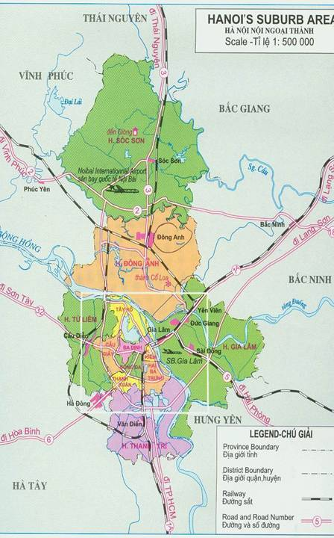
Figure 3 Location of target communes studied in tilapia seed production in rice field intervention
Note that these communities were purposely chosen as being areas where the Papussa project had not worked previously in order to reduce any previous biases or connections with the project.

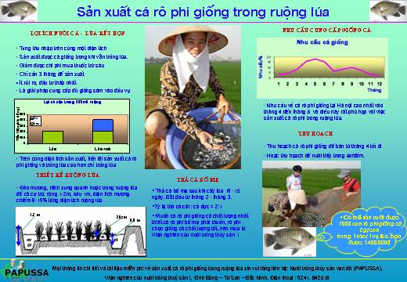
Figure 4 Poster explaining tilapia seed production in rice fields prepared in Vietnamese and placed in public locations for intervention.

Different locations for showing the poster were trialed to assess the potential for dissemination of this information: Road, market, health centre, Commune's People Office
miscellaneous goods shop where people often visit.
* Meeting with farmers on 24th December: we organized a meeting with 55 people including poor farmers, women, local authorities in villages and Phu Dong commune in order to introduce tilapia seed production techniques. We then also put up the posters in public places such as house of culture in villages, village market, commune office etc.
* Initial results of intervention
- Summary result from survey forms, most people answered that they have never seen or heard about tilapia seed production in rice fields before. About 60 -75% people in Duc Tu answered they have heard/seen/ how to produce fish in rice fields and about 30% have cultured tilapia for food before. But in Phu Dong commune about 80% answered that they never heard and 100% never seen tilapia seed production in their commune.
- 100% people in Duc Tu, Phu Dong and Sieu Quan communes answered that they liked the poster, it had nice presentation and was easy to understand. 20-30 % of people in Duc Tu answered that they liked present poster without the seed requirement graph (which they did not understand) and the present poster should be in a bigger size for farmers and older people so that it is easy to read.
- 10-15% people think that they can apply this technique in their next crop. The rest also answer that they like this model but they think it would be difficult to do because of problems with water supply, marketing or where to sell fish seed, theft etc.
- At present we are preparing to apply tilapia seed production in 3-5 HHs in each commune by March next year 2006. This will require the HHs to be chosen, co-operation with the farmers, preparation of broodstock, design and modification of rice field layout, etc.
- Contact telephone numbers for RIA1 were given at the bottom of the posters but nobody actually contacted to RIA1 via the telephone number. We think to use telephone as means for contact in Vietname is expensive for poorer farmers also that most of them do not have telephones in their house. Moreover the poor farmers do not have the habit of using telephones so we then decided to go on and organize a meeting in the community for the rice farmers as a modified methodology to adapt to the initial response and uptake to the poster.
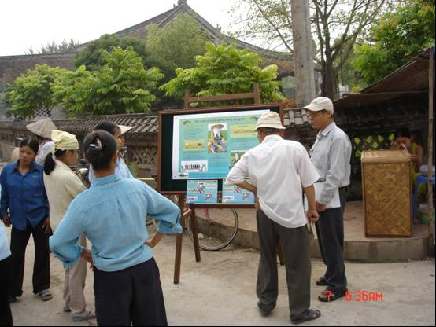
Figure 5 The team trialling the poster in the field

b. Produce an Aquatic Plant Cultivation User's Manual/booklet which describes how to grow the various different aquatic plants in Hanoi. The first drafts were completed and translated into Vietnamese. This intervention is now waiting for Stirling to incorporate this booklet with those from the other 3 PAPUSSA cities with the aim finally to produce one User's Manual for Aquatic plants which can be read and used widely throughout the region. The draft of booklet is attached in the annex of this report.

8. Interview farmers to produce aquatic plants video
One of interventions for all 4 cities was to produce an Aquatic plants video.William Leschen from Stirling came to Hanoi to produce a DVD video of aquatic plants cultivation in peri-urban Hanoi. The team went out into the field to helped Mr. Will to interview typical aquatic plant farmers, pharmaceutical sellers and village agriculture officials, whilst also collecting video of the production process from fields preparation, planting, harvesting processing and packing and then on to sales to the consumers in markets and supermarkets in Ha Noi. During this field work information on production techniques was also collected from farmers in order that it could be included in the aquatic plants users manual.. The Hanoi video has been incorporated into aquatic plants footage from the other 3 cities to produce a 25 minute DVD showing the importance and impact of aquatic plants cultivation in the region. Whilst presently having published the DVD with an English soundtrack in 2006 it will also be available in Vietnamese, Thai and Khmer versions.

9. PhD. work
a. Mrs Phuong Visit Stirling University: 12th January- 9th April
During this time Mrs. Phuong visited the Institute of Aquaculture, University of Stirling in order to carry on and develop her PhD study. This involved:
- First draft of Literature review
- Revising and developing proposal for water treatment capacity and potential of different aquatic plants and fish production systems in Bang B, Tran Phu and Dong My communes, Hanoi.
- She also gave a 40 minute presentation to the First Annual Stirling University Postgraduate Students Conference on her work in the project.
Also during her visit Mrs Phuong continued working on PAPUSSA outputs including:
Workplan of interventions, Policy Brief with Stirling students and Baseline database analysis.
She also attended a numbers of seminars including Local Watershed Management in Rural Sri Lanka and The Potential of Web CT in Interactive Learning Programmes.

b. Water sampling for treatment capacity (January- ongoing)
Weekly water sampling started in January 2005 in the following aquatic production systems: Morning glory, water mimosa, water dropwort, water cress, fish in ponds in Bang B, Tran Phu and Dong My communes. This will continue until next April 2006 in order that we obtain a full seasonal cycle.
This work also included a consultation workshop held at RIA1 on 11th of May with 12 farmers whose systems were chosen for water quality analysis and therefore their capacity to treat wastewater. Mrs. Phuong gave a presentation on feedback about water quality and the future proposed workplan for water sampling in order to inform farmers and get their agreement. Dr. Tuan Anh and Tuan from the National Institute of Hygiene and Epidemiology (NIHE) also attended and also gave their proposed plan for bacterial water sampling.
By 27 December 2005 we had collected 360 water samples to analyse Ammonia, Nitrite, nitrate, total phosphorous, ortho phosphorous, BOD, COD. Also 19 sediment samples were collected for analysis of total phosphorous, NH₄⁺ available, COD, total of nitrogen in each of 10 typical aquatic production systems from beginning and end of crops. The results will be written up into a report by 2006.

10. Project Visits to RIA1
* Dr. David Little came to Hanoi in May. On 14 May he visited the field with Phuong and Tuan Anh (NIHE) to identify systems for water quality analysis. He also met all staff members and viewed Phuong's work on her PhD in treatment capacity as well as giving comments on the intervention using the tilapia seed production poster. On 20th May he had a meeting with Dr. Tuan and Phuong concerning PAPUSSA progress and also met Dr. Cam from NIHE and *Helle Marcussen (PhD student from KVL Copenhagen) on 21st May.
* Helle Marcussen (KVL) also visited RIA1 on the 19th May to collected fish samples and water sampling at RIA1 for her PhD work.
* William Leschen visited Hanoi for PhD works such as marketing surveys in retail, wholesale markets and supermarkets from 18 July to 4 August. The Papussa staff also went with him for the surveys and gained good experience in learning and practicing methods and research ideas.
* Albert Salamanca from Durham University visited RIA1 from 16 August to 1 September. We also went with him to interview 12 households in 4 communes for his PhD about land use trends and their livelihoods issues. We then converted the resulting conversations from the tape recorded interviews into computer as type in words and were also involved in the translation from Vietnamese into English.
* William Leschen and Dr Benoy Barman (World Fish Centre Dhaka) visited RIA1 and the National Fish Seed Centre from 20th September. to November 5th for surveying markets and the development of aquaculture in the surrounding provinces of Cao Bang, Lang Son, Ha Tay and Hai Duong.
* Dr. David Little came to Hanoi on the 29th October 2005 and Dr Stuart Bunting came to Hanoi on the 16 November 2005. Both of these PhD supervisors visited the field in Bang B, Tran Phu and Dong My for supervision progress of water treatment capacity and to guide Ms Phuong for data analysis.

11. Dhaka worshop from 22-23 Nov. in Gulshan, Dhaka, Bangladesh

A DFID funded workshop on Peri-urban aquatic production and improvement of the livelihoods of the urban poor in Southeast Asia was held in Dhaka Bangladesh between 22-23rd November. Ms. Phuong presented an overview of Peri-urban aquatic production systems in Hanoi through the findings from three years of the Papussa project, as well as participating and interacting in the various group sessions with the other international participants. This workshop was good for the exchange and analysis of experiences of a variety of stakeholders from different countries regarding the potentials and limitations of peri-urban aquatic production as a strategy for livelihood improvement in the Bengal region. The majority of participants from Bangladesh were unaware of the significant volumes of peri-urban produced fish and aquatic plants in Ha Noi – the majority of which is grown using urban waste water. Edible aquatic plant cultivation is not common in Bangladesh and a number of the participants were particularly interested in the methods for mimosa and morning glory production used in Ha Noi.
The specific objectives of the workshop were:
- To facilitate the inclusion of peri-urban aquatic production in national and local policies and programmes.
- To establish a Bengal platform for information exchange and mutual support in the field of peri-urban aquatic production in South East Asia
- To disseminate and widen the scope of Papussa and incorporate the work and experiences of other stakeholders

12. Problems Encountered Section
- The Baseline Questionnaire was too complex and long so farmers were not really very happy to answer all questions during surveys.
- Farmers do not have habit to write any record or note book so data we collected depended very much on their memory and recall therefore making some of the responses and data obtained open to question.
- The Monitoring survey seemed boring and repeated itself with some of the farmers.
- The Farmers harvest is scattered during months and depends on each individual household harvesting activities. For monitoring survey 3 we cannot get all harvest data of all households so we have to come back again a 4th time to collect production data after the fish harvest.
- It is hard and boring to check 3 time data repeating after entry by each questionnaire of all over 800 set of questionnaires.
- For the intervention most of poster disappeared after a week we put on the wall because of poor quality of glue so easy pull down and some of farmers collected it.
- Aquatic plants booklet have a draft already in both English and Vietnamese. We are waiting for decision from Stirling for further final product.
- With agreement between RIA1 and NIHE that they collect water sample at the same time whenever farmers are pumping waste water. But the fact farmers can phone us during weekend but NIHE not often ready to go to the field resulting in a number of the samples being taken without NIHE present to take bacterial samples..

12. Publications

1. Phuong, N.T.D. and P.A.Tuan (June 2005). Current status of Peri-urban Aquatic production in Hanoi Urban Agriculture Magazine (RUAF Netherlands). Also available on RUAF website www.ruaf.org.

2. Tien, T.T.H., P.A.Tuan, N.T.D Phuong and W. Leschen. Feeding cities - Dong My, a peri-urban community in Hanoi, Vietnam, involved in the cultivation of fish. Aquaculture News 32/October 2005. pp 3-5. Institute of Aquaculture. University of Stirling.

3. Posters in Vietnamese
(1) Marketing channels of fish and aquatic plants in Hanoi,
(2) Result of Participatory Communities Appraisal in Peri-urban Hanoi.
(3) Tilapia seed production in rice field

4. Booklet and leaflet of techniques: Tilapia seed production in rice field

THIRD INDIVIDUAL PARTNER ANNUAL REPORT
Covering period from 1st January 2005 to 31st December 2005

Partner 6: University of Agriculture and Forestry (UAF)

Ho Chi Minh City, Vietnam.

Personnel involved in project:
1 | Dr. Le Thanh Hung | Principal Investigator
2 | Dr. Vu Cam Luong | Researcher
3 | Mr. Huynh Pham Viet Huy | Research Assistant
4 | Mr. Tran Van Minh | Fieldwork staff
5 | Ms. Nguyen Thi Thanh Truc | Fieldwork staff
6 | Ms. Bui Thi Phuong Thao | Fieldwork staff
7 | Mr. Pham Ngoc Tam | Fieldwork staff
8 | Mr. Nguyen Thanh Tam | Fieldwork staff

OBJECTIVES

The main objectives of the project in the year 2005 were:

- To fully complete data collection for the last monitoring survey
- To build a comprehensive database on household livelihoods of peri-urban aquaculture farmers.
- To carry out project interventions, including disseminating the project SOS reports, technical interventions on aquatic production systems
- To produce an aquatic plants technical booklet as a part of an overall Users Manual for cultivating aquatic plants in the 4 Papussa study cities.
- Water sampling for nutrient fluxes analyses in different aquatic production systems
- Identifying and implementing appropriate intervention(s) on aquatic production systems in HCMC.
- To finalize the baseline and monitoring data analyses in order to produce a scientific report.

ACTIVITIES

1. Follow up from the Progress and Planning meeting in Penang December 2004

After the meeting, the remaining part of the third and last monitoring survey that had not been done was then completed between 1st January to 28th February 2005 with the remaining 121 households surveyed.

2. Data entry and cleaning

Monitoring data were then entered into the database with the involvement of all 4 project staff between 1st March and 30th April 2005. Applying the same method previously used, a local network was employed between computers to avoid errors of synchronizations, which were used at the end of each day/week for good database management and checking.

3. Collecting information on cultivation techniques for aquatic plants in HCMC

As agreed in PP meeting, the HCMC team was producing a small technical booklet for aquatic plants cultivation for the two main species of morning glory and water mimosa cultivated in and around HCMC. Information was gathered from different sources including the baseline/monitoring database, PCA reports, and also updated information from detailed interviews with some farmers. The booklet of the two species was completed between May and June 2005 mainly by Huynh Pham Viet Huy and Bui Thi Phuong Thao.

4. Dissemination and data collection for State of the System (SOS) report intervention

Over 150 SOS reports produced last year were disseminated as a means of intervention to senior stakeholders. SOS reports attached with a short questionnaire were sent out to many government agencies and market related organizations to take responses on the quality, meaning and the significance of PAPUSSA SOS report to the receivers. This project dissemination process was carried out between 15 December 2004 and 15 January 2005 by the whole UAF PAPUSSA team. Responses were backing up 2 weeks later. However the response rate was very low so the team had to go out once more for directly collecting the responses during March to May 2005. Data are being entered onto an Excel spread sheet for analysis which is currently being done by Huynh Pham Viet Huy and Pham Ngoc Tam.

5. Database Training Workshop held in Siem Riep – Cambodia

In order to assist the data analysis, the database training was conducted in Siem Riep between the 3rd – 7th July 2005. Mr. Huynh Pham Viet Huy, research assistant of UAF PAPUSSA partner attended the training getting all required analysis techniques and contributing to complete the whole baseline and monitoring data of PAPUSSA project.

6. Project visits to UAF

Mr William Leschen (UoS) had a visit to UAF during 8th – 11th July 2005. This visit was to inspect the data entry process and to take video clips on aquatic plants culture activities around peri-urban areas of HCMC. UAF project staff – Thao, Tam, and Truc were actively involved in the task of interviewing aquatic plant farmers by acting as interviewers and translators for Mr. Will. They were also taking part in translating the content of video clips into English. Mr Will also made visits to ornamental fish farms and gained some general views on this kind of activities in HCMC.

After Mr. Will’s visit, Dr David Little (UoS) came to HCMC for a short one-day visit. During the visit, Dr Little was taken to intervention sites – Da Phuoc Commune, Binh Chanh; and ornamental fish farms and shops in HCMC. Mr Huy, Ms Truc and Mr Ngoc Tam went with Dr Little to Da Phuoc commune. Dr Luong and Mr Thanh Tam took the responsibility of introducing Dr Little to ornamental fish sites.

7. Preliminary production of baseline survey report

Based on the preliminary analysis and further data checking conducted after the P and P meeting, a draft baseline report was produced by Huynh Pham Viet Huy with e reference to William Leschen’s suggestions. An outline of the content of this report is attached as an annex.

With almost complete data analyses, some findings of the study have been reported, as follows:

Aquatic production systems are still playing important roles in livelihoods of involved farmers though the significant levels they act are different from one place to another in peri-urban areas of HCMC. Besides benefits, farmers in different locations are suffering various difficulties in their production activities which could lead to many uncertainties in their normal life. Seasonality doesn’t seem to have an important impact on farmers’ life though it really has some certain significance as flooding was considered to be the most important threat to aquatic production systems.
Although a valid comparison between aquatic production farmers and other income earning activity members of the same communities could not be conducted from our findings, a general picture of AFPS farmers’ livelihoods and their aquatic production status has been drawn from the study. Findings from the study should be a main reference for the City Authority when they carry out future planning so that aquatic production activities in HCMC can remain at least at their present status or if possible can be developed further. The main findings from the analysis are listed in the Annex.

8. Initiating the individual partner intervention

According to the information gained during PCA studies as well as baseline and monitoring surveys, fish farmers in many peri-urban communities received very limited technical information from any source. Though pond preparation and management techniques are rather simple, farmers usually lack of these technical information which could be very important to maintain a good yield from their aquaculture ponds. With this above farmers’ limitation, a Technical Fact Sheet on “Pond Preparation and Management” were produced and disseminated to 4 peri-urban communities, including Dong Thanh commune (Hoc Mon district), Da Phuoc and Phong Phu communes (Binh Chanh district), and District 9, which are fish culture communities involved in the PAPUSSA project. Responses and evaluation from farmers will be collected by interviews using structured questionnaires.

The proposed content of the fact sheet was tested carefully whether it is helpful and applicable for targeted farmers by direct discussions. Besides the technical information given based on the literature, further technical information that are desired by farmers were also asked during testing step, which was conducted by PAPUSSA project staff. This testing step was also used to check whether technical terms used in the technical fact sheet are easily understandable for farmers.

After the testing step was completed, the fact sheet was designed in the form of an annual calendar, which is thought to be the best form for farmers to look at daily. The fact sheet was then printed and disseminated during December 2005. Besides farmers, some other places were also provided with the technical fact sheet, such as Farmers Union at Commune level, Womens Union (also commune level), and Agriculture Extension Station(s).

Responses will be collected in January and February 2006, by using structured questionnaires. The results will be complied in the form of a report showing the usefulness of the technical fact sheet to farmers aquaculture activities.

9. Ornamental fish study

Since the new study on status and potential of ornamental fish in peri-urban areas of HCMC was accepted by the EC, some initial steps have been done between then and the present time.

Dr. Vu Cam Luong was taken on as the person responsible for co-ordinating and carrying out the ornamental fish survey on 1st July 2005. He had a meeting with AIT partner members, including Prof. Lin and Ms. Wanwisa between 11-15th July 2005 where methodology protocol and timescale of the ornamental fish PAPUSSA sub-project was agreed amongst the partners present.
Following the protocol, secondary data collection and key informant interviews were carried out during 18th – 31st August 2005. General information on ornamental fish industry in HCMC was gathered from different stakeholders involved in the industry.
In order to conduct PCA meetings, visits to key ornamental fish farmers were made during 10th – 22nd August 2005. Two PCA meetings were then held on 19th and 24th August 2005 in Ward 15 of District 8 and in Ward 17 of Go Vap District, respectively. The PCA reports have been produced and included in the Annex
A survey on retailers/wholesalers in ornamental fish domestic markets was also carried out through different steps. Questionnaires were prepared during 1st – 7th September 2005 followed by pre-testing step which was done during 10th – 15th September 200. The actual survey was implemented with 36 ornamental fish stores in HCMC in the period of 15th September – 15th October 2005. The survey was aimed to collect information on marketing network for ornamental fish in HCMC.
Another investigation on import / export activities was done by visiting the government agencies and key informants during 16th – 25th October 2005). The main objective of the survey was to collect data on import / export activities based on quantity of many ornamental fish species, the constraints faced by ornamental fish importers and exporters, and future trends of ornamental fish development in HCMC.
The survey on the ornamental fish production was carried out during 26th October – 30th November 2005. The steps include questionnaire preparation (26-31 Oct 2005); pre-testing (1-7 Nov 2005) and the actual survey with 40 ornamental fish farms in HCMC (10 – 30 Nov 2005).
Data analysis and reports production were started on 1st December 2005 and will be finished in January 2006. The proposed main contents of the report are as follows:
a. The distribution channels and marketing network supporting for ornamental fish production in peri-urban of Ho Chi Minh City
b. The current/past state of freshwater ornamental fish production in peri-urban of Ho Chi Minh City
c. The comparisons between BKK and HCMC’s ornamental fish industries (will be implemented after the meeting in BKK during 16-18 Jan 06)
d. SWOT analysis (Strength-Weakness-Opportunities-Threatening)
e. A management strategy for sustainable development of freshwater ornamental fish production in peri-urban of Ho Chi Minh City
A DVD video for dissemination on ornamental fish marketing and production activities in HCMC was also recorded during December 2005. This DVD will be edited and finalized to present marketing network, import / export activities, production, and interviews with key persons involved in the industry in HCMC. In future it will disseminated out to a wide range of stakeholders both in HCMC and Bangkok as well as internationally. It is hoped that one of the outcomes of this study is to inform and perhaps encourage interested individuals to consider growing ornamental fish as a viable and lucrative income earning activity within and on the outskirts of HCMC.

10. Publications

Urban Agriculture Magazine

Another important matter was the publication of a special Peri-urban Aquaculture edition of the RUAF Netherlands based Urban Agriculture Magazine. Based on the first years results including PCA reports, institutional report, market analysis report, an article was written about the aquatic production systems in HCMC by Huynh Pham Viet Huy and Le Thanh Hung. This special edition was published in June 2005 and is available on the RUAF website at: www.ruaf.org/UAmagazine.

11. “Peri-urban aquatic production and improvement of the livelihoods of the urban poor in SE Asia” Workshop Dhaka, Bangladesh 21-22nd November 2005.

Dr Le Thanh Hung, the PI of PAPUSSA-UAF attended the workshop in Dhaka and shared experience on peri-urban aquatic production systems in Ho Chi Minh City by presenting findings from the three years of the Papussa project in HCMC. The presentation is attached in this report as an annex. During the workshop there was particular interest from the Bangladeshi hatchery owners present in the production systems used for growing fish seed in and around HCMC as well as the financial benefits of using waste water and non waste water.

12. Problems and Constraints

Due to different nature of farmers’ water exchange methods applied for different systems, water sampling for nutrient fluxes analysis of some selected systems has not been completed. Some systems cannot be sampled in the dry season (e.g. morning glory) while in some others water samples cannot taken during rainy season due to overflows (e.g. water mimosa).

Another constraint for project’s output completion was the low response rate for SOS report dissemination that is an important intervention of the project. Respondents were supposed to send their answers back but very low proportion of them did the job. Although the staff had to come and collect the responses directly at corresponding institutions, the number of answers for this study is still low in comparison to the total disseminated SOS reports. This might somehow affect to the result of the study.

INDIVIDUAL PARTNER ANNUAL REPORT
January – December 2005

INCO-DEV Project: PAPUSSA

Proposal No: ICA4-2001-10072

Partner 7: Royal University of Agriculture (RUA), Cambodia

Personnel involved in the project:

Mr. Chhouk Borin Principal Investigator
Mr. Khov Kuong Team Leader, Researcher
Ms. Sok Daream Researcher -
Mr. Sok Seyha Research Assistance
Ms. Holl Tharin Health team surveyor
Ms. Thak Socheat -
Mr. Huot Kong Heang -

SUMMARY

The Royal University of Agriculture, Phnom Penh is one of the PAPUSSA partners having been under the support of the European Union. Year 3 of the Papussa project and its constituent work packages have involved the following main activities:

- 2nd Monitoring Questionnaire data processing and coding
- Household interview for 3rd Monitoring survey.
- SOS dissemination and dialogue
- Producing growing manual of Morning glory and Water mimosa
- BL and Monitoring database training workshop in Siem Reap
- Phnom Penh Peri-urban Aquatic Production Film produced by BBC world service
- Database checking, analyzing, and writing up report of Baseline and Monitoring survey
- Writing and Publication of Article for Urban Agriculture Magazine

ACTIVITIES

- 2nd Monitoring Questionnaire Data Processing (January 2005)

The 2nd Monitoring survey with 200 households in study sites of Phnom Penh was completed since early December 2004. Starting the year 2005 the questionnaire responses were coded and entered completely into the Baseline and Monitoring database.

- 3rd Monitoring Survey (Jan – March 2005)

The 3rd monitoring survey interview as planned in year 2004 was initiated in the middle of January 2005. The interview was scheduled to be carried out in line with the health survey which was implemented by the health survey team. The survey was completed at the beginning of February in which 200 households in 5 communities (Tnout Chrum and Kbal Tumnub in Boeung Cheung Ek area, Phum Muoy in Beung Kok area, Buon Village and Duong Village) were successfully interviewed. This was followed by questionnaire responses coding. Later, the project team spent a total of one month in March for the 3rd Monitoring data entry into the Baseline and Monitoring database and this was made ready for initial database analysis.

- SOS Dissemination and Dialogue (Jan –April 2004)

After receiving the SOS dialogue questionnaires from ETC, Netherlands the translation of SOS dialogue questionnaire immediately made available by the RUA team since January. Before they were officially used, the questionnaires had been piloted with 2 fisheries and 2 non-fisheries people. Responses were collected and analyzed for further improvement of the questionnaire as well the distribution method.

The amended questionnaires then were attached with the Phnom Penh SOS report and sent to various senior stakeholders aiming to get back the comments of those people on content, the presentation and lay out of the reports, their view on the situation mentioned in the reports, and any interventions could be recommended in the given situation to the development of production of fish and aquatic plants in/around Phnom Penh city.

From March to April 2005, 77 SOS reports with attached questionnaires were distributed to the selected NGOs, Government agencies, local authorities, donors, and many other specialists who they were considered as directly or indirectly involved in aquatic food production in urban areas of Phnom Penh city. At the end of the process only 63 of them were reported to have actually received the reports and only 23 of them sending a response on the attached questionnaires. The RUA team with the purpose of storage and analysis of SOS responses from the senior stakeholders, created the SOS database and data entry finished on 10th June of 2005. The analysis tended to categorize the result by type of stakeholders, the report of this dialogue will be produced by January 2006.

- Develop Intervention Protocol on experiment of Integrated System of Morning glory and Snakeskin gourami fish with Effective Micro-organisms

The trial experiment of cultivating snakeskin gourami fish with floating morning glory in pre-constructed cages was an early idea of intervention in third year Papussa project. Later, another variable (Effective Microorganism) was decided to be included in the experiment. This experiment was planned to be held in part of Beung Cheung Ek lake area in which water would be be at a certain level appropriate for fish culture. Estimated time of cultivation was 4 months (June-September, 2005) (see the detail protocols in Appendix 2)

Unfortunately the experiment was cancelled at initial implementation due to managerial problems, delay in budget allocation and limited time frame remaining in the project.

- Writing Aquatic Plant Cultivation Booklet (June – July 2005)

The booklet of aquatic plant growing is an intervention activity of the project partners as in the purpose to share the technical and practical experiences amongst farmers and served the information for related stakeholders. The process occurred through small workshops with 5 to 6 farmers as they were sharing their traditional techniques, experiences and problems encountered in morning glory and water mimosa growing. Since the target of the booklet are mostly lowly educated farmers so the booklet was made into a practical Users Manual with very simple text descriptions and picture illustrations. This process was carried out during June and to be sent for editing under Mr. Will Leschen (UoS). Translation into English and amendment was fulfilled amongst the team and Will by the end of July. The booklet will be incorporated with the other 3 city partners booklets to produce one overall Users Manual for the whole region. Once this has been completed and compiled in English it will then be translated and published into the 3 native languages so it can be disseminated out within each country.

- Drafting BL and Monitoring Survey data analyzing (June 2005)

As the Baseline and Monitoring data collection finished at the end of March, the working team preliminarily analyzed the data during the month of June. The result of this analysis were just in chart and graphic form which this was used as basic idea and materials for database analysis training in Siem Reap (03-08 July 2005).

- BL and Monitoring Database Workshop in Siem Reap, Phnom Penh (04-08 July, 2005)

In order to make amendments to the database and to make the data analysis more meaningful for the report, BL and Monitoring Data analysis training was held for strengthening capacity of the staff. The workshop was held in Siem Reap, Cambodia from 04-08 July, 2005. Before the training, BL and Monitoring data were completely entered into the database by each partner. Technical support was offered by Stirling University/University of Durham to all Papussa partners (Ho Chi Minh City, Hanoi, Phnom Penh and Bangkok). Analyzing keys including research hypotheses and BL and Mon report guideline were provided by Dr Francis Murray, and Mr. William Leschen, with co-ordination of Mr. Albert Salamanca and Miss Wanwisa Saelee. A clear forward workplan for remaining months of the year was produced by the end of the workshop.

- BL and Monitoring Data Analysis and Draft Report ( August – December 2005)

Database Training in Siem Reap provided us more knowledge on the data structure and data analysis. The database checking and cleaning were done again throughout the remaining months as agreed during the planning in the database training workshop, however this cleaning has still to be finalized. As the data analysis went on day by day, more data errors were more found and verified with the hard copy of the questionnaires.
The draft report of Baseline and Monitoring Survey report was produced at the end of year 2005) in which the result of analysis was divided into 3 main chapters - Household Detail, Production System, and Institution. Each chapter was described based on the analysis through the proposed hypothesis produced during the training workshop and additional hypothesis upon each city finding. (See the summary of analysis in the Results section)

OTHER ACTIVITIES

- Visit of Mr. William Leschen

Mr. William Leschen from University of Stirling visited Phnom Penh on 1st of July to discuss about further activities plan for Phnom Penh team and sorting out the problems encountered by Phnom Penh team associated with technical and financial issues. His visit to Phnom Penh was followed by the Database training workshop in Siem Reap from 4th to 8th July 2005.

- The visit of Mr. Albert Salamanca, PhD study, Durham University, UK

Mr. Albert Salamanca visited Phnom Penh during May 2005 for his PhD data collection. The team was working with him in facilitation and translation for his interview with some selected elders who have been settling in the study villages for years. The interviews were recorded in cassettes and transcripted by the team into local language then interpreted into English. During the interviews, he was also trying to identify the relationship of the interviewees whether the man or woman had relatives who are living in the village.

- Co-operating with BBC Natural World to produce film on Production in Aquatic Peri-Urban System Using Waste Water from the city

The team worked with Ms. Romaine Lancaster, BBC Natural World from UK and Mr. Albert Salamanca from UoD to produce a film on Production in Aquatic Peri-Urban Systems Using Waste Water from Phnom Penh city on 08-09 November, 2005. The film will be displayed on a BBC channel and hopefully will soon be uploadable on the Natural World website.

The film shots included the general situation of Beoung Cheng Ek Lake, Cheng Ek national museum, and the interview with morning glory producers in Beoung Cheng Ek area, and morning glory sellers in Demkor market. Mr. Albert Salamanca was interviewed on activities of PAPUSSA project in region. The livelihoods of morning glory producers in Beuong Cheng Ek area was explained by Mr. Khov Kuong. Mr. Srun Limsong, director of Inland Fisheries Research Institute was also interviewed on the aquatic cultivation and fisheries management in the lake. Another interview on Skin problems of morning glory producers in Beuong Cheng Ek which was surveyed in the last years work package was carried out with Dr. Chan Vichit, Director of the National Clinic for Dermatology & STD Unit

- Attending the Policy Workshop in Dhaka, Bangladesh (22-23 November, 2005)

Mr. Khov Kuong, team leader of Phnom Penh- Papussa team attended the workshop on “Peri-Urban Aquatic Production and Improvement of the Livelihood of the Urban Poor in South East Asia” which was held in Dhaka, Bangladesh on 22nd to 23rd November, 2005. He amongst the other Papussa partners from different cities, who also attended the workshop, presented the experiences and findings from the 3 years of the Papussa project in Phnom Penh. The presentation was followed by questions of the participants from Bangladesh and India in which they were interested in the growing techniques of the aquatic plants and fish, market channels and land ownership status of the urban aquatic farmers. Mr. Khov Kuong was also selected as representative to all Papussa partners in the working group of Urban / Peri-urban Aquaculture Development Committee (UPADC) as the committee’s purpose is to make possible Communication and Information Exchange towards the sustainable development of peri-urban aquaculture in the region

- Editing reports

PCA reports from each four villages (Kbal Tumnub, Tnout Chrum, Muoy, and Duong), marketing analysis and Institutional analysis reports has been edited since September and they were finalized and put in the website at the end of July 2005

- Staff leaving

On 31 December, 2005 Mr. Sok Seyha has resigned from Papussa project for his study for Master Degree at Royal University of Agriculture, Cambodia.

RESULTS

- Completion of Activities

- All Baseline and Monitoring Survey were successfully completed in February 2005 and all of 800 questionnaires were entered into database, with completely database checking up and cleaning. The enhanced data analysis and draft report was produced and will be corrected and finalized by the end of April 2006.

- From March to April 2005, About 77 SOS reports with attached questionnaires were distributed to the selected NGOs, Government agencies, local authorities, donors, and many other specialists. About more than 400 copies of SOS reports were distributed to un-target stakeholders during meeting or celebration events in Phnom Penh.

- The compilation of the booklet of Aquatic Plants growing manual was successfully completed and finalized and pending for publishing and distribution during the extended period of the project in year 2006.

- Publication and reports

- Article on “Peri-Urban Aquatic Food Production Systems in Phnom Penh, Cambodia” and case study of morning glory farmer in BCE lake. The article was published in Urban Agriculture Magazine – ETC Netherlands.

- A case study on “Health Problems of a farmer engaged in Water Morning Glory cultivation in Beoung Cheung Ek Lake, Phnom Penh, Cambodia” by Mr. Sok Seyha was posted on the PAPUSSA website.

- Phnom Penh-Papussa Annual Technical and Financial report 2004

- Phnom Penh-Papussa 6 monthly report 2005

- 2 Aquatic Plant Booklets in electronic file for publishing and distribution

- The Initial Results of Baseline and Monitoring analysis and report

All partners during the database training in Siem Reap agreed on the report structure and initial research hypothesis proposed by William Leschen (UoS) and Albert Salamanca (UoD) for the consistency however more hypotheses would be developed based on the context of findings of individual partners. The initial results extracted from the Baseline and Monitoring data analysis and draft report are shown in Appendix 3.

Summary of initial results of Baseline and Monitoring Analysis:

- Morning glory producer households generally have larger number of members compared to fish culture (8-10 in each household)
- Aquatic plant growers had higher rate of dependency in households as more household members in their young age were non income earners
- Aquatic plant producers have relatively lower education levels compared to fish farming households.
- In general Fish producers own larger land areas than aquatic plant producers as those aquatic plant producers were likely to own only the land for their housing, only a few own their agricultural production land, most land for aquatic plants production is rented on non permanent leases.
- Credit was of importance for communities producing morning glory in waste water as NGO micro credit and private lenders were the most popular but neighbours or friends were indicated as a source of credit in communities of fish production.
- Clarias catfish in non wastewater produce the highest annual production (tons) followed by Morning glory.
- The annual income of morning glory ranks in the lowest level due to its cheap product price. However, the input to this system was also much lower and the turnover time was considerably shorter as farmers can harvest part of it regularly once a week for household income.
- Morning glory is the most productive system amongst other peri-urban aquatic production systems (about 7 ton/ha) while fish is about 4 ton/ha.
- There is more chance for women to get involved in aquatic plant production rather than fish production as most of their work is associated with plant harvesting and selling. Fish production commanded more male labor for maintaining farm operations.
- Young adults were found as mainly involved in morning glory production but Fish production demands more skilled workers with older ages.
- For both aquatic plant and fish production, more labour was demanded in terms of working days per week in the 3rd monitoring period (Nov- Feb) as fish producers were likely to harvest their fish and start the new production cycle which need extra labourers.

- Clarias fish farmers tend to intensify their production in the season where other species were less produced (Monitoring 1), unlike Pangasius where the production cycle is fixed and they tend to harvest specifically at the beginning of year (Monitoring 3).
- The inputs were more intensified with fish pellets, protein adding to regular feeding of rice bran and trash fish for Clarias production in Monitoring 1. Pangasius producers tend to intensify inputs as mainly the trash fish for feeding during Monitoring 3 as they become close to the period of harvesting. However it is difficult to describe the production of Pangasius in wastewater as their inputs were mainly based on canteen waste.
- The production of morning glory was very seasonal as it is associated with main factors including flooding level, rainfall, and pest intrusion and many other subsequent factors. It was found that the production is at its peak during Monitoring 1 (May –July)
- It seemed that the average production land for morning glory and fish production in peri-urban areas of Phnom Penh were almost similar even a bit different. The production systems tend to occupy land of around 1000-5000 m² per household.
- More than half of morning glory producers tend to rent in land for their production.
- It was notably observed that fish producers around the city tend to increase their production area year by year and some of them tend to own the land for securing the existence of their production.
- The results indicated a quite limited involvement in institutions. Only 20 of 133 households producing morning glory were involved in institutions mainly the education support group, micro-credit, and youth union.
- Fish producers were very limited in their institution membership as associated with fear of sharing their information resulted from loss of trust between farmers and institutions working with them and frequently projects did not involve them in making decisions for their benefit.
- Some of the Morning glory producers perceived that government should help their production with agriculture extension and health maintenance, while some fish producers need fisheries extension.
- Amongst both morning glory and fish producers, few of them received Aquatic food production system training while most of them have learned their producing and management methods from relatives or neighbours.

PROBLEMS ENCOUNTED

Technical Problems

The main technical problems encountered by Phnom Penh team during year 3 of the project included:

- Due to lack of experience in using such huge databases for Baseline and monitoring data entry made it very difficult for the team with almost all processes. Although the training was made available by the project coordination from University of Stirling for the database use and management but several errors still occurred during those data entry which sometime caused the team to get stuck until the immediate solution of comments were given by the database designers. The associated problem also occurred during database replication. In order to make safe for the original database which was just completed entering all baseline and monitoring data, replication then was created. Later the replicated version was used for checking and verifying towards cleaning up the database, unfortunately the problem occurred again as database could not be used due to breaks in its table relationships. As a result the team had to turn back to use the previous original data which this need to be cleaned up again. The subsequent step of beginning data analysis could not be carried out until this process of data cleaning had been properly completed.

The 3rd monitoring survey interview also had its associated difficulties for the field staff particularly related to the availability of the interviewees. This was mainly due to such people and peri-urban households having very busy and full working days often being involved in a number of income earning activities. And it was often not possible to meet the same person whom we met in the previous monitoring survey sometime we met husband or wife for interview.

Financial Problems

- Financial problem might be the most adverse problem for Phnom Penh team. We experienced the delay in transferring budget and local management. This resulted in delay of almost activities which reduced time allowance for implementation. This also led into limited quality of the outputs. Another consequence was also associated with this financial problem, the experiment on Integrated System of Morning glory and Snakeskin gourami fish with Effective Micro-organisms as part of the intervention of the project have not been fulfilled due to delay in budget for implementation.

PLANNED ACTIVITIES FOR EXTENDING PERIOD IN 2006

January 2006

- P and P meeting at AIT, Bangkok to present the results of the year 2005 and discuss on the 2006 work plan.

- Mr. Khov Kuong from RUA traveling to Stirling until April for completion of all Phnom Penh- Papussa project outputs

- SOS dialogue database to be analyzed and the draft report to be completed at the end of January and hopefully this would be finalized by February.

February – April 2006

- The Technical Annual Report 2005 to be completed and submitted to Stirling. Protocols and designs of the intervention activities will be attached with.

- Translation of Aquatic plants booklet into local language to be completed by the end of February. The booklet will be published during April to distribute all stakeholders particularly farmers.

- Baseline and monitoring survey report to be completed at the end of April 2006 for submission to Stirling.

May – June 2006

- Draft version of Policy Brief from ETC (RUAF) to Phnom Penh team by the end of May. Phnom Penh partner will be revising and comments then return the revised version to ETC by end of June 2006.
- All final reports to be in to Stirling by end of June.

July 2006

- RUA team to disseminate the report and policy brief to all stakeholders.

Phnom Penh- Papussa Work plan 2006

Activities | Jan | Feb | Mar | Apr | May | Jun | Jul
PnP meeting in Bangkok

Mr. Khov Kuong to Stirling

SOS dialogue report

Technical Annual report 2005

Translation of Aquatic plants booklet
Baseline and Monitoring survey report
Policy Brief revision

Report and Policy brief dissemination
Framework INCO-DEV Project: PAPUSSA (Production in Aquatic Peri-Urban Systems in Southeast Asia)

Annual Report for Year 2005

Proposal No:ICA4-2001-10072

Partner 8: Faculty of Fisheries, Kasetsart University, Thailand

Personnel involved in project:

Dr. Ruangvit Yoonpundh Principle Investigator
Dr. Varunthat Dulyapurk Principle Investigator
Mr. Chumpol Srithong Principle Investigator
Mr. Thanasorn Rakdontri Researcher
Ms. Aree Srisaipatanakul Researcher
Ms. Warnida Jahrare Researcher

Work activities of the project carried out by the KU Partner during the third year (2005) are as follows:

- To conduct the third monitoring survey and database training workshop at Siem Riep, Cambodia during 4-8 July 2005
- To develop the baseline and monitoring survey analysis.
- To conduct the project intervention – organic production of morning glory
- To conduct water quality monitoring
- To produce the Users Manual booklet of aquatic plants cultivation around Bangkok
- Others

- To conduct the third monitoring survey and database training workshop at Siem Riep, Cambodia during 4-8 July 2005

The third household monitoring survey was conducted during January to March 2005. A total of 212 households of the three communities, 110 households in Nongpraongai, 52 households in Suanprixthai and 50 households in Lumsai Village, were interviewed by KU staff. Data entry of the three monitoring surveys was also done in March 2005. A database training workshop was held at Siem Riep, Cambodia during 4-8th July 2005. Mr. Thanasorn Rakdontri, representing from KU, attended this workshop. The objectives of this training were addressed by the project coordinator (Mr.William Leschen) as follows:

- To be aware of problems and inaccuracies in data entry and then to be in a position to correct them – data cleaning.
-To review Baseline analysis carried out so far and develop/add areas which are currently not included.
-To review Monitoring survey analysis carried out so far and develop this in more detail – major part of the weeks work.
-To end the week with a format for the report in which our findings from the data analysis will be presented.

- To conduct the project intervention – organic production of morning glory

The project intervention was carried out as on-farm trials between August to November, 2005. The objective of project was to produce a pesticide free aquatic plant, morning glory (green/organic products) which is normally intensively cultivated around Bangkok using chemical fertilizers and pesticides. Around 2 rai (0.32 ha.) of land was allocated from a farmer at Nongpraongai sub-district, Nonthaburi province and 12 ponds were constructed to compare between the traditional farmer’s practice system (inorganic fertilizer + pesticide uses) and good agricultural practice (GAP) system (organic fertilizer + biotechnology using fish and herbal treatments). The project coordinator (Mr. William Leschen) encouraged one of our KU staff (Mr. Thanasorn Rakdontri) to apply this project intervention for his Masters thesis.

- To conduct water quality monitoring

Analysis of nutrient fluxes based on total nitrogen and total phosphorus was monitored within the two systems, hybrid catfish and morning glory culture systems. Three replicated ponds of each system were studied. One pond of each system was monitored in dry season and another two ponds were done in wet season. Hybrid catfish ponds located in Lumsai sub-district, Lumlukka district, Patumthani province, i.e. 50 km. northeast of Bangkok while morning glory ponds were in Nongpraongai sub-district, Sai-Noi district, Nontaburi province, i.e. 40 km. northwest of Bangkok. Water supply in a canal was randomly sampled to analyze the nutrient input. At the final harvest, water samples in ponds were collected by KU staff at the beginning of discharged water, mid and bottom pond water level for analysis of nutrient outputs. All water samples were kept in ice box foam and transported to analyze at the laboratory of Department of Aquaculture. The secondary data of each system was collected from interview with farmers such as stocking seeds, types and amounts of feed and fertilizers used, total harvested yield and other management during the cultivation periods. A report will be completed and submitted on water quality and nutrient flux analysis to KVL partner by April 1st 2006.

- To produce the Users Manual booklet of aquatic plants cultivation around Bangkok

A Users Manual booklet of morning glory and water mimosa intensively cultivated in and around Bangkok was prepared. The contents of manual were field preparation, cultivation methods, fertilization and management, harvesting and packaging, transportation, marketing and disease problems. Water mimosa grown more extensively in canals was also reviewed. This booklet when completed is to be amalgamated with similar booklets produced in the other three Papussa cities in order to make an overall manual for the whole region which will be translated.

5 Others

- To distribute State of the System (SoS) report dissemination

More than 600 copies of SoS reports had been already distributed to various significant targeted groups of stakeholders since 2004 including 30 copies for the policy workshop meeting on “Peri-Urban Aquatic Production and Improvement of the Livelihood of the Urban Poor in South-east Asia” at Dhaka Bangladesh, November, 22-23, 2005 attended by principle investigator (Dr. Ruangvit Yoonpundh).
Some responses of feedback were obtained from those representative persons/institutions. A Database was set up for entering the responses and feedback from the questionnaires which were sent out with the SoS reports and then analysed. The short report of findings from this feedback was produced (included in Annex).

- To conduct Aquatic plants Video

An Aquatic plants video was made by Stirling in conjunction with the KU and AIT staff between 7-14 October, 2005. The context of the aquatic plants video was focused on morning glory and mimosa cultivation, consumption and marketing. Interviews were carried out by KU staff with the Assistant Executive Director of Bangkok’s main wholesale market (Talaad Thai) on the important role of the wholesale market, important areas for aquatic plants production especially morning glory and the trends and preferences of Bangkok consumers, as well as with two other market traders. Besides this, the video also showed example pictures of growing morning glory and mimosa in natural canals in and around Bangkok, transport and marketing (including the growing influence of supermarkets) and people’s consumption of morning glory in canteens and restaurants. An interview was also done with one local farmer, Mr. Booncherd Kongdan, who had much experience on intensive morning glory farming and marketing of this aquatic plant in the production area, Sai Noi district, Nonthaburi province. Similar video was shot in the three other Papussa cities and this was all incorporated together to produce a 25 minute video showing the importance of aquatic plants cultivation to peri-urban households, markets and ultimately to the consumer.

- To improve and finalize PCA reports

PCA reports of the four communities previously produced in the year 2003 were already re-organized the sequence of the content. The context was also improved following the comments addressed by the project coordinator (Mr. William Leschen).

- Others activities related to project

The important other activities related to project done in this year 2005 were as follows:
  - A field visit to the relevant sites with Dr. David Little and his colleagues and AIT consultant colleagues (Professor Lin, Ms. Wanwisa Saelee and Mr.Albert Salamanca) by the end of March 2005.
  - A field visit to one kind of mixed fruits and vegetable organic farming system located in Rangsit district, Patumthani province with AIT consultant colleagues (Professor Lin, Ms. Wanwisa and Mr. Albert Salamanca) in order to be a guideline for useful ideas to the project intervention in mid April, 2005.
  - A mid year progressing report to the project coordinator (Mr. William Leschen) and a field visit to expected project intervention site during his visit to KU June, 28-30, 2005.
  - Participation of the principle investigator (Dr. Ruangvit Yoonpundh) in the policy workshop meeting on “Peri-Urban Aquatic Production and Improvement of the Livelihood of the Urban Poor in South-east Asia” at Dhaka Bangladesh, November, 22-23, 2005 which was jointly organized by Bangladesh Fisheries Research Forum (BFRF), Practical Action, Department for International Development (DFID), Aquaculture and Fish Genetics Research Programme (AFGRP), University of Stirling (UoS) and Production in Aquatic Peri-Urban Systems in Southeast Asia (PAPUSSA). At this workshop Dr Ruangvit gave a presentation to an international audience on the findings of the Papussa project in Bangkok. Much interest was shown by the Bangladeshi participants particularly in the scale and potential of aquatic plants culture in Bangkok as well as the considerable income and employment created by the culture of ornamental fish in and around the city.
  - A field visit to project intervention site with Dr. David Little and AIT consultant colleagues (Professor Lin, Ms. Wanwisa Saelee and Mr. Albert Salamanca) to discuss the results based experiment of the project intervention with the land owner during December, 8-9, 2005.

Results of Baseline and Monitoring Analysis

Some important preliminary results of baseline and monitoring analysis of the three communities were shown as follows:

- The gender status of family members related to aquatic food production systems in the three communities showed a little higher percentage of women than men (Figure 1 in Annex). The relatively similar average family members of all aquatic food production systems were 4-5 persons per a household with an overall range from 1 to 9 persons per household.
- Religion of household head’s revealed all Buddhist appeared at Nongpraongai village (intensive cultivation of morning glory) whereas Islam occupied mostly in water mimosa growing in canal and some involved in fish polyculture at Suanprixthai village. Christianity was also a smaller group found in hybrid catfish farmers in Lumsai village (Figure 2 in Annex). - Note all Figures quoted in Annex
- Age groups of family members working in aquatic food production systems either men or women ranged from 20-59 years old (Figures 3 and 4).
- The proportion of land rented for aquatic food production was higher in households that have more intensified production (morning glory and monoculture of hybrid catfish) than those of other systems (Figure 5).
- Most family members of aquatic food production systems (over 50%) finished only up to primary school level (Figure 6). However, it is noticed that there was a higher level of education for fish farmers that have more intensified fish culture in Lumsai village than those of aquatic plant growers and fish polyculture.
- Much more production experience (>10 years) was observed in households that have more intensified aquatic food production systems (morning glory and monoculture of hybrid catfish) than those of water mimosa growers in the SPT canal and fish polyculture. (Figure 7).
- Fish farmers, monoculture of hybrid catfish and hybrid catfish seed producers, were found to generate higher average annual incomes than those of aquatic plant growers and fish polyculture farmers (Figure 8).
- It appeared that there were more women than men involved in aquatic plant production systems (morning glory and water mimosa) whereas fish farmers seemed to have more men involved. (Figure 9).
- Migration based on household heads of aquatic food production both aquatic plant growers and fish farmers appeared the highest in Suanprixthai village, the area that is the closest to Bangkok around 20 km. (Figure 10).
- In general there was a sharp decline in aquatic food production in the winter season except for fish polyculture production that increased in this period probably resulting from a partial harvest and longer period of culture (Figure 11).
- Selling fish at farm gate was found to be mostly preferred by fish farmers while wholesale markets were another and important market channel for direct sale of their products. (Figure 12).
Please see Annex for further Figures and details

Initial Results of Project Intervention
- Morning glory cultivation in chemical systems gave a total gross yield (8,225 kg/180 m² pond) - nearly twice as much as the total gross yield of morning glory obtained from morning glory cultivation in organic systems (4,518 kg/180 m² pond) over the 4 month period of the trial.
- Total gross fish yield and survival rate of fish were found similar at both cultivation systems. i.e. 2.7-3.0 kg/pond and 61-63%
- Contamination of the chemical residue “Organophosphate omethoates” was measured and found at the level of 1.84 mg/kg in the sample of morning glory in chemical systems at the fifth harvesting or around 65 days of the cultivation period.

A full version of the results will be included in a report to be submitted by the end of the project.

Results of Nutrient budgets and water qualities

Intensive monoculture of hybrid walking catfish
- Hybrid walking catfish (Clarias macrocephalus x Clarias gariepinus) was intensive monoculture in the earthen pond.
- Around 80-90% of slaughter house-waste by products of chicken (all skeletons after get rid of meat including head and visceral organs) was a major fish feed. They were grinded first before feeding fish while a floating pelleted feed containing 30-35% protein accounted 10-20%.
- Most culture system was semi-closed, only water was pumped into pond for maintaining the water level. There was no water exchange throughout the culture period over 5 months. However, water was drained out from pond to natural water bodies for harvesting.
- The major nutrient inputs of total nitrogen (TN) and total phosphorus (TP) in intensive monoculture of hybrid catfish in the earthen pond came from feed ranging by average of 90.74-91.87% TN and 94.34-98.04% TP during in dry and wet seasons.
- While nutrient lost was mainly due to the derivation of harvested hybrid catfish yield of around 73.06-79.32% TN and 16.76- 30.14% TP during in dry and wet seasons.
- Other lost were discharged water during the harvest 8.55-11.6% TN, 7.59-10.84% TP and sedimentation 9.37-19.1% TN, 62.91-73.43% TP during in dry and wet seasons.
- From the results, it could be estimated that nutrient fluxes of 13.82-20.09 g/ton of TN and 1.2-3.78 g/ton of TP were discharged with drained water during the final harvest of hybrid walking catfish. This increased the risk of eutrophication, toxic algal blooms and deterioration of water quality in the surrounding areas.

Intensive cultivation of morning glory
- The morning glory was intensively cultivated in the paddy field around Bangkok in which a variety of chemical fertilizers and chemicals were used throughout the period of cultivation about 3-3.5 months.
- Three morning glory farms were monitored the performance of nutrient fluxes during the period of cultivation; one farm in dry season and other two farms in wet season.
- Results revealed that the major source of nutrient input based on total nitrogen (TN) and total phosphorus (TP) for morning glory cultivation was chemical fertilizers which a variety of 25-7-7 was a preferable uses while morning glory stem for plantation and water inflow during the growing period were the minor sources of nutrient contribution. While lost of nutrients was obviously from sediment uptake, remnants of un-harvested morning glory and drained water, respectively.
- Compositions of TN input throughout the cultivation period of morning glory for dry and wet seasons were 95.75-98.21% chemical fertilizer, 1.46-3.69% water inflow, and 0.33-0.57% morning glory for planting, respectively. Similarly, TP input throughout the cultivation period of morning glory for dry and wet seasons were 94.77-96.65% chemical fertilizer, 2.98-4.59% water inflow, and 0.37-0.63% morning glory for planting, respectively.
- While little lost of TN throughout the crop was accounted 2.00-2.02% for morning glory production and 4.77-8.70% for drained water during dry and wet seasons. A similar result was appeared in the lost of TP, 3.39-3.46% for morning glory production and 4.86-10.09% for drained water during dry and wet seasons. Over 85% of both TN and TP was lost by the sediment uptake, remnants of un-harvested morning glory and drained water, respectively
- Based on the results of drained water it could be estimated that nutrient fluxes of 11.39-13.06 g/ton of TN and 1.44-1.87 g/ton of TP were discharged with drained water at the final harvest of morning glory. This probably increased the adverse affect to surrounding environments especially the water supply canal such as eutrophic water, toxic algal blooms and deterioration of water quality.

PROJECT OUTPUTS IN 2005

In summary, project outputs completed by the KU Partner during 2005 are listed as follows:
- First draft reports of baseline and monitoring results of the three communities, were produced and some results were reported during the policy workshop meeting on “Peri-Urban Aquatic Production and Improvement of the Livelihood of the Urban Poor in South-east Asia” at Dhaka Bangladesh, November, 22-23, 2005.
- First draft reports of nutrient budgets of the two peri-urban aquatic systems, hybrid catfish culture and morning glory cultivation were produced.
- Over 600 SoS reports have already been distributed to various target groups. Some responses of feedback were obtained and analyzed to produce a short report of findings.
- The Users Manual booklet of morning glory and water mimosa intensively cultivated in and around Bangkok were produced but both of them still require final editing and have not been translated in own country language yet.
- An Aquatic plants DVD video of aquatic plants cultivation and marketing for 4 Papussa cities including Bangkok was produced and given its first showing at the Dhaka peri-urban aquaculture workshop in November.
- A review of Aquatic Food Production Systems in Bangkok had been already published in Urban Agriculture MAGAZINE No. 14, JULI 2005.

PROBLEMS ENCOUNTERED IN THE PROJECT IN 2005

Problems encountered in the project during 2005 were concluded as follows:

- On farm trials for the project intervention could not work closely in controlling the systems, and the frequency of transportation at least twice a week required more budget used for data collection.
- Late arrival of budgets was also a big problem for the management of field work plan based on available budgets in hand.As a result of this KU asked for and received advances from the co-ordinators (UoS) during the year in order to carry on the project work.

PROPOSED WORKPLAN FOR NEXT HALF YEAR 2006

- Complete all outstanding reports of the project.
- Dissemination of project intervention (organic morning glory trial) findings to local farmers, markets, supermarkets, food safety and hygiene, environmental and government related stakeholders.
- Progress and Planning of the PAPUSSA project is coming on 16-18 January, 2006 at Asian Institute of Technology, Bangkok, Thailand.

Contract number : ICA4..-CT-2002-10020 | Year : 2005
Data sheet
for annual report
(to be completed by the co-ordinator at 12-monthly intervals from start of contract. Figures to be up-dated cumulatively throughout project lifetime)

1. Dissemination activities | Totals (cumulative)
Number of communications in conferences (published) | 11
Number of communications in other media (internet, video, …) | 25
Number of publications in refereed journals (published) | 1
Number of articles/books (published) | 8
Number of other publications – including DVD and video | 9
2. Training
Number of PhDs | 4
Number of MScs | 16
Number of visiting scientists | 1
Number of exchanges of scientists (stays longer than 3 months) | 0
3. Achieved results
Number of patent applications | 0
Number of patents granted | 0
Number of companies created | 0
Number of new prototypes/products developed | 0
Number of new tests/methods developed | 6
Number of new norms/standards developed | 0
Number of new softwares/codes developed | 0
Number of production processes | 1
4. Industrial aspects
Industrial contacts | yes |  | no | x
Financial contribution by industry | yes |  | no | x
Industrial partners : - Large | yes |  | no | x
- SME | yes |  | no | x
Other Achievements

In Year 1

- Participatory Community Appraisals (PCA) were successfully carried out in 16 peri-urban communities involved in different categories of aquatic production systems in 4 SE Asian cities. The majority of previous interdisciplinary participatory type research has been carried out with rural communities eg Participatory Rural Appraisal (PRA) and Rapid Rural Appraisal (RRA). To our knowledge such research methodologies have not been applied in the context of urban aquaculture and its associated communities before.

- Institutional and markets analyses relating to peri-urban aquatic production
were also carried out in the 4 cities leading to publication of specific reports
for each city.

- The four aquaculture/fisheries based SE Asian Partners considerably developed their staff and institutional capacities in interdisciplinary research through both standard and field training workshops and provision of training manuals and protocols prepared by the Universities of Stirling and Durham. Areas of particular development for the partners were in the socio- economic analysis of peri-urban communities and their associated aquatic production systems, as well as the capacity to carry out institutional and market analyses.

- Junior project staff of 4 SE Asian partners developed their English language and report writing skills throughout the year through their interactions with other project partners.

- Also by the years end producing overviews of the current and dynamic status of cultivating fish and aquatic plants in each of 4 SE Asian cities which were presented back to stakeholders in the State of the System meetings for their validation and further inputs.

- By the end of the first year creating and developing a multifaceted platform for dissemination of the projects outputs to stakeholders on many different levels. This was achieved through different channels: the development of a project internet site, project publications, and the State of the System (SOS) Workshops – from which subsequent bi-lingual SOS reports will be available for dissemination next year.

In Year 2

- Comprehensive standardised household baseline and monitoring questionnaire surveys were formulated and then implemented in 200 households related to a wide range of aquatic production systems in each of our 4 study cities: Hanoi, Ho Chi Minh City, Bangkok and Phnom Penh. These surveys covered household socio-economic information, production systems, seasonality, urban migration issues, markets, related institutions, health and future trends.

- The subsequent large dataset gathered from the 4 cities was entered into a
standardised Access database and preliminary analyses presented at the
projects Progress and Planning meeting in December.

- Building on the first years research activities above State of the System reports (4) were published and then began to be disseminated to senior stakeholders in each of the 4 cities as well as internationally. This began a wider process of senior stakeholder engagement which will be further developed in 2005.

- The project website continued to be developed and saw an overall increase in
the number of visitors compared to 2003. In 2004 it was visited on average
20 times a day with December being the most popular month with
804 visits.

- More specific health studies were carried out in Phnom Penh and Hanoi
relating to occupational health problems especially skin diseases for those
cultivating aquatic plants in waste water, as well as analysis of aquatic plants
for accumulation of toxic metals. Preliminary results were presented at the 7th
Asian Fisheries Forum in December in Penang.

- Relating to the above a special session on the Status of Peri-urban Aquatic
Systems in South Asia was held in December at the 7th Asian Fisheries Forum in Penang where 9 presentations were given to an international audience on the activities, research and findings from the first two years of the Papussa project.

- Despite budgetary constraints and loss of important project team staff the four fisheries based city partners continued to increase their institutional capacities for interdisciplinary research, progress which was particularly noted for the two Vietnamese partners, RIA1 and UAF HCMC who in 2004 no longer required regional support and help from the Asian Institute Of Technology, Bangkok.

In Year 3

- Wider dissemination and formation of sub region Forum to share information on Urban aquaculture following Peri-urban Aquaculture workshop in Dhaka, November 2005, where presentations on Papussa findings were given to an international audience.

- Aquatic plants DVD – Hidden Harvest and Natural World documentary video on aquatic plant growers in Beung Cheung Ek lake Phnom Penh, Cambodia disseminating out Papussa findings to a wider audience and encouraging networking and sharing information through their promotion on the Papussa website.

- Preliminary data and analyses from Household Baseline and Monitoring Survey and Health Surveys beginning to identify and produce findings appropriate for inclusion in Policy Briefs.

- Interface between research findings and target stakeholders broadened and
developed by year through pilot interventions, in the process producing and
disseminating project findings in practical user friendly formats, eg rice fish
fingerling booklet and poster in Ha Noi, “Aquaculture calendar” in HCMC,
and aquatic plants cultivation users manual in all 4 cities.

- Further development and capacity building within partners junior staff to
produce and publish articles and case studies related to their individual cities.

- 2005 saw the development of the comparative, peri-urban ornamental fish production study which is already highlighting the potential for its further expansion in and around HCMC and offering an alternative livelihood strategy for peri-urban food fish farmers who are increasingly constrained by deteriorating water quality, food safety concerns and encroaching urbanisation.

- 1 new production process refers to the intervention trial in Bangkok which is
comparing the co- cultivation of morning glory and fish (gourami) in ponds
using no chemicals with the more traditional commercial cultivation of
morning glory using chemicals. To our knowledge this former “chemical free”
production system has not been previously studied or commercially tested.

- The six new test methods developed refer to the 5 sampling protocols listed in
Annex 1 as well as from year 1 our modified methodology used to carry out
Participatory Community Appraisal in an urban rather than rural context.
Carrying out effective participatory appraisals in an urban environment
necessitates significant modifications to the normal methods used in more rural
communities where PCA was originally conceived and developed.

Less than 500 employees.

