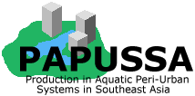

PAPUSSA Activities Report

Ornamental Fish Study Tour in Bangkok on 4-7th April2006

By Wanwisa Saelee (Hall)
AARM/Asian Institute of Technology
PO Box 4, Klong Luang, Pathumthani 12120, Thailand

Study Tour Organisers and Guides

Ms. Wanwisa Saelee Staff, Asian Institute of Technology, BKK

Prof. C. Kwei Lin Consultant, Asian Institute of Technology, BKK

List of Participants

1. Mr. Nguyen Van Lan Chairman of the HCMC Tropical Fish Association and vice chairman of the HCMC Ornamental Creatures Association

2. Mr. Vo Van Sanh (Ba Sanh) Fresh water Ornamental fish farmer from Binh Thanh District, HCMC

3. Ms. Vo Thi Uyen, Farmer in ornamental fish breeding and grow-out (partial self-
support)

4. Trinh Bien, HCMC Department of Agriculture and Rural
Development, Ornamental Fish Management Division

5. Le Van Quy, HCMC Department of Aquatic Resources Management,
Import-Export Ornamental Fish Division

6 Do Viet Nam, UAF's student, ornamental fish trader, working on
ornamental fish thesis (self-support)

7. Dr. Vu Cam Luong Lecturer – Ornamental fish project, Nonglum (UAF)
University, HCMC

8. Mr. Nguyen Thanh Tam Junior Lecturer – ornamental fish project, Nonglum
(UAF) University, HCMC

4th April 2006 (Tuesday)

On 4 Apr 2006, we picked up the 8 participants from Ho Chi Minh City (HCMC) from Don Muang Airport at the beginning of the ornamental fish study tour in Bangkok between 4-7th April 2006. The idea for this visit originated and developed from a study within the PAPUSSA project on the current state and potential of ornamental fish production in peri-urban areas of Ho Chi Minh City based on a comparison with Bangkok and its surrounding provinces in Thailand.
As the host, I planned to bring them to observe the activities that the Department of Fisheries (DOF) undertake to support ornamental fish farmers in Thailand and what is done in order to get a health certificate.
We then proceeded to the “Regional Community Forestry Training Centrer for Asia and the Pacific” which belongs to the Thailand Collaborative Country Support Programme (RECOFTC) where they were to stay during this trip. This place was very quite near to Kasetsart University and the Department of Fisheries and with a reasonable price (600 Baht for a standard double room). (http://www.thaicf.org/

5th April 2006 (Wednesday)

We had an appointment at 8.30 in front of the RECOFTC.

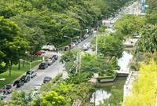
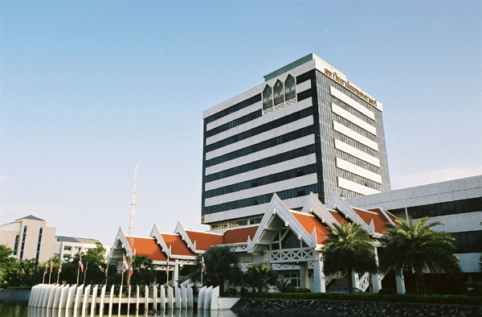
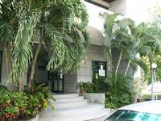

Figure 1 Kasetsart University and the Regional Community Forestry Training Centre for Asia and the Pacific

- Visit to the Aquatic Animal Health Research Institute (AAHRI)

Thanks to Prof. Lin and on behalf of his wife (Dr. Kamonporn) who used to work as the Director of this Institute, we had very good care from the DOF officer and staff there. The AAHRI Officer Dr Tithiporn Laoprasert who is a fish health research expert gave a presentation to the group on the mandate and work of AAHRI. This included fish health research, fish disease control and inspection, drug and chemical control, aquatic animal clinic, training and collaboration. After her presentation we visited the aquatic animal clinic (which is open five days a week to serve fish farmers, fish exporters and fish fanciers). We also examined the process of obtaining health certification for exporting fish. Both services are provided free of charge by AAHRI. Staff often visit fish farms at the farmers request to provide further advice on disease prevention and health management. The participants were also invited to visit the virus laboratory.

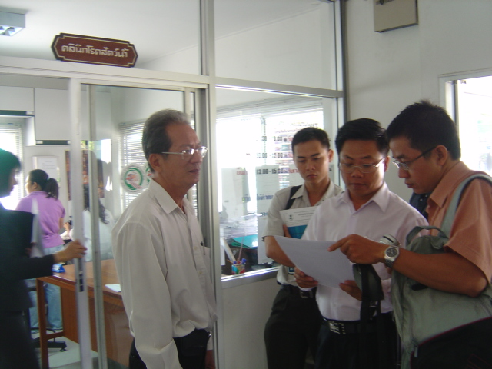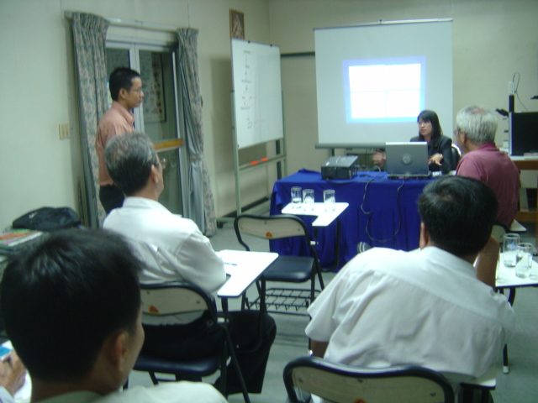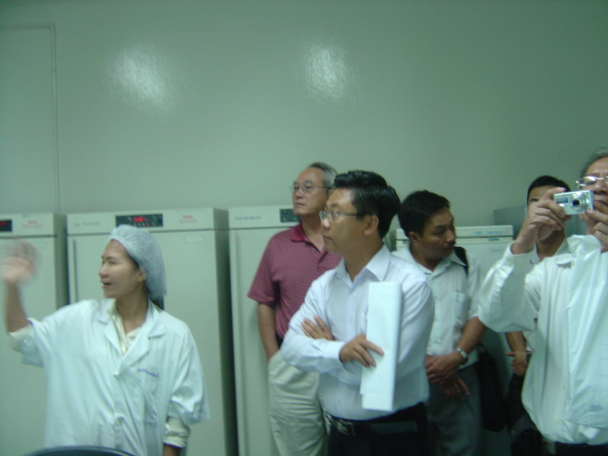
Figure 2 Visit to the AAHRI
2. Visit of Bangkok Aquarium and the Aquatic Plant Research Institute

After having visited the Bangkok Aquarium for an hour, the DOF staff kindly showed us the Aquatic Plant Research Institute which is located on the 5th floor of the building nearby.

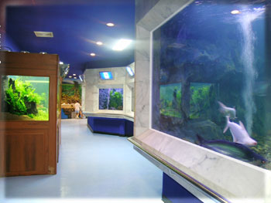
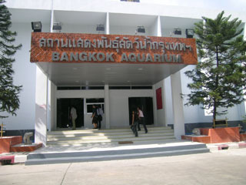
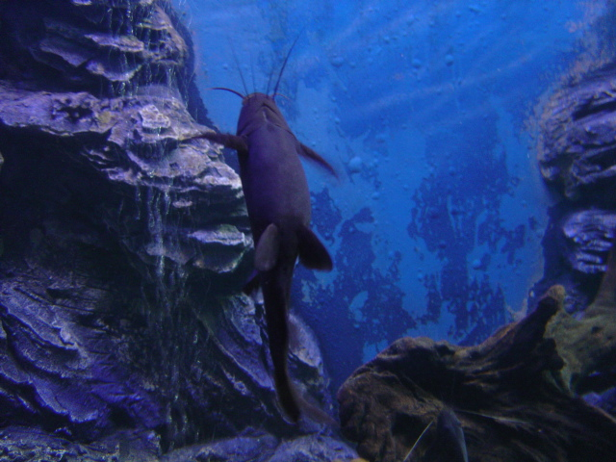

Figure 3 Visit to the Bangkok Aquarium

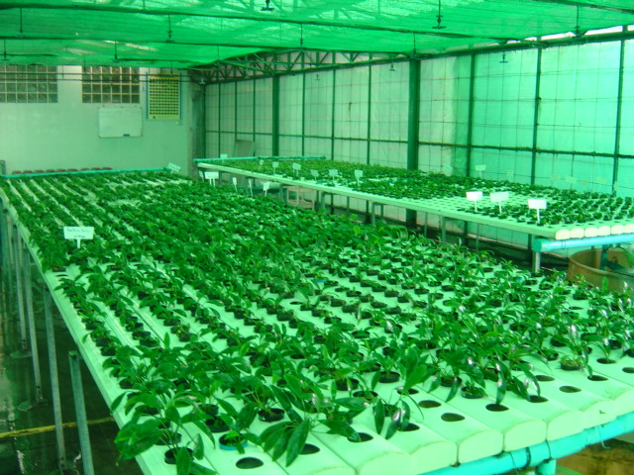
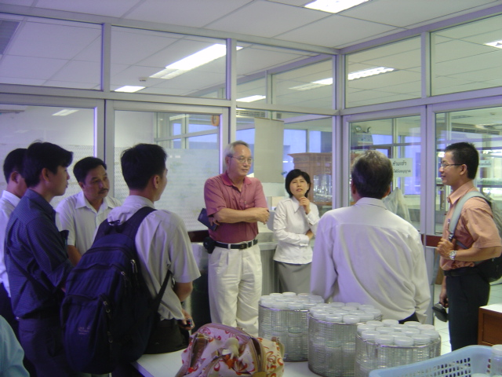
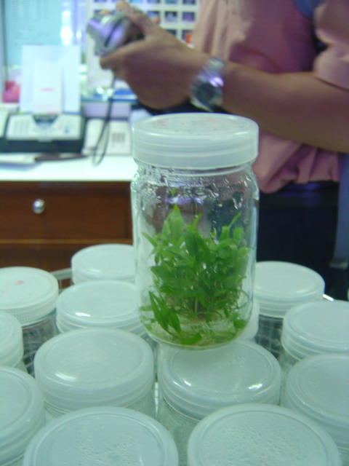

Figure 4 The Aquatic Plant Research Institute

In the afternoon we visited the biggest Goldfish farm in Thailand (THAI SUWAN INTER) (http://www.ranchushop.com/Thaisuwan). This farm imports several varieties of goldfish from Japan and sells in Thailand. For the visiting group it is a very good example of farm management following the DOF regulations. There is something here that Vietnam doesn’t have yet but we hope that this trip will give them some ideas on how to improve their farm management and develop their own regulations to support the ornamental fish import-export in the future.
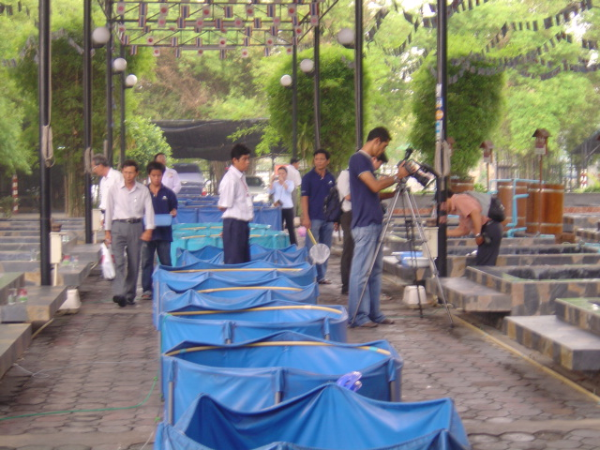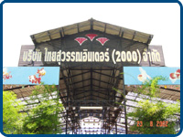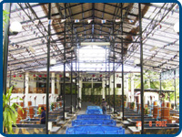
Figure 5 Visit to Thai Suwan Inter (Goldfish Farm)
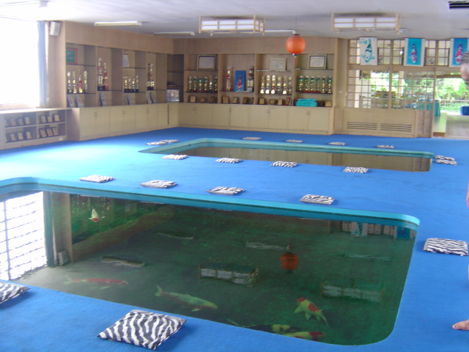
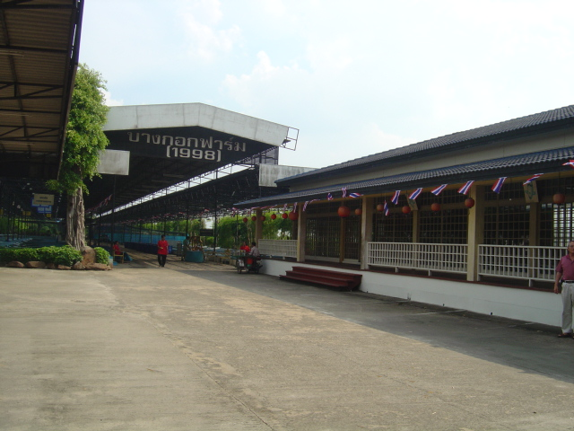
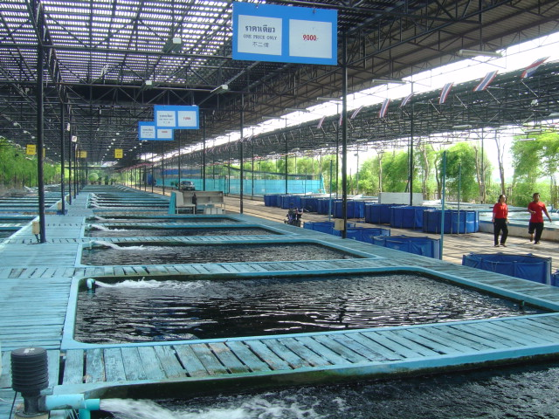

Figure 6 Visit to the Fancy Carp farm (Bangkok Farm)

In the late afternoon we visited a fancy carp farm which used to be the first farm that combined a fish farm and a leisure time activity at the same place. Normally this farm opens everyday for the people to visit the fish farm (free of charge). You can have a look at the fancy carp both indoor and outdoors. High quality fancy carp are ready for sale here (quite expensive but reasonable considering the quality).

6th April 2006 (Thursday)

- Visit the Guppy Farm at Nakhorn Pathom Province

On Thursday we started early morning to visit the Guppy fish in Nakhorn Pathom which is located 50 km out of Bangkok. Thanks to Dr. Ruangvit, (Papussa Project Principal Investigator, Kasetsart University, Bangkok) who introduced me to Mr Frank, the owner of the Guppy fish shop, we had his kind guidance during the whole days trip.

We then had an appointment in front of the Thai Wax Museum in Nakhorn Pathom and then headed to visit Mr. Chaiya’s Guppy fish farm which is located 2 km from the museum.

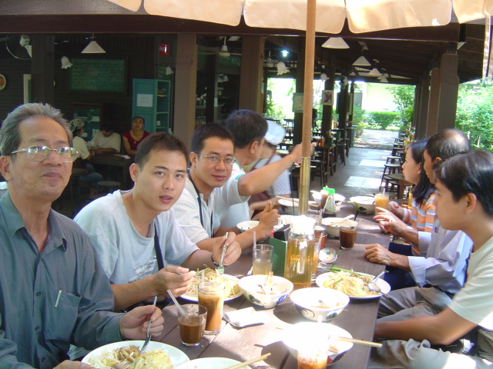
Figure 7 Hungry work!!! The Group having Pho Thai for breakfast along the road to the guppy farm

Mr.Chaiya is the owner of Chaiya Guppy fish farm which has more than 200 cement tanks (size 2mx2mx50 cm high) which are well organized in an area of 0.25 ha. He breeds and nurses/ongrows guppy fish until market size and then sells to the export companies. Mr. Chaiya incomes is about 5,000 US$ per month with only 3 family members working on the farm, a highly successful business.
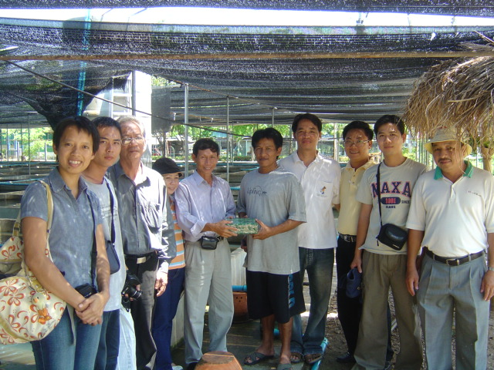
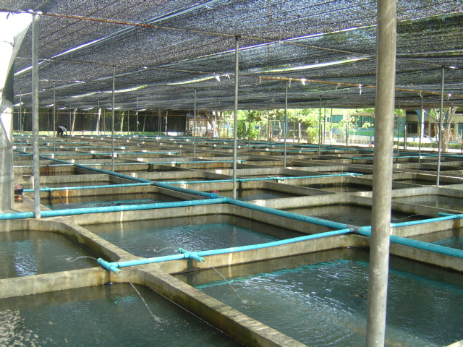
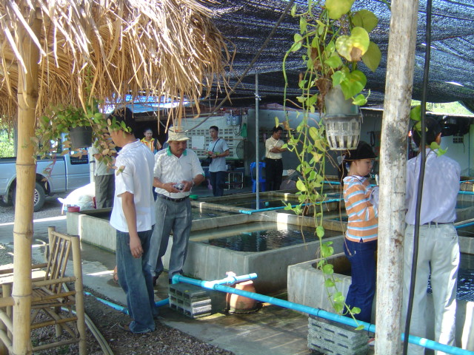

Figure 8 Visited the Guppy fish Farm
2. Visit Mahachai 2 and Chatuchak Market

After visiting the guppy fish farm, Mr. Frank and his wife kindly brought us to the Mahachai Market 2 which is similar to The Chatuchak Market in Bangkok but double its size. He showed us and introduced us to many of the owners of the fish and pet shops in the market, as we had in our group Mr. Nguyen Van Lan, chairman of the HCMC Tropical Fish Association and vice chairman of the HCMC Ornamental Creatures Association. Mr. Lan wanted to invite the Thai ornamental fish farmers to join the first ornamental creatures’ festival in HCMC on September 2006. The group participants were interested by many of the fish shops at the market as they were thinking to export fish to Vietnam during this time and looking into potential other new markets nearby.

After having spent some time visiting Mahachai Market 2 we moved back to Bangkok as the next destination was Chatuchak Market, which besides its reputation as the weekend market of Bangkok, is also known as the biggest wholesale market of ornamental fish in Thailand. We were very lucky that Thursday was an official holiday and most of the fish and pet shops were open so we spent almost 2 hours there.

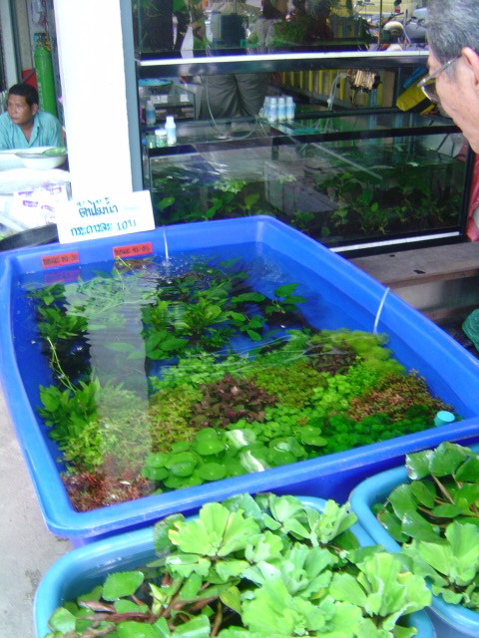
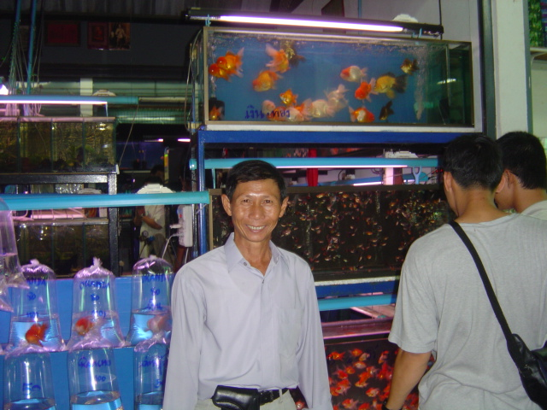
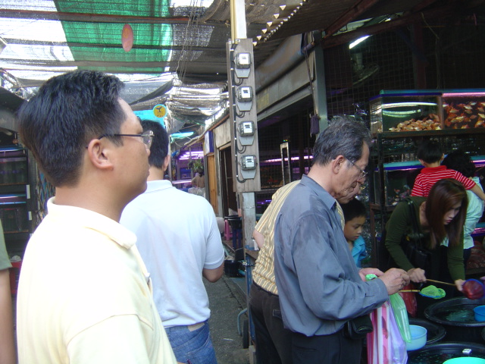

Figure 9 Visit to the Mahachai 2 and the Weekend Market Chatuchak Market

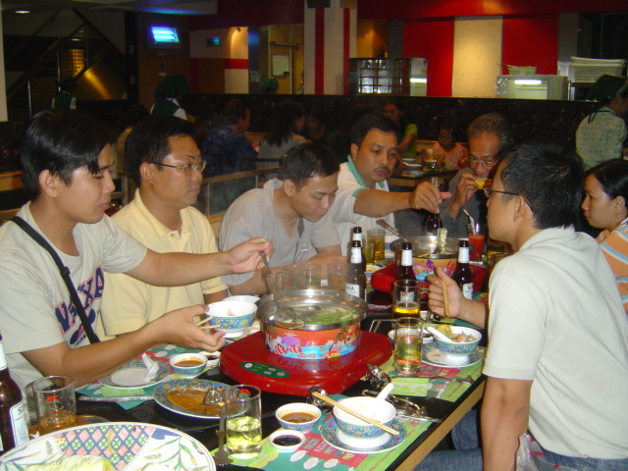
Figure 10 Group Dinner at MK Suki, Siam Square as there was a popular demand to bring them to visit Siam Paragon in the evening

7th April 2006

1. Visit to the Aquatic Plant Company (White Crane Aquarium, 1999)

The last day of the ornamental fish study tour in Bangkok, was to visit an aquatic plant company as requested by the participants after the first day, when they visited the Aquatic Plant Research Institute of DOF Thailand. We were invited by the White Crane Company which is one of the 2 biggest producers of ornamental plants in Thailand. This company is located in Chachengsao Province, about 50 km distance from Bangkok and we needed to be back at Don Muang Airport at 1pm, so this was tight schedule but we proceeded and took a risk to go through the famous traffic jams of Bangkok.

Mr. Vichai Tienrungsri, the owner of the White Crane Aquatic Plant Co. was very kind to show us everything about his business. The participants were very interested because ornamental plants are very expensive and are becoming popular in HCMC. Khun Vichai showed us everything in his farm without hiding anything which was very kind of him indeed. It was a pity that we had a very limited time to stay there, but we then said goodbye and left his farm at noon to rush for the airport.

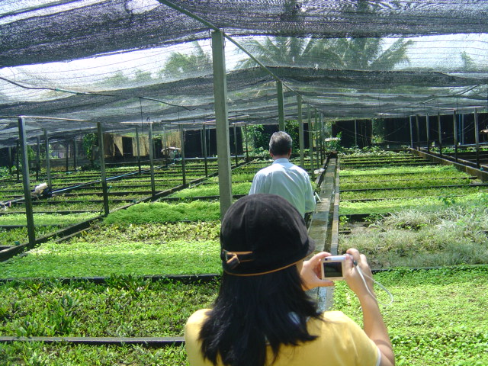
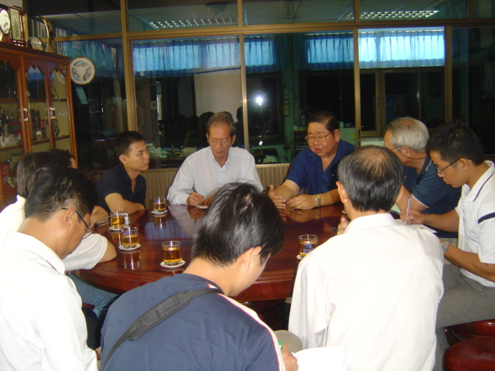
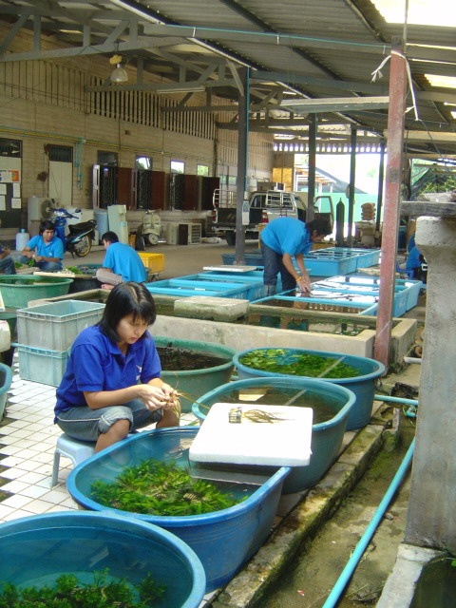

Figure 11 Visit to the White Crane Aquatic Plants company

Special Thanks to;

1. The Aquatic Animal Health Research Institute (AAHRI)
Department of Fisheries, Kasetsart University Campus, Jatujak Bangkok 10900 Thailand.
Tel: (662) 579-4122, 579-6803 and 579-6977 Fax: (662) 561-3993
Website; http://www.fisheries.go.th/aahri

2. White Crane Aquarium (1999) Co., Ltd.
11/1 Moo 21, Saladang 5, Bangnampraew,
Chachoungsoa, 24000, Thailand
Tel. +663 8845222, +663 8593111
Fax. +663 859311

3. Thaisuwan Inter (2000) Co., Ltd.
. 22/25 Moo 2 Sukontarot Rd., Lardprao, Bangkok, 10230, Thailand
Tel. +662 9078823-5
Fax +662 9078826
4. Bangkok Farm Co., Ltd.
45 Ramindha km 26, Safari World Bangkok
Tel +662 914-1527-8

5. Mr. Chaiya Subin (Guppy Fish Farm)
43 Moo 1 Tambol Khunkaeow, Nakronchaisri District, Nakonprathom Province, 732110
Tel. +669 7674170

Summary

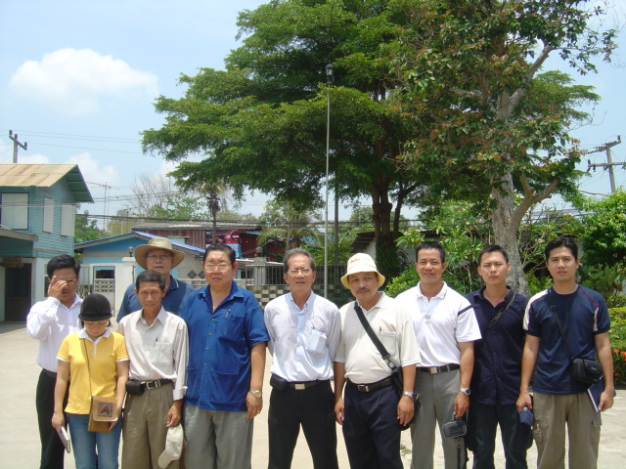

This trip included 3 full days, visiting a number of several places that were related to the ornamental fish and plants business sector. Hopefully the participants were happy and got a lot of experience from their tour around Bangkok. More similar trips would be a great opportunity for both Thai and Vietnamese farmers to exchange ideas and knowledge or do business together in the future.
At the end I would like to convey my thanks to Prof. Lin for his kindly support all through the three days and his very much helpful connections. Thank you very much to Khun Frank and his wife, Khun Chaiya Guppy fish farm and to Khun Vichai at White Crane Company.
We have also encouraged and hope our Vietnamese visitors will on their return to HCMC share and disseminate out their experiences and knowledge gained from this visit to their colleagues and a wider audience in HCMC.

