INCO: International Scientific Cooperation Projects (1998-2002)

Contract number: ICA4-CT2002-10020
Comparative Ornamental Fish Industry Study Bangkok and HCMC



Title: Production in Aquatic Peri-urban Systems in South East Asia:
The Current State and Potential of Ornamental Fish Production in Bangkok, Thailand.

Wanwisa Saelee

PO Box 4, Aqua Outreach Programme, Aquaculture and Aquatic Resources Management Field of Study, School of Environment, Resources and Development, Asian Institute of Technology, Khlong Luang, Pathumthani 12120, Thailand

Project homepage : http://www.papussa.org

Keywords : (5 maximum) Aquaculture, peri-urban, south-east Asia

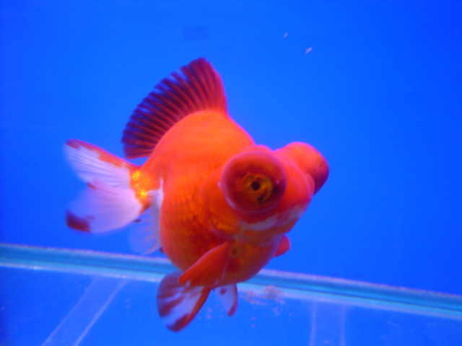
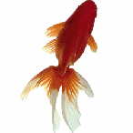
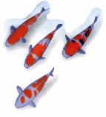
TITLE : PRODUCTION IN AQUATIC PERI-URBAN SYSTEMS IN SOUTHEAST ASIA

COORDINATOR

University of Stirling  Institute of Aquaculture  Stirling  FK9 4LA  UK | Dr Little, David  E-M : d.c.little@stir.ac.uk  TEL :44-1786-467923  FAX : 44-1786-472133
CONTRACTORS

The Royal Veterinary and Agricultural University  Dept. Veterinary Microbiology  Stigbojlen 4  Frederiksberg  1871  Denmark | Dr Dalsgaard, Anders  E-M : ad@kvl.dk  TEL : 4535282720  FAX : 4535282757
The National Institute of Hygiene and Epidemiology  Dept. of Microbiology  1, Yersin St.  10000, Hanoi  Vietnam | Prof Cam  E-M : cam@fpt.vn  TEL : 8448219074  FAX : 8449715470
University of Durham  Dept. of Geography  South Road  DH1 3LE, Durham,  UK | Dr Rigg, Jonathan  E-M : j.d.rigg@durham.ac.uk  TEL : 441913747305  FAX : 441913742456
Research Aquaculture No. 1  Dept. of Aquaculture  Dinh Bang, Tuson  Bac Nin  Vietnam | Dr Pham, Anh Tuan  E-M : patuan@fpt.vn  TEL : 8448781084  FAX : 8448273070
The University of Agriculture and Forestry  Faculty of Fisheries  Quan Thu Duc  Ho Chi Minh City  Vietnam | Dr Le Thanh Hung  E-M : lthunggts@hcm.vnn.vn  TEL : 84-8-8963343  FAX : 84-8-8963343
Royal University of Agriculture  Faculty of Fisheries  POBox 2696  Dangkor District  Phom Penh  Cambodia | Mr Chhouk, Borin  E-M : chhoukborin@hotmail.com ; 012898095@mobitel.com.kh  TE L : 855-12-898-095  FAX : 855-23-219-690
Kasetsart University  Dept. of Aquaculture, Faculty of Fisheries  Phaholyothin Road  10900  Bangkok  Thailand | Dr Yoonpundh, Ruangvit  E-M : ffisrvy@ku.ac.th  TE L : 662 5792924  FAX : 662 5613984

List of Contents

1. Introduction…………………………………………………………………. 4
2 General Information about Ornamental fish trade in Thailand………….4
3 Ornamental fish production from central Thailand……………………... 12
4 References……………………………………………………………………18
5 Appendix 1: List of ornamental fish species……………………………….19
6 Appendix 2: List of Cichlids Species Successfully Bred in Thailand……..23
7 Appendix 3: Diagnostic Requirements for Regional Quarantine and
Health Certification Attempt for Regional Harmonization……………….29

1. Introduction

The ornamental fish industry in Thailand has now developed into a significant income generating sector within the Thai economy with Bangkok and its surrounding provinces being at the hub of this growing industry. The culture of ornamental fish can result in rapid cash production and is relatively easy to start as many of the current growers were able to begin their businesses as a hobby or small scale farming enterprises. Thailand has a richness of natural resources such as suitable climate, natural rivers and traditional experience in the culture of fish so that the Thai farmer can readily culture ornamental fish. Presently it is estimated that more than 3 thousand families in Thailand are producing ornamental fish (Nattapol, 2003) with an export value of currently around 1,000 million baht (25 million US$) per year. This indicates the scale and the number of people in Thailand working within this industry.

Recently the ornamental fish industry in Thailand has been developing very fast as we can see from the increasing number of wholesale markets primarily located in and around Bangkok which now has 5 wholesale markets in Bangkok and 2 wholesale markets in Ratchaburi Province which is located 100 km from Bangkok. There has also been a corresponding growth in the related media available with many specialised ornamental fish magazines and books now available in Thai, whilst the internet has allowed increasing access for producers, traders and consumers alike to easily find information about ornamental fish and ornamental fish and plant shops. It is now possible to buy every kind of ornamental fish and plant through the internet from many countries around the world. This technology becomes more worldwide and is a very important tool in the international growth of the ornamental fish market.

Many indicators show that the ornamental fish sector in Thailand has sharply increased in the last ten years and still has very good prospects in the future, especially in the number of ornamental fish exporters in Thailand which is increasing from 70 companies in 2001 to more than 150 companies in 2005 (Pet-Mag magazine no.73, 2005). Currently the domestic market for ornamentals within Thailand is only 10 to 15% of the fish produced in the country with most of the growth in the industry occurring through the export sector.

The objective of this review is to describe the current status of the production, distribution and associated market channels for freshwater ornamental fish in peri-urban Bangkok. It is also part of a larger survey which will also involve comparisons with the current state of ornamental fish production in peri-urban, HCMC, Vietnam.

2. General information about ornamental fish trade in Thailand

Thailand has a very high potential for producing ornamental fish because of its suitable environment and climate as a tropical country. The ornamental fish exporting industry started in Thailand around 1962 and the Thai exporters have got at least a 10% share of the market within Asian countries. The total value of ornamental fish sales throughout the world in the present day is more than 10,000 million Thai Baht per year (25 millions US$). This does not include the sale of aquarium equipment which makes up more than 2,000 million Thai Baht per year (50 million US$) and is still expanding. 90-95% of ornamental fish produced in Thailand are freshwater ornamental fish such as Guppies, Gold fish and Discus etc. with less than 5% marine ornamental fish since Thailand has strict regulations in the capture and trading of marine animals and plants unlike the Philippines and Indonesia who currently export the bulk of marine ornamental fish often using non sustainable methods of capture.

  - The distribution and marketing network for ornamental fish in Thailand

The ornamental fish database from Department of Fisheries showed that in 2001 in Thailand there were more than 1,500 freshwater ornamental fish producers with more than 350,000 people involved within the freshwater ornamental fish sector. The distribution and marketing network for ornamental fish in Thailand is relatively well organized and is described as follows: Wild collectors of the fish are small-scale fishermen who work in small groups in different areas of the country. Fish from the wild are usually collected at the beginning or during the late flooding season (June - October) depending upon the type of fish. Most of these collectors are well trained by wholesalers or exporters who also provide them with initial advance payments prior to delivery of the fish. The fish are then kept in good conditions until sent for stocking in a quarantine unit similiar to a nursing pond until fish have been transferred to the breeder depending on their agreement (Sidthi and Amornrat, 2003). Breeders usually restrict themselves to breeding of limited fish varieties. Discus and other valuable fish breeders are mostly located in downtown Bangkok with specialized tank/ aquarium recirculating systems where they can obtain a good quality municipal mains fresh water supply. Other breeders are mostly located near irrigation canals. It is a mandatory requirement for fish rearing facilities to obtain a license from the Department of Fisheries which then sends biologists to check the sanitary conditions of the facilities. Suppliers collect fish either from the breeders or from middlemen/ collectors before selling them on to exporters, wholesalers, and retailers or directly to the public. Exporters buy fish from the suppliers or their contract collectors. The fish are then acclimatized in quarantine units. The quarantine period can last from few days to few weeks depending upon the health condition of the fish and personal experiences of the exporter. The distribution and marketing network for the ornamental fish market in Thailand is shown below in Figure 1:
Wild collectors

Exporters
≥ 85% international market
Breeders

Suppliers

Retailers
Public
Wholesalers
Import brood stock
10-15%: local market

Figure 1 The distribution and marketing network for the ornamental fish in Thailand
  - Ornamental fish markets of Thailand

1.) Local retail shops and markets

For the local market in Thailand there are more than 1,000 ornamental fish stores countrywide, with 50% of these located within the Bangkok area and the rest in regional centers such as Chiangmai, Phuket, Nakornratchasrima, Khonkaen and Udonthani provinces (Figure 2).

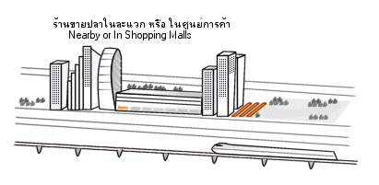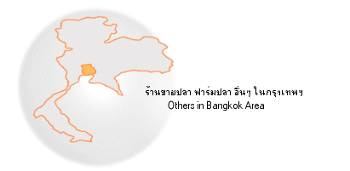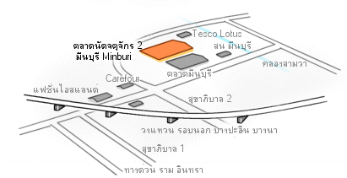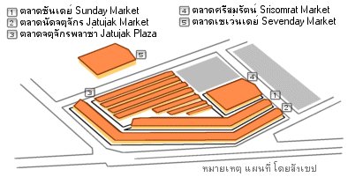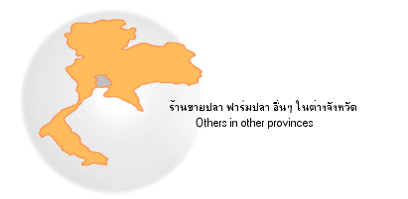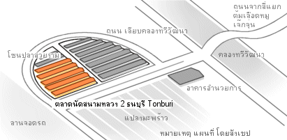

Figure 2 Map of the ornamental fish markets in Thailand

- Jatujak Market

The biggest wholesale market for ornamental fish in Bangkok is located at Jatuchak Sunday market area and is open from Tuesday early morning until Wednesday evening. This market is the oldest in Bangkok. Its infrastructure is well organized and it functions as both bidding wholesale market for producers, suppliers, collectors and retailers in Bangkok and surrounding peri-urban areas, whilst it is also has retail outlets which are open for members of the public at the weekend. There are more than 122 ornamental fish shops registered within Jatujak Market administration office. Each area within the market specializes in different species such as arowana, betta, cichild, goldfish, other fish, aquatic plants and accessories shops as shown in Figure 3 below:

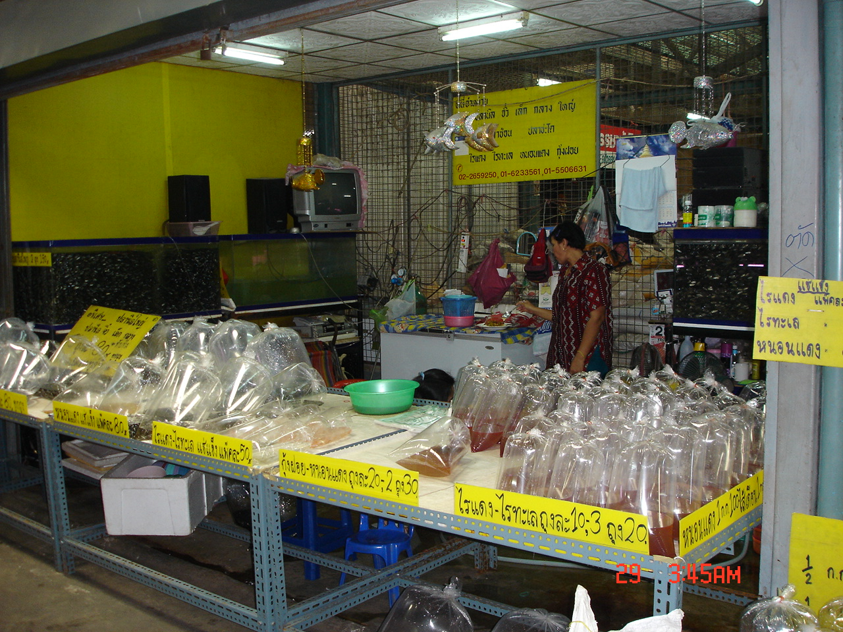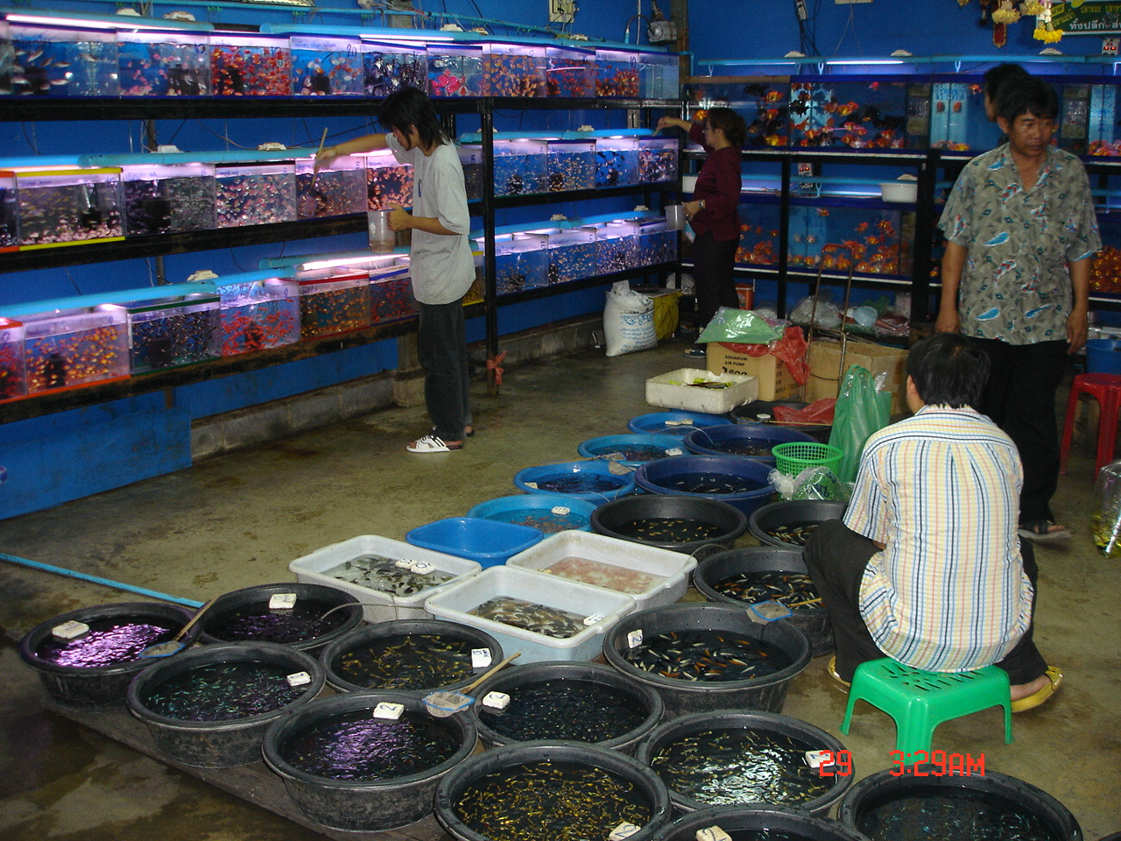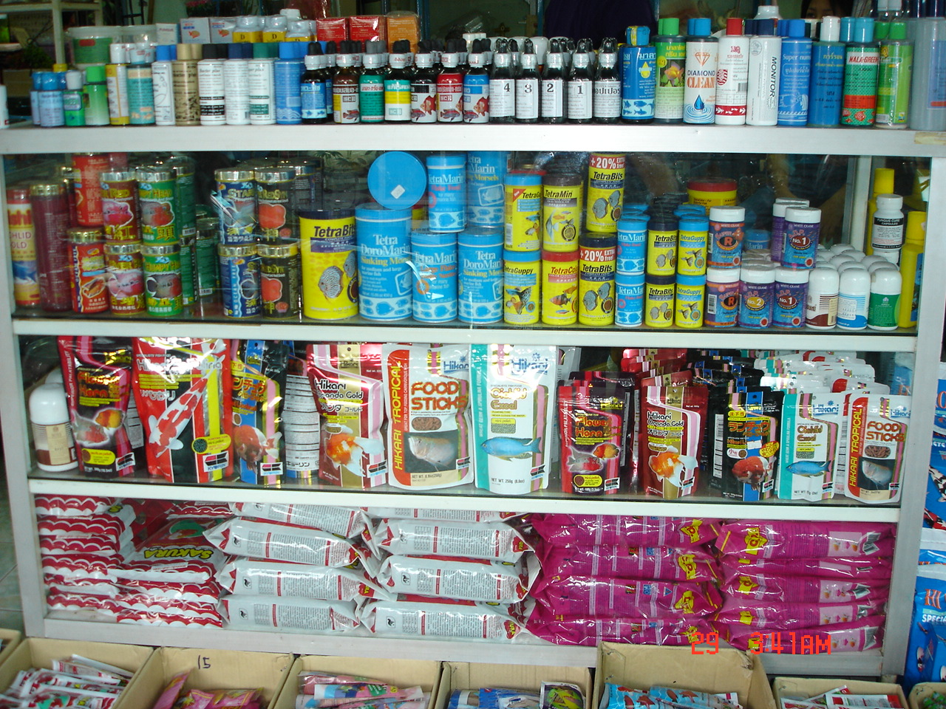

Figure 3. Jatujak Sunday Market in Bangkok – different types of stores within the market.

- Other markets

Other markets in Bangkok, as shown in Figure 4, include 2 new wholesale markets called Fish Zone are located in 2nd Jatujak at Meanburi and Thinburi Markets which have many ornamental fish and accessories shops in the same area. Another wholesales market is located at Ratchaburi province, an area 140 km outside Bangkok where many freshwater ornamental fish are produced in earthen ponds.

Figure 4 Ornamental fish shops in Thailand 2005
** Total 1,047 shops in Thailand, data from www. Ninekaow.com/fishstore

2.) Export Markets

Considering the actual number of ornamental fish exported from Thailand statistics from the Thai Customs Department and the Department of Fisheries show that the volume of ornamental fish exported from Thailand is increasing every year. However most of these data tend to under- estimate the export volume (Sidthi and Amornrat, 2003).

Table 1. Export Statistics for Ornamental Fish from 2001 to 2005 from the Thai Customs Department
Year | 2001 | 2002 | 2003 | 2004 | 2005 (Jan-Jun)
Value in Thai Baht | 989,702,658 | 797,595,941 | 755,521,561 | 837,571,036 | 436,661,771
Importing Countries | 77 | 73 | 77 | 83 | 72

***1 US$ ~ 40 Baht

This export market of Thai Ornamental fish can be separated into 2 groups as shown below:

2.1) Imported for sale in their country only

United States and Japan are the most important customers for this market. U.S.A. is the biggest ornamental fish market in the world according to USA market with no taxes for fish importing and exporting. Most of the ornamental fish that the U.S.A imports from Thailand are small fish such as Betta (Siamese fighting fish), Koi Carp, Guppies, Cichilds and Discus.

Table 2. U.S. Imports for Consumption Statistics of Fish, Ornamental, Live: Customs Value by HTS Number and Customs Value for all Countries (Annual+ Year-To-Date (YTD) Data from Jan-May)

HTS Number | Num of country by importing value | Country | 2004 | 2004 |  | 2005 | Percent Change 2004-2005
HTS Number | Num of country by importing value | Country | In 1,000 Dollars |  |  |  | Percent Change 2004-2005
0301100000 Fish, Ornamental, Live | 1 | Singapore | 8,474 | 3,620 | 3,521 |  | -2.70%
0301100000 Fish, Ornamental, Live | 2 | Thailand | 8,376 | 3,723 | 3,782 |  | +1.60%
0301100000 Fish, Ornamental, Live | 19 | Vietnam | 237 | 113 | 106 |  | -6.20%

For the Japanese market, indigenous and high value fish are required, especially, larger sizes as they can save time and money in growing them. From 1998-2002, Thailand increased the value of its exported ornamental fish to Japan every year until 2003 when the value dropped 50% due to economic decline and the Koi Carp disease (Koi Herpes Virus, KHV) which was found in cultured common carp causing mass mortality of common carp and Koi in Japan since 2002 (Nagasawa, Fish for the people, v.2 num. 3:2004). This had severe implications and directly affected the worldwide market and sales of Koi Carp. However, despite this Japan is still one of Thailand’s most important customers for ornamental fish.

Figure 5 Export Statistics of Ornamental Fish to Japan from 2001-2004
* Data from the Thai Customs Department

  - Importing for Re-export Market

The important customers who are importing fish from Thailand for the purpose of re-export again are Singapore and Hong Kong which are very big competitors in ornamental fish market throughout the world. Both have very high technology based infrastructure within their industries allied to relatively low costs of shipment compared to Thailand.

Figure 6 Exporting Statistics of Ornamental Fish to Hong Kong and Singapore from 2001-2004
*Data from the Thai Customs Department

From these two main markets for Thai ornamental fish exports which, include 4 important importing countries: U.S.A., Japan, Singapore and Hong Kong. Export statistics from the Thai customs Department from 2001-2004 show that these 4 markets importing ornamental fish from Thailand as 91.24, 79.10, 71.32 and 65.10 percentage of their total export value. The results show a very high exporting value in 2001 at 91.24% but it decreases to 65.10% because of the Koi Carp disease outbreak in Asia and Thai fish are more open to European markets.

Figure 7 Export Statistics of Ornamental Fish exported from Thailand to its 4 main markets from 2001-2004
*Data from the Thai Customs Department

  - Other Markets

- European markets

European markets become more and more important for the Thai exporter as we can see the trend of exporting value is steadily continuing to increase (see Figure 8). The main importing countries are France, Germany, Poland and UK. For exporting ornamental fish to European countries high quality fish are essential as well as the need for official health certification. However during the winter season in Europe demand declines so that most of the ornamental fish farmers will produce less fish between October until January each year.

- Other markets.

Thailand is now the. 3rd largest producer of ornamental fish in Southeast-Asia and is increasingly well-known as a fish breeder with potential to produce large volumes of ornamental fish and plants throughout the year due to its climate. Other markets of fish exporting are extending to Africa, Middle East of Asia and other countries that have such a bad condition for breeding fish such as temperate countries: Korea, Canada and Australia or some countries in the region for example India, Sri Lanka and Malaysia who still need to develop their own breeding technology.

Figure 8 Exporting Statistics of Ornamental Fish to European Markets from 2001-2004
*Data from the Thai Customs Department

3. Ornamental fish production from Thailand
3.1 Major Species of Ornamental Fish in Thailand
Freshwater ornamental fish are originally collected from the wild and cultured in the aquarium. More than three hundred different species such as shark, barb, Siamese fighting fish, catfish, golden fish, scar venture, eel, loach, rasbora, gourami, botia, knife fish, brackish, oscar, discus, livebearers and carp are now being bred by small family farms (Appendix 1). More recently, African and American cichlids began to become available to dealers and hobbyists. The number of these new species that have been discovered and imported to Thailand is around two hundred fifty. Almost all of them are now being successfully bred, grown and exported mainly from the central part of the country surrounding Bangkok (Appendix 2.).
Ornamental fish species for export from Thailand can be separated as below.
- Siamese fighting fish
- Native Thai freshwater fish (Epalzeorhynchos sp.) for example: Red fin shark, Red tail shark, Silver Shark and etc.
- Vivaparous fish
  - Guppy fish (Poecilia reticulate) which is name by the body color for example: Neon tuxedo guppies, Goldren tuxedo guppies, King Cobra guppies and etc.
  - Mollies (Poecilia latipinna) including Balloon and Platy (Xiphophorus sp.)
- Gourami (Colisa sp.): Dwarf gourami, Blue dwarf gourami, Diamond gourami and etc.
- Golden fish (Carassius sp.): Runchoo, Hollunda, Comate and etc.
- Discus (Symphysodon sp.) name by body colour and ลวดลาย as follow; Brown discus, Red turquoise, Green and blue, Snake skin, Solid pigeon blood and Spotted discus.
- Angel fish (Pterophyllum sp.): Half black angel fish, Marble angel fish for example.
- Oscar (Astronotus sp.) have different colour for example: Tiger oscar, Golden oscar, Albino red oscar and etc.
- Barb (Puntius sp.): Tiger bard, Red cheek barb and etc.
- Peacock fish (Aulonocara sp.): Sunshine peacock, Red peacock, Blue peacock and etc.
- Other fish: some native freshwater species under CITES including Jullian's brook (Probarbus jullieni), Mekong giant catfish (Pangasius gigas), Asian arowana (Scleropages formosus) are also prohibited for export. In addition three native freshwater species of Dwarf clown loach (Botia sithimunkii), freshwater batfish (Oreoglania siamensis), and Siamese tiger perch (Colus microlepsis) are prohibited for export under the Thai wildlife protection act 1992 (Sidthi and Amornrat, 2003).

Figure 9. A t l a s o f F r e s h w a t e r F i s h e s
Siluriformes    • Mochokidae ปลากลับหัว Synodontis  • Loricariidae ปลาซัคเกอร์  • Pimelodidae ไทเกอร์โชว์เวลโนส ซีบร้าไทเกอร์  • Pangasiidae ปลาสวาย ปลาบึก ปลาเทโพ | Perciformes    • Cichlidae ปลาหมอสี  • Belontiidae ปลากัด ปลากระดี่  • Coiidae ปลาเสือตอ ปลากะพงลาย
Cyprinodontiformes (ปลาหางนกยูง คิลลี่ฟิช)    Poeciliidae ปลาหางนกยูง ปลาสอด | Gymnotiformes (ปลาไหลผี แบล็คโกสต์)    Apteronotidae ปลาแบล็คโกสต์
Characiformes (ปลา Characins ชนิดต่างๆ)    • Characidae นีออน พาคู้ ปิรันย่า | Cypriniformes (ปลาคาร์พ ปลาตะเพียน)    • Cyprinidae ปลาคาร์พ ปลาทอง ปลาซิว  • Cobitidae ปลาหมู ปลาค้อ
Osteoglossiformes (ปลาตะพัด กราย งวงช้าง)    • Osteoglossidae ปลาอะโรวาน่า  • Arapaimidae ปลาอะราไพม่า | Lepisosteiformes (ปลาปากจระเข้ อัลลิเกเตอร์)    • Lepisosteidae ปลาปากจระเข้ ปลาการ์
Rajiformes (ปลากระเบน)    • Potamotrygonidae ปลากระเบนน้ำจืด อะเมซอน | Polypteriformes (ปลาบิเชีย รีดฟิช)    • Polypteridae ปลาบิเชีย รีดฟิช

3.2 Source of ornamental fish producers in Thailand
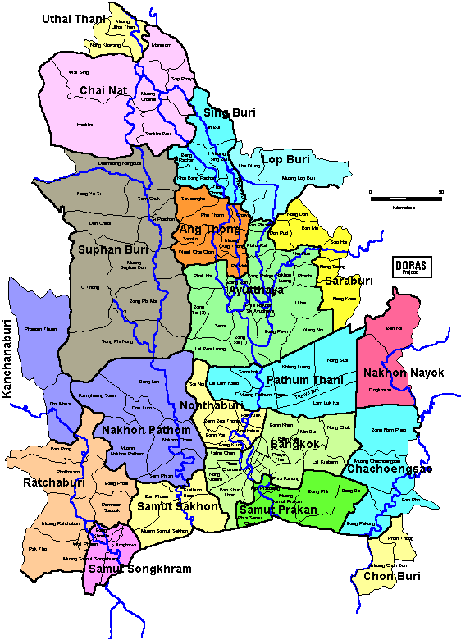
Ornamental fish producers in Thailand are distributed throughout Bangkok and other surrounding provinces nearby because the market is mainly in Bangkok and near the airport in case of shipment for international customers. Each area around Bangkok tends to specialize in producing different species of fish as the shown below:

Figure 10 Map of the central provincial area of Thailand
1. Bangkok metropolitan area is the source of high value fish producers and breeders of Discus, Oscar, Koi carp and Botia. Meanburi District specializes in Golden fish and Guppy farms.
2. Ratchaburi province is located in western central Thailand and produces the largest numbers of ornamental fish throughout the country. Most of the fish producers are located in Potaram and Banpong districts. Ornamental fish produced from this province are generally Golden fish and guppies. Native Thai freshwater fish are also popularly grown here such as Red fin shark, Red tail shark, and Silver Shark.
3. Nakonpathom province is the biggest producer of Siamese fighting fish in the country. Most of producers are located in Nakronchaisri district and specialize in the Chinese variety.
4. Chacheangsao province is an important region for producing many species of ornamentals including Mollies, Koi carp and guppies.
5. North-Central provinces of Thailand: Nakonsawan, Sukhothai and Supanburi Provinces have many food fish producers for example Barb, Gourami and Pangasius. In the meantime they also as a sideline sell fingerlings of these species to be used as aquarium fish due to high demand and competitive prices.
3.3 The ornamental fish exporting process
The ornamental fish exporting methodology
Producers
Collectors
Exporters
Exporting agency
Airway
Buyers

Figure 11 The ornamental fish exporting methodology

How to get a Health certificate or the permission for trading live fish from Department of Fisheries

The process for exporting ornamental fish from Thailand can be illustrated as follows:

1. The foreign buyer contacts the exporter (in Thailand) then the exporter waits for the order and (for some countries) sets an advance payment of 50% of the value of the fish. The exporter then contacts the Department of Fisheries in order to obtain get a health certificate (Appendix 3.)
If a person wishes to trade live fish of the species below they need to get permission from Department of Fisheries.

ปลาหมูอารีย์  (Dwarf clown loach)Botia sidthimunkii | 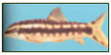
  ปลาช่อนยักษ์ (Arapaima)Arapaima gigas | 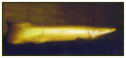
ปลาติดหิน  (Freshwater batfish)Oreoglanis siamensis | 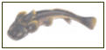
  ปลายี่สกไทย (Jullian’s brookcarp)Probarbus jullieni | 
ปลาเสือตอ  (Siamese tiger perch)Coius microlepis | 
  ปลาบึก (Mekong giant catfish)Pangasius gigas | 
ปลาตะพัด (Asian arowana) Scleropages formosus | 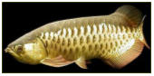

Figure 12 List of species that need official permission before trading

2. Whenever, ornamental fish farmers or exporters wanted to export their fish out of Thailand they need the health certificate from The Aquatic Animal Health Research Institute, DOF Thailand. And they need to send a required sample of each species of ornamental fish as shown in a previous paragraph. After the fish have passed the test DOF will give a health certificate to guarantee the fish have no disease following the standard diagnostic Bacterial, viral and parasite samples testing methods. This guarantee is for 7 days so, exporters need to ship their fish before the certificate expired date. If they cannot export ornamental fish on time they need to get a new health certificate from the DOF again even for the same group of ornamental fish.

The amount of aquatic animals sampled from exporters to send to The Aquatic Animal Health Research Institute, DOF Thailand for getting health certification is dependant on the number exported as shown below:

1. Number of aquatic animals for exporting 1,000 pieces, Required 10 pieces for testing
2. Number of aquatic animals for exporting 100-1,000 pieces, Required 5 pieces for testing
3. Number of aquatic animals for exporting 50-100 pieces, Required 4 pieces for testing
4. Number of aquatic animals for exporting 20-50 pieces, Required 3 pieces for testing
5. Number of aquatic animals for exporting less than 20 pieces, Required 2 pieces for testing
6. Need to separate ornamental fish in their bags/ packaging by species as shown in the invoice.

The Thai DOF has just started to issue a certificate for ornamental fish farms that pass “GAP”: (good aquaculture practice). DOF will send officers to check the ornamental fish farm twice a year by taking fish samples, checking the farm quality such as cleanliness, water quality, husbandry and fish quality. The farmer who has this certificate will be able to sell or export fish without a health certificate in the future. Presently there are 83 ornamental fish farms which have the GAP certificate and DOF Thailand is working very hard on pushing every ornamental fish farm to have a GAP before 2008.

Packing Details

After everything is done the fish are packed. All fishes are packed in double plastic bags with Styrofoam which is then placed inside a strong cardboard box size 60x45x32 cm. One box contains about 15.00 kg excluding individual packing which is about 20 kg per box. Normally the packing detail is dependent on the experience and techniques of the exporting company. The exporter can guarantee the fish within 24 hours after the fishes arrive at the buyers destination.

PAYMENT
Advance payment is requested in order to cover freight charge, packing charge, cost of fish and normally paid by Bank transfer, credit or Telegraphic Transfer (TT) dependent on the exporter’s individual conditions of sale. Some companies can give credit to buyers from between one - three months.
DELIVERY

The shipment is normally made within 3 days after receiving this payment.

References

Chapman, Frank A., Sharon A. Fitz-Coy, Eric M. Thunberg, and Charles M. Adams. 1997. United State of America Trade in Ornamental Fish. Journal of the World Aquaculture Society 28, 1 (March):1-10.

Department of Fisheries. 2005. Ornamental fish documents (Online). Available URL:
www.nicaonline.com/articles/site

Department of Fisheries, Thailand. 2005. (Online). Available URL:
http://www.fisheries.go.th/fish/web2/hotnews.php

Fishery Statistics Analysis and Research Group, 2004: Freshwater Fish Farm Production 2001. Fishery Information Technology Center, Technical Paper No.10/2003, Department of Fisheries, Bangkok., 65 pp.

Food and Agriculture Organization of The United Nations. 1977- 2003. FAO Fishery Statistics Commodities. Italy: Food and Agriculture Organization of United Nations.

Nattapon T., 2003. The Potentiality of Ornamental Fish Export of Thailand. Bangkok. Ramkhumhang University, 185 pp.

Parinya N., 2005. An Analysis on the Business System and Investment of Discus Fish Farming in Bangkok. Thailand. Kasetsart University., 85 pp.

Sidthi B And Amornrat S., 2004. The Current State of the Ornamental Fish Industry in Thailand. Department of Fisheries, Thailand. 22 pp.

.

The Customs Department. 2005. Import-Export Statistics (Online). Available URL :
http://www.customs.go.th/Statistic/StatisticIndex.jsp

Appendix 1: List of Ornamental Fish
Ornamental Fish Species Exported from Thailand
Native Ornamental Fish Species Successfully Bred in Thailand

Scientific Name | Common Name | Thai Name
Balantiocheilos melanopterus | Silver shark | ปลาหางไหม้
Barbodes altus Puntius altus | Red tail, Tinfoil barb | ปลาตะเพียนทอง
Barbodes gonionotusPuntius gonionotus | Common silver barb | ปลาตะเพียนขาว
Barbodes gonionotusPuntius gonionotus | Albino common silver barb | ปลาตะเพียนขาวเผือก
Barbodes schwanenfeldiiPuntius schwanenfeldii | Schwanenfeldiis tinfoil barb | ปลากระแห
Betta splendens | Siamese fighting fish | ปลากัด
Brachydanio albolineatus | Pearl danio | ปลาซิวสาละวิน
Chitala ornataNotopterus chitala | Silver clown knife | ปลากราย
Crossocheilus siamensisEpalzeorhynchos siamensis | Siamese fling fox | ปลาเล็บมือนาง
Epalzeorhynchos bicolorLabeo bicolor | Red tail black shark | ปลาทรงเครื่อง
Epalzeorhynchos frenatumLabeo frenatum | Red fin shark | ปลากาแดง
Epalzeorhynchos frenatumLabeo frenatum | Albino rainbow shark | ปลากาแดงเผือก
Gyrinocheilus aymonieri | Siamese algae eater | ปลาน้ำผึ้ง, อีดูด
Gyrinocheilus aymonieri | Golden algae eater | ปลาน้ำผึ้งเผือก
Helostoma temmincki | Kissing gourami | ปลาจูบ, ปลาหมอตาล
Hypsibarbus wetmorei | Golden belly barb | ปลาตะพาก
Leiocassis siamensis | Bumblebee catfish | ปลาแขยงหิน
Leptobarbus hoeveni | Golden shark, Pink tailed barb | ปลาบ้า
Morulius chrysophekadion | Black shark | ปลากาดำ, กา, เพี้ย
Mystus filamentus | Yellow mystus | ปลากดเหลือง
Osphronemus goramy | Giant gourami | ปลาแรด
Osphronemus goramy | Albino giant gourami | ปลาแรดเผือก
Pangasius larnaudii | Black ear catfish | ปลาเทโพ
Pangasius sanitwongsei | Chao phraya giant catfish | ปลาเทพา
Pangasianodon hypophthalmusPangasuis suitchi | Pangasius cat, Irridescent shark | ปลาสวาย
Puntius orphoides | Red cheek barb | ปลาแก้มช้ำ
Puntius partipentazona | Tiger barb | ปลาเสือสุมาตรา
Wild Native Ornamental Fish Species
Scientific Name | Common Name | Thai Name
Acantopsis choirorhynchos | Horse face loach | ปลารากกล้วย
Barara urophthalmoides | Least rasbora | ปลาซิวหนู
Bararas maculata | Spotted rasbora, Pygmy rasbora | ปลาซิวเพชรน้อย
Barilius pulchellus | Stream barilius | ปลาน้ำหมึก
Botia beauforti | Chameleon botia | ปลาหมูลาย
Botia eos | Red tail botia | ปลาหมูหางแดง
Botia helodesBotia hymenophysa | Banded botia, Tiger loach | ปลาหมูข้างลาย
Botia modesta | Yellow tail loach | ปลาหมูหางเหลือง
Botia modesta | Yellow tail botia | ปลาหมูขาว
Botia morleti | Shunk botia | ปลาหมูคอก
Chaca bankanensis | Angler catfish | ปลากระแมะ
Chitala blanci | Blanc's stripe featherback | ปลาตองลาย
Garra cambodgionsisGarra taeniata | Stone lapping fish | ปลาเลียหิน
Kryptopterus bicirrhis | Glass catfish | ปลาก้างพระร่วง
Macrognathus siamensis | Spotted spiny eel | ปลาหลดจุด
Macrognathus taeniagasterMacrognathus circumcinctus | Zigzag eel | ปลาหลดลาย
Mastacembelus armatus | Armed spiny eel | ปลากระทิงดำ
Mastacembelus erythrotaenia | Fire spiny eel | ปลากระทิงไฟ
Nandus oxyrynchus | Black tiger fish | ปลาเสือดำ, ดุมซี
Notopterus notopterus | Gray featherback | ปลาสลาด, ตอง, ฉลาด
Ompok bimaculatus | Butter catfish | ปลาชะโอน
Osteochilus microcephalus | Bonylip barb | ปลาร่องไม้ตับ, เลียหิน
Pangio kuhliiAcanthopthalmus kuhlii | Kuhlii loach | ปลาปล้องอ้อย
Puntius eugrammus | Striped barb, Zebra barb | ปลาตะเพียนลาย
Puntius lateristriga | T barb, Spanner barb | ปลาอีกอง
Puntius ticto | Stoliczkae's barb | ปลามุมหมาย
Rasbora boraptensis | Red tailed rasbora | ปลาซิวหางแดง
Rasbora dusonensis | Rosefin rasbora | ปลาซิวควาย
Rasbora espei | Lambchop rasbora | ปลาซิวข้างขวานเล็ก
Rasbora heteromorpha | Harlequin rasbora | ปลาซิวข้างขวานใหญ่
Rasbora sumatrana | Sumatran rasbora | ปลาซิวควายหางแดง
Rasbora trilineata | Scissor tail rasbora | ปลาซิวหางกรรไกร
Tetraodon nigroviridis | Spotted puffer | ปลาปักเป้าจุดดำ
Trichogaster leerii | Diamond gourami | ปลากระดี่มุก
Exotic (non indigenous) Ornamental Fish Species Successfully Bred in Thailand
Scientific Name | Common Name | Thai Name
Astronotus ocellatus | Tiger oscar | ปลาออสก้าเสือ
Astronotus ocellatus | Golden oscar | ปลาออสก้าทอง
Astronotus ocellatus | Albino tiger oscar | ปลาออสก้าเสือเผือก
Astronotus ocellatus | Albino red oscar | ปลาออสก้าทองเผือก
Aulonocara baenschi | Sunshine peacock | ปลาหมอมาลาวีเหลือง
Aulonocara rubescens | Red peacock | ปลาหมอมาลาวีแดง
Aulonocara stuartgranti | Blue peacock | ปลาหมอมาลาวีน้ำเงิน
Botia lohachata | Pakistani loach | ปลาหมูปากีสถาน
Brachydanio rerio | Zebra danio | ปลาม้าลาย
Carassius auratus | Comet goldfish | ปลาทองโคเมท
Carassius auratus | Ryukin goldfish | ปลาทองริวกิ้น
Carassius auratus | Oranda goldfish | ปลาทองออรันดา
Carassius auratus | Black moor goldfish | ปลาทองรักเล่ห์
Carassius auratus | Pearlscale oranda goldfish | ปลาทองเกล็ดแก้ว
Colisa lalia | Dwarf gourami | ปลากระดี่แคระ
Colisa lalia | Blue dwarf gourami | ปลากระดี่แคระฟ้า
Colisa sota | Golden honey gourami | ปลากระดี่ไฟ
Corydoras aeneus | Bronze cory | ปลาแพะบรอนซ์
Corydoras aeneus | Albino bronze cory | ปลาแพะบรอนซ์เผือก
Gymnocorymbus ternetzi | Black tetra | ปลาเสือเยอรมัน
Haplochromis chrysonotus | Electric blue II | ปลาหมออิเล็คทริกบลู
Hyphessobrycon megalopterus | Black phantom | ปลาแบล็คแฟนทอม
Hyphessobrycon serpae | Serpae tetra | ปลาเซอร์เป้
Hypostomus plecostomus | Pleco hypostomus | ปลาซัคเกอร์
Moenkhausia scanctaefilomenae | Glassy moenkhausia | ปลามองค์เฮาเซีย
Mystus leucophasis | Upside down catfish | ปลาแขยงอัพไซด์ดาวน์
Poecilia latipinna | Mollies | ปลาสอดมอลลี่
Poecilia reticulata | Neon tuxedo guppies | ปลาหางนกยูงนีออน
Poecilia reticulata | Golden tuxedo guppies | ปลาหางนกยูงโกเด้นท์
Poecilia reticulata | Cobra guppies | ปลาหางนกยูงคอบบร้า
Pseudoplatystoma fasciatum | Tiger shovelnose catfish | ปลากดเสือ
Pterophyllum scalare | Half black angel fish | ปลาเทวดาครึ่งชาติ
Pterophyllum scalare | Marble angel fish | ปลาเทวดาหินอ่อน
Pterophyllum scalare | Golden diamond angel fish | ปลาเทวดามุก
Pterophyllum scalare | Black angel fish | ปลาเทวดาดำ
Puntius conchonius | Rosy barb | ปลาโรซี่บาร์บ
Symphysodon discus | Discus | ปลาปอมปาดัวร์
Xiphophorus helleri | Swordtail | ปลาสอดหางดาบ
Xiphophorus maculatus | Platy | ปลาสอดแพลตตี
Exotic Ornamental Fish Species Breeding in Progress
Scientific Name | Common Name | Thai Name
Aplocheilichthys macrophthalmus | Lamp eyed panchax | ปลาแลมพ์อาย แพนเชกซ์
Apteronotus albifrons | Black ghost knife fish | ปลาผีหางด่าง
Boehlkea fredcochui | Cochu's blue tetra | ปลาเตตร้าน้ำเงิน
Botia macracanthus | Clown botia | ปลาหมูอินโด
Cheirodon axelrodi | Cardinal tetra | ปลาคาร์ดิเนล เตตร้า
Glossolepis incisus | Red rainbowfish | ปลาเรนโบว์แดง
Hasemania nana | Silver tip tetra | ปลาซิลเวอร์ทิพ เตตร้า
Hemigramma rhodostomus | Rummy nose tetra | ปลารัมมีโนส
Hemigrammus erythrozonus | Glowlight tetra | ปลาโกลว์ไลท์ เตตร้า
Hyphessobrycon amandae | Ember tetra | ปลาเอ็มเบอร์ เตตร้า
Hyphessobrycon erythrostigma | Bleeding heart tetra | ปลาบลีดดิง ฮาร์ท เตตร้า
Hyphessobrycon herbertaxelrodi | Black neon | ปลานีออนดำ
Melanotaenia boesemani | Boesemam's rainbowfish | ปลาเรนโบว์สองสี
Myxocyprinus asiaticus | Hi fin loach | ปลาหมูไฮฟิน
Paracheirodon innesi | Neon tetra | ปลานีออน
Phenacogrammus interruptus | Congo tetra | ปลาคองโกเตตร้า
Phractocephalus hemioliopterus | Red tail catfish | ปลากดเร็ดเทล
Polypterus bichir | Bichir | ปลาบิเชียร์
Polypterus delhezi | Armored bichir | ปลาอาร์เมอร์ บิเชียร์
Puntius titteya | Cherry barb | ปลาเชอร์รี่ บาร์บ
Tanichthys albonubes | White cloud | ปลาไวท์เคลาด์
Telmatherina ladigesi | Celebes rainbowfish | ปลาเรนโบว์ซีลีเบซ

Appendix 2: List of Cichlids Species Successfully Bred in Thailand
Scientific Name | Thai Name
Acarichthys heckelii | เฮคเคลิอาย
Altolamprologus calvus "black" | คาลวัส แบล็ค
Altolamprologus calvus "pearly" | คาลวัส ไวท์
Altolamprologus compressiceps "Chaitika" | คอมเพรสสิเซ็ปส์ ไซติก้า
Altolamprologus compressiceps "golden-head" | คอมเพรสสิเซ็ปส์ โกลเด้นเฮด
Altolamprologus compressiceps "Kalambo" | คอมเพรสสิเซ็ปส์ กาลัมโบ
Altolamprologus compressiceps "Kigoma" | คอมเพรสสิเซ็ปส์ คิโกมา
Altolamprologus compressiceps "Kipilli" | คอมเพรสสิเซ็ปส์ คิปิลิ
Altolamprologus compressiceps "orange" | คอมเพรสสิเซ็ปส์ ออเรนจ์
Altolamprologus compressiceps "red fin" | คอมเพรสสิเซ็ปส์ เรดฟิน
Altolamprologus compressiceps "red" | คอมเพรสสิเซ็ปส์ เรด
Altolamprologus compressiceps "Tanzania" | คอมเพรสสิเซ็ปส์ แทนซาเนีย
Altolamprologus compressiceps "Yellow-head" | คอมเพรสสิเซ็ปส์ เยลโลเฮด
Altolamprologus sp. "Sumbu" | คอมเพรสสิเซ็ปส์แคระ ซัมบู
Apistogramma agassizii | อากาซซิส
Apistogramma bitaeniata | ไบทีเนียต้า
Apistogramma borellii | โบเรลลิอาย
Apistogramma cacatuoides | คาคาทอยเดส
Apistogramma hongsloi | ฮองสโลอาย
Apistogramma macmasteri | แม็คมาสเตอร์
Apistogramma nijsseni | นิจเซน
Apistogramma viejita | เวียจิต้า
Amphilophus citrinellum | เรดเดวิล, ฟลามิงโก
Amphilophus rostratum | รอสตราตัมโกลด์
Archocentrus nigrofasciatus | คอนวิคท์, ม้าลาย
Archocentrus sajica | ซาจิก้า
Aristochromis christyi | คริสตี้
Asprotilapia leptura | เล็ปทูรา
Astronotus ocellatus | ออสก้าร์
Aulonocara baenschi | เยลโลพีค็อก, มาลาวีเหลือง
Aulonocara ethelwynnae | อีเธลวีนนี
Aulonocara gertrudae | เกอร์ทรูดี
Aulonocara hansbaenschi | เรดไซด์พีค็อก, มาลาวีน้ำเงินคอแดง
Aulonocara hueseri | ฮูสเซอราย, ไนท์พีค็อก
Aulonocara jacobfreibergi | เจคอปไฟรเบอร์กาย
Aulonocara jacobfreibergi "red" | เรด เจคอปไฟรเบอร์กาย
Aulonocara kandeensis | กานเดอเอนลิส
Aulonocara korneliae | คอร์เนลลี
Aulonocara mamelela | มาเมเลลา
Aulonocara sp. "Marleri" | มาเลอรี
Aulonocara maylandi | เมย์แลนดาย, อาปาเช่
Aulonocara rostratum | รอสตราตัม
Aulonocara saulosi | เซาลอสอาย
Aulonocara stuartgranti "blue neon" | บลูนีออน
Aulonocara sp. "Chitende-type north" | ชิเทนเด ไทพ์ นอร์ท
Aulonocara sp. "Fort Maguire" | ชิเทนเด ฟอร์ท มาไกวร์
Aulonocara sp. "Lwanda" | ลวานดา
Aulonocara sp. "Lwanda red dorsa" | ลวานดา เรด ทอป
Aulonocara stuartgranti "Maulana" | มาอูลานา
Aulonocara sp. "Rubescens" | เรดพีค็อก, มาลาวีแดง
Aulonocara sp. "walteri" | วอลเตอราย
Aulonocara steveni | สตีเวนอาย ยูซิสยา
Aulonocara stuartgranti | สจวร์ทแกรนทาย
Aulonocara stuartgranti (from Cobue, Mozambique) | โคบัว
Aulonocara stuartgranti "Ngara peacock" | นการา
Aulonocara stuartgranti "flavescent peacock" | สจวร์ทแกรนทาย ยูซิสยา
Aulonocranus dewindti | เดอวินทาย
Benthochromis tricoti | ไทรคอตติ
Boulengerochromis microlepis | ไจแอนท์ทังกันยิกา
Buccochromis lepturus | เล็ปทูรัส เขียว
Buccochromis rhoadesii | เล็ปทูรัส เหลือง
Callochromis macrops | มาครอปส์
Callochromis macrops melanostigma | เมลาโนสติกมา
Callochromis pleurospilus | เพิลยูโรสไปลัส
Chalinochromis brichardi | คาลิโนบริซาร์ด
Chalinochromis popelini | คาลิโนพอพเพลลินาย
Chalinochromis sp. "Ndobhoi" | คาลิโนนดูบอฮ์ย
Champsochromis caeruleus | โธลา
Copadichromis azureus | อซูริอัส
Copadichromis borleyi "Kadango" | คาดันโก
Copadichromis borleyi "Yellow fin" | โบเลย์อาย เยลโลฟิน
Copadichromis chysonotus | แจ็คสัน
Copadichromis quadrimaculatus | ควอดริมาคูลาตัส
Copadichromis verduyni | เวอร์ดายนาย
Copadichromis virginalis | เวอร์จินาลิส
Copadichromis Trewavasae "Likoma" | อึมโลโต ลิโกมา
Copadichromis Trewavasae "Lupingu" | ไอเวอรี่เฮด
Copara nicaraguense | นิคาราเกวนเซ่
Crenicara punctulata | พังคทูลาต้า, เฮอร์คิวลิส
Crenicichla cyanonotus "red pike" | เรด ไพค์
Crenicichla strigata | ออเรนจ์ไพค์
Cyrtocara moorii | บลูดอลฟิน
Ctenochromis horei | ฮอริอาย
Cyathopharynx furcifer | เฟอร์ซิเฟอร์
Cynotilapia afra "Jalo Reef" | อัฟรา จาโล
Cynotilapia afra "cobue" | อัฟรา โคบัว
Cyphotilapia frontos "Kavalla" | ฟรอนโตซ่า คาวัลลา
Cyphotilapia frontosa "blue Mpimbwe" | ฟรอนโตซ่า บลู มพิมบเว
Cyphotilapia frontosa "blue Zaire" | ฟรอนโตซ่า บลู แซร์
Cyphotilapia frontos "blue Zambia" | ฟรอนโตซ่า บลู แซมเบีย
Cyphotilapia frontos "Burundi" | ฟรอนโตซ่า บูลุนดี
Cyphotilapia frontos "kasanga" | ฟรอนโตซ่า คาซังก้า
Cyphotilapia frontos "Kigoma" | ฟรอนโตซ่า คิโกมา
Cyprichromis leptosoma | เล็ปโตโซมา
Cyprichromis sp. "leptosoma jumbo" | เล็ปโตโซมา จัมโบ้
Dimidiochromis compressiceps | ปากยาว
Dimidiochromis kiwinge | คิวิงเก้
Dimidiochromis strigatus | สตริกาตัส
Ectodus descampsii | เดอแคมพ์สิอาย
Enantiopus melanogenys | เมลาโนจินี
Eretmodus cyanostictus | เซียโนสติกตัส
Etroplus maculatus | โครมายด์
Exochochromis anagenys | อานาจีนี
Fossorochromis rostratus | รอสตราตัส
Geophagus surinamensis | สุรินาเมนลิส
Gnathochromis permaxillaris | เพอร์แม็คซิลลาริส
Gymnogeophagus meridionalis | เมอริดิโอนาลิส
Haplochromis nyererei | นยาเรเรอาย
Haplochromis obliquidens | ออบลิควิเดนส์
Hemichromis lifalili | แรมแดง
Hericthys pearsei | เพอร์สอาย
Heros severus | เซเวอรุ่ม
Heterotilapia buttikoferi | บัตเตอร์
Hypselecara coryphaenoides | ช็อคโกเล็ต
Julidochromis dickfeldi | ดิ๊กเฟลด์
Julidochromis marlieri | มาร์ลิเออร์
Julidochromis ornatus | จูลิโดออร์นาตัส
Julidochromis regani | จูริโดรีแกน
Julidochromis sp. "Gombi" | กอมบิ
Julidochromis transcriptus | ทรานสคริปตัส
Labeotropheus fuelleborni | ปากโลมาตัวอ้วน
Labeotropheus fuelleborni "Katale orange-side" | ปากโลมาคาตาเล
Labeotropheus trewavasae | ปากโลมาตัวผอม
Labeotropheus caeruleus | กล้วยหอม
Labeotropheus sp. "Hongi" | ฮองกิ
Labeotropheus sp. "pearlmutt" | เพิร์ลมัทท์
Laetacara curviceps | เคิร์ฟวิเส็ปส์
Laetacara dorsigera | สไมล์ อคารา
Lamprologus moorii | มัวลิอายแลมโพรโลกัส
Lepidiolamprologus elongatus | อีลองเกตัส
Lodotropheus sprengerae | รัสตี้
Melanochromis joanjohnsonae | โจแอนจอห์นสัน
Nandopsis festae | เฟสเต้
Nandopsis trimaculatum | ไตรมาคูลาตัส
Nandopsis dovii | โดวีอาย
Nandopsis friedrichstahlii | ฟรีดรีคส์ธาลลิอาย
Nandopsis grammodes | แกรมโมเดส
Nandopsis managuense | มานาเกวนเซ่
Nandopsis tetracanthus | เตตร้าแคนธัส
Nandopsis urophthalmus | ยูรอฟธาลมัส
Nannacara anomala | อโนมาลา
Nannacara nematopus | นีมาโตพัส, พระจันทร์, ปิ๊คมี่
Nanochromis transvestitus | ทรานส์เวสไตตัส
Neolamprologus brevis | หมอหอยเบรวิส
Neolamprologus brichardi | แซงแซว
Neolamprologus buescheri | แซงแซวบุชเชอร์
Neolamprologus caudopunctatus | คอโดพังคเตตัส
Neolamprologus cylindricus | ไซลินดริคัส
Neolamprologus falcicula | ฟัลซิคิวลา
Neolamprologus fasciatus | ฟาสเซียตัส
Neolamprologus lemairei | เลอมายลิอาย
Neolamprologus longior | เลลลูปอาย
Neolamprologus multifasciatus | มัลติฟาสเซียตัส
Neolamprologus ocellatus | หมอหอยออสเซลลาตัส
Neolamprologus pulcher | แซงแซวพัลเชอร์
Neolamprologus pulcher "daffodil" | แซงแซวแดฟฟอดิล
Neolamprologus sexfasciatus | เซ็กส์ฟาสเซียตัส
Neolamprologus similis | หมอหอยซิมิลิส
Neolamprologus tetracanthus | เตตร้าแคนธัส
Neolamprologus tretocephalus | เทรตโตเซฟาลัส
Nimbochromis fuscotaeniatus | ฟัสโคทีเนียตัส
Nimbochromis linni | ลินนาย
Nimbochromis livingstonii | ลิฟวิงสตันนิอาย
Nimbochromis polystigma | โพลีสติกมา
Nimbochromis venustus | วีนัส
Ophthalmotilapia boops | บูบส์
Ophthalmotilapia nasuta | นาสุตัส
Ophthalmotilapia ventralis | เวนทราลิส
Otopharynx lithobates | ลิโธเบทส์, เรดทอป
Papiliochromis altispinosa | แรมโบลิเวีย
Papiliochromis ramirezi | รามิเรซ, แรม
Papiliochromis nigripinnis | ไนกริพินนิส
Papiliochromis bleekeri | บรีเกอร์
Papiliochromis polleni | โพลเลน
Pelvicachromis pulcher | คริบเบนสิสพัลเชอร์
Pelvicachromis subocellatus | ซับออสเซลลาตัส
Pelvicachromis taeniatus | ทีเนียตัส
Petenia splendida | สเปลนดิด้า
Petrochromis ephippium | เอพฟิเพียม
Petrochromis famula | เปโตรฟามูลา
Petrochromis sp. "Texas" | เปโตรเท็กซัส
Petrochromis sp. "Texas red-fin" | เปโตรเท็กซัสเรดฟิน
Petrochromis trewavasae | ทรูอาวาสซี
Placidochromis electra | อิเล็คตร้า
Placidochromis milomo "VC 10" | มิโลโม
Placidochromis phenochilus | ฟีโนคิลัส
Protomelas annectens | แอนเน็คเทนส์
Protomelas similis | ซิมิลิส
Protomelas fenestratus | เฟเนสตราตัส
Protomelas fenestratus "Taiwan" | ไต้หวัน รีฟ
Protomelas sp. "spilontus Tanzania" | สไปโลโนตัสแทนซาเนีย
Protomelas spilonotus | ซัลเฟอร์เฮด
Protomelas taeniolatus | ซูลู
Pseudotropheus acei | ไวท์เทล
Pseudotropheus aurora | ออโรรา
Pseudotropheus barlowi | บาร์โลวอาย
Pseudotropheus demasoni | ดีมาสัน
Pseudotropheus elongatus | อีลองเกตัส
Pseudotropheus elongatus "Chewere" | อีลองเกตัสชีวีรี
Pseudotropheus estherae | ซีบร้าเรด
Pseudotropheus fainzilberi | ซีบร้าห้าสี
Pseudotropheus greshakei | ไอซ์บลู
Pseudotropheus greshakei "red-fin albino" | ไอซ์บลูเผือก
Pseudotropheus lombardoi | ลิลลี่
Pseudotropheus macrophthalmus | มาครอปธาลมัส
Pseudotropheus saulosi | เซาลอส
Pseudotropheus socolofi | โซโคลอฟ, หมอฟ้า
Pseudotropheus sp. "daktari" | ดาคตาริ
Pseudotropheus callainos | ซีบร้าบลู
Pterophyllum altum | เทวดาอัลตัม
Pterophyllum scalare | เทวดา
Sciaenochromis fryeri | อิเล็คทริกบลู
Symphysodon aequifasciata | ปอมปาดัวร์
Telmatochromis bifrenatus | ไบเฟรเนตส
Thorichthys meeki | ไฟร์เมาท์
Tropheus brichardi "Karilani" | การิลานี
Tropheus brichardi "Malagarasi" | มาลาการาซี
Tropheus brichardi "Msalaba" | มซาลาบา
Tropheus brichardi "Ujiji" | ยูจีจิ
Tropheus duboisi | ดูบวาอาย
Tropheus moorii | มัวลิอาย
Tropheus moorii (from Kasaba Bay) | กาซาบา
Tropheus moorii "Chaitika" | ไชติกา
Tropheus moorii "Chimba" | ชิมบา
Tropheus moorii "Chipimbi" | ชิพิมบิ
Tropheus sp. "Ikola" | อีโคลาไกเซอร์
Tropheus moorii "llangi" | อีแลงกิ
Tropheus moorii "Kachese" | คาเชเซ
Tropheus moorii "Kalambo" | คาลัมโบ
Tropheus moorii "Kapampa" | คาพัมปา
Tropheus moorii "Kasanga" | คาซังกา
Tropheus moorii "Mpulungu" | มพูลุงกู
Tropheus moorii "Muzi" | มูซิ
Tropheus moorii "Ndole" | นโดเล
Tropheus moorii "red rainbow" | เรดเรนโบ
Tyrannochromis macrostoma | แม็คโครสโตมา
Uaru amphiacanthoides | อูลู
Vieja argentea | อาร์เจนเทีย
Vieja guttulata | กัททูลาต้า
Vieja maculicauda | มาคูลิคอด้า
Vieja synspilum | ซินสไปลุ่ม
Xenotilapia flavipinnis | ซีโนทิลาเปีย ฟลาวิพินนิส
Xenotilapia melanogenys | ซีโนทิลาเปีย เมลาโนจีนีส์
Xenotilapia ochrogenys | ซีโนทิลาเปีย ออคโครจีนีส์
Xenotilapia papilio | ซีโนทิลาเปีย ปาปิลิโอ

Ref: Pichit Thaiyernwong, 2001, Cichlids Project: "Miracle Cichlids" Pet-Mag. 161 pp.

Appendix 3:
Diagnostic Requirements for Regional Quarantine and Health Certification Attempt for Regional Harmonization
KamonpornTonguthai
Department of Fisheries, Thailand
Quarantine and Health Certification
Quarantine is defined as a process which involves pre-border, border and post-border activities including pre-movement certification, movement, confinement on arrival, checking during confinement, releases and subsequent monitoring as appropriate.
The certification process is aimed to reduce the risk of spreading aquatic animal disease when moving from place to place, country to country and region to region. The level of risk in introducing or spreading pathogens within the country is lower than that through interregional trades.
To minimize the risk of disease transmission through pathogen carrying animals, the status of animal health must be inspected, screened and certified. Proper health certification generally requires proper disease diagnosis at the pre-movement screening. However, the level of disease diagnostic capability varies among countries. In some countries the certification is difficult to implement because of inadequate disease diagnostic facilities and expertise. Under this situation, post border activities are very important and become the responsibility of the recipient countries.
At present, trade activities and movements of live aquatic animals are in very large volumes. It is difficult to establish adequate confinement facilities at borders of the receiving ends for quarantine purpose. Therefore, pre-movement screening would provide a more realistic alternative procedure. However, diagnosis for disease screening must meet the requirement of both trading partners.

Diagnostic Requirement
In order to obtain proper certification for minimizing the risk of spreading of infectious diseases, the following requirements must be met.
1. adequate diagnostic facilities with capable diagnosticians
2. acceptable diagnostic procedures
3. acceptable protocols and procedures for certification.
As mentioned earlier diagnostic capacity in each country is different particularly among the Southeast Asian countries. At present, certain countries already have very advanced facilities and capability, while others have limited capability. This lack in uniformity results in each country having it’s own procedure and protocol, and possibly that some of those procedures cannot be accepted by the trade partners thus causing problem of trade barriers.

Diagnostic Requirement for Quarantine and Health Certification.
In addition to above requirements, it is also necessary to include the following aspects to guarantee proper quarantine and health certification.
1. Competency of authorities for quarantine and health certification
2. Establishment of adequate confinement activities
3. Farm inspection as pre-border activity
4. Establishment of inspection unit at the border
5. Information exchanges among trading partners
Diagnostic procedures to meet the minimum risk requirement are often time consuming that may cause mortality risk of inspected animals. Up-to-date information occurrence of infectious disease among trading countries would reduce the diagnostic time to other countries. Farm inspection as a pre-border procedure would help to reduce disease occurrence.
Regional Harmonization
The variability in capabilities to diagnose the disease of living aquatic animals is a common cause for each country to set its requirement for quarantine and health certification. Consequently, the certification issued by one country may not meet the requirement of other countries, particularly from those countries where diagnostic capability is not established.
In countries which governments recognize the importance of quarantine and health certification in preventing the spread of diseases, their diagnostic facilities and capability are well established. It will take time for all countries to meet the international standard for certification.
To avoid unjustified trade barriers and to minimize the risk of disease spreading, regional harmonization must be established. It is suggested that the following aspects must be considered, agreed and established.
1. Standard protocols and procedures to be applied in diagnosis of serious diseases within the
region.
2. Standard health certificate to be used in the region.
3. Information exchanges among competent authorities of trading partners in order to reduce unnecessary diagnosis.

